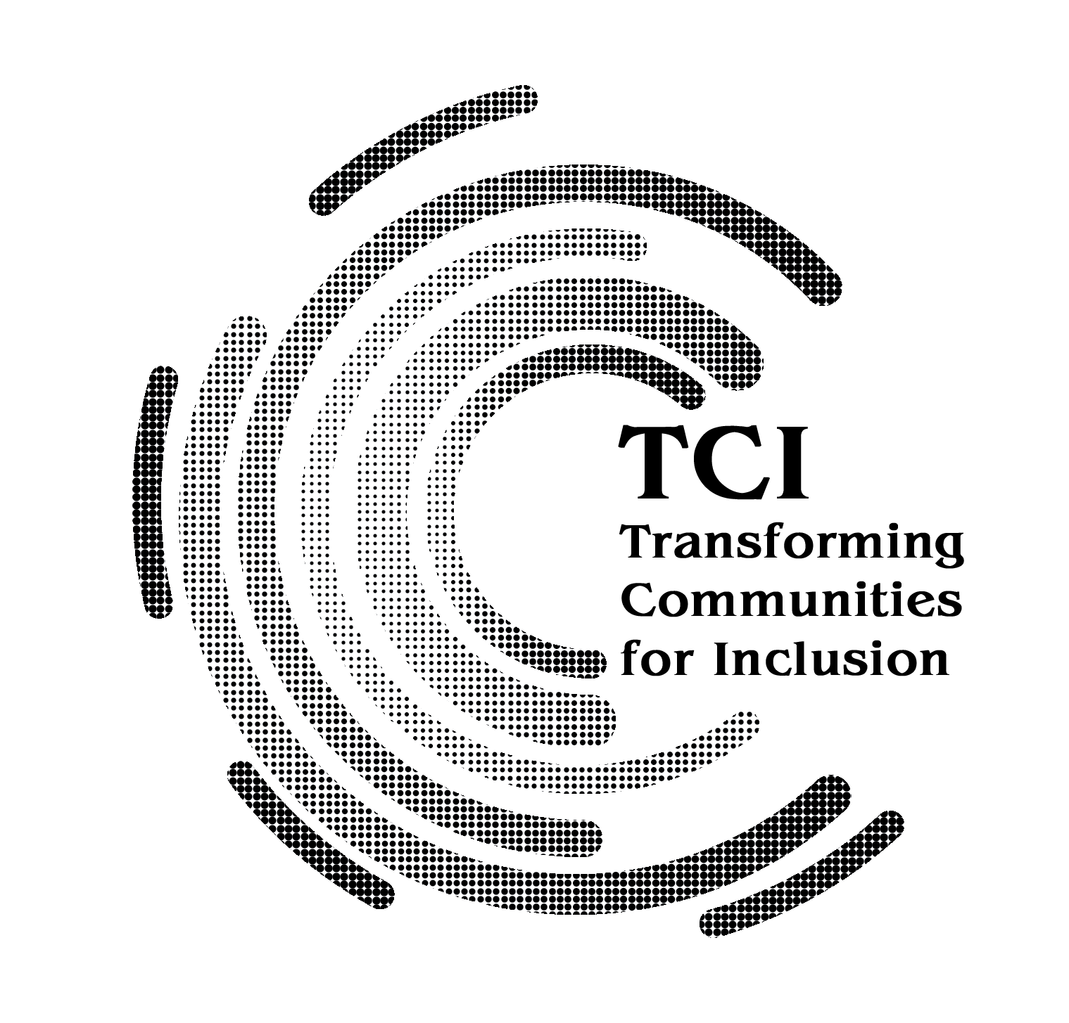
FAQs about TCI memberships
1. Can an individual member also join TCI anywhere in the world?
TCI favours organizational memberships. However, we understand that in several countries, independent OPDs of persons with psychosocial disabilities may not exist. It is a core strategy of TCI, to enable the formation of OPDs of persons with psychosocial disabilities at the national level. Therefore, individuals who would like to emerge as leaders in their countries, join hands with the cross disability movements there, are very welcome to join as individuals.
2. Can OPDs which are operating at provincial level apply for membership?
TCI invests in supporting co-operations and solidarity, and building organizations at the national level. TCI promotes co-operation of provincial OPDs with the national OPD. However, we understand that in several countries, a unified national organization of persons with psychosocial disabilities may be difficult. Therefore, provincial OPDs of persons with psychosocial disabilities can apply for membership to TCI, with the purpose of joining in the national processes.
3. Can there be more than 1 national DPO from within a country, applying for core membership?
Yes, so long as the object of the organization is the mobilization and advocacy of human rights of persons with psychosocial disabilities in line with the Convention on Rights of persons with Disabilities.
4. Can OPDs from all countries apply for membership?
TCI is an independent, global organization of persons with psychosocial disabilities. Nationals from all countries may apply for membership. TCI considers sub regions as a geographic unit, and are presently covering more intensively- South Asia, South East Asia, West Asia, East Asia, Pacific Islands, MENA regions East Africa. West Africa and Latin America. We also have a few members in USA, Europe and Canada. However, any OPD of persons with psychosocial disabilities, or a cross disability organization supporting a cohort of persons with psychosocial disabilities, may apply for membership from anywhere in the world.
6. Can family members or family members organizations join TCI as core or Associate members?
No. TCI is a global DPO. Membership is only for OPDs of persons with psychosocial disabilities or their cross disability supporters. If strongly CRPD orientated, a few family organizations advocating for transformation, can apply as ‘ally’.
7. Is TCI a "professional" forum?
TCI cultivates "experts by experience" through trainings, capacity building, cross country exchanges, country visits, fellowships etc. It also develops pedagogy and practice of the CRPD, especially on Article 19 and Inclusion. It provides strategic thinking and technical guidance to stakeholder groups, service providers, people in governance, policy makers' forums including various debates happening at the international policy level. TCI also brings several experts by experience to UN forums such as COSP, etc.
8. Can people who self identify as “user” or “survivor” join as core members?
TCI is a post CRPD movement and for a core member, identity questions would be around being a person with a psychosocial disability, embracing that and resourcing it in advocacy. “User survivors” and persons with “mad” identities, if they are open to the possibility of other identities, believe in a joint quest, put faith behind the CRPD, are staunch in their advocacy for abolition of force in psychiatry and in advocacy for community support systems and caring networks, they would find what TCI offers useful and may consider joining the platform as a core member. TCI welcomes community builders and those who advocate for supportive psychosocial ecosystems- Inclusion!
9. Can people and organizations apply to join as Ally?
An ally is a friend of TCI. Members who are allies have no role in governance. They could be technical support partners, closely support DPOs of persons with psychosocial disabilities, a person supporting our movement from other roles and capacities such as researcher, activist, etc., a person or organization such as a family group which shares TCI values on inclusion, and are a collaborator.
10. On what basis does SC approve applications for associate membership?
TCI at all times maintains a number majority of persons with psychosocial disabilities in the membership cohort. The number of associate membership spots available for cross disability organizations and persons is released from time to time by the Secretariat. Criteria for approving associate member applications from cross disability organizations are: Applicants are closely supporting the movement of persons with psychosocial disabilities in their country; Applicants are cross disability leaders or activists who work closely with a core member. Usually, a core member will suggest or nominate an associate member.

Membership is only one of the many ways by which TCI invites collaborations. There are many other ways of partnering and / or co-operating with TCI. If there are very concrete ideas and interest in connecting with us, please send a letter of inquiry to secretariat@tci-global.org

