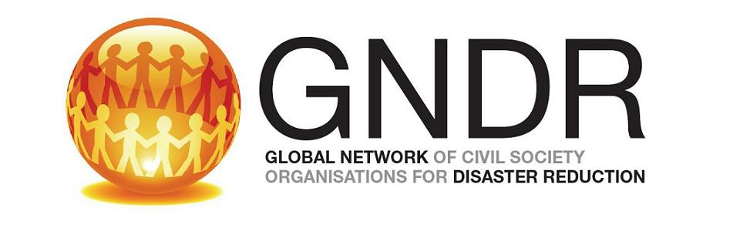

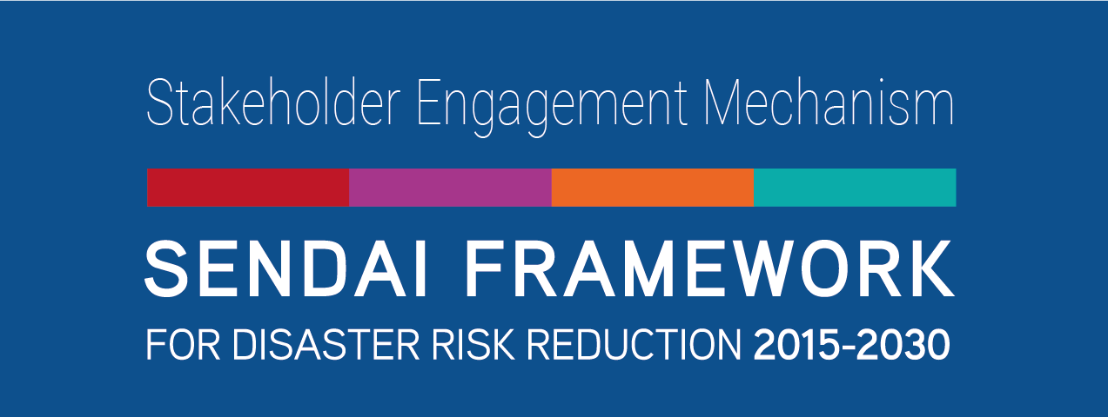
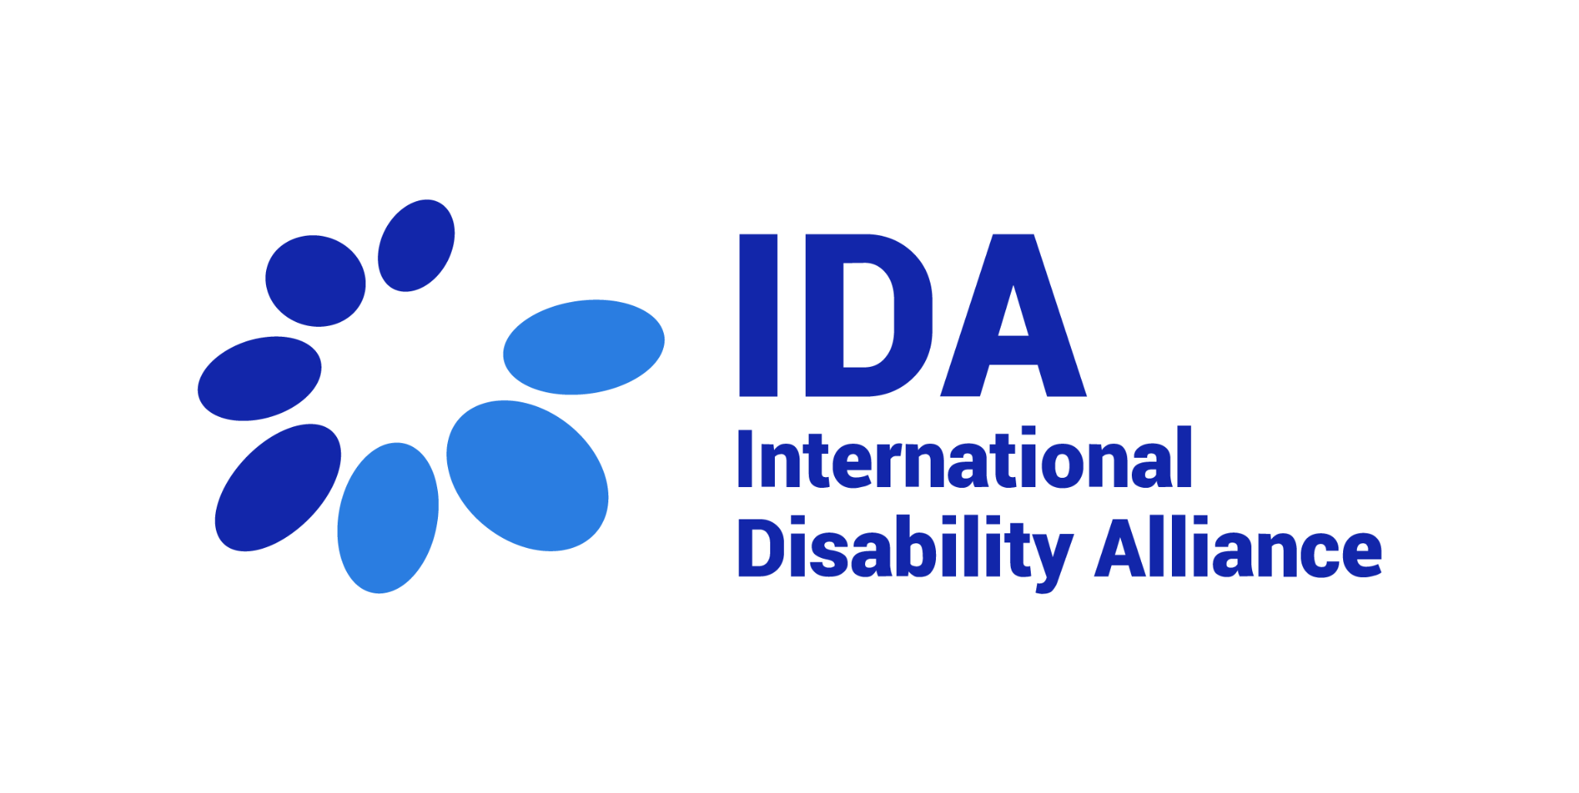


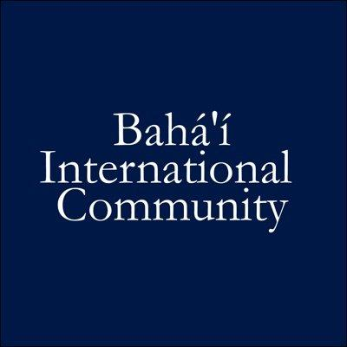
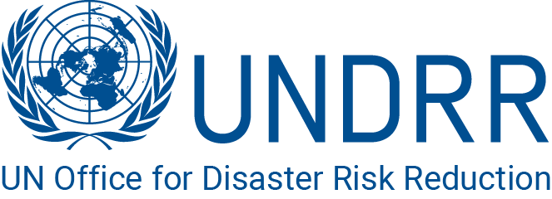

COP 27 Side Event

Localised Solutions to Reduce Climate Induced Loss & Damage for the Most Vulnerable
Venue: Memphis, Sharm El-Sheikh International Convention Centre (SHICC)
Date & time: 10th November, 11:30-13:00 (local time Egypt)
Join online: https://www.youtube.com/watch?v=R77Ram8caXI&list=PLBcZ22cUY9RJc1scZLmb8SdZezq3IM00i&index=45

Background
Climate change increases the frequency and intensity of hazards. Climate-related disasters have almost doubled compared to the previous twenty years. Affected communities and populations face multiple challenges, for instance by increasing poverty, as well as to their sustainable access to food, water and livelihoods. This results in an increase of the community's vulnerability.

A sustainable and effectfull solution to this negative spiral of climate change, hazards, vulnerability and risk, requires localised risk reduction lead by representatives of the communities at most vulnerable situations. Risk reduction, and prevention reduces escalating climate hazards´ negative impacts. Local actors, practitioners and communities possess the knowledge of both the risks and the solutions. Enhancing the capacity of these communities along with ensuring pre-conditions for meaningful participation including access to information, minimises their risks and vulnerability, and thereby contributes to long and short term reduction in climate change induced loss and damage.

Objectives
- Share local solutions including by representatives of the groups at highest situations of vulnerability to reduce climate induced loss and damage.
- Facilitate a discussion and knowledge dissemination about a focus on vulnerability to identify and assist the most at risk to prepare for hazards.
- Provide a platform for knowledge exchange between decision makers, communities and practitioners, to stimulate enhanced localisation of climate action.

Organisers
Hosted by: Nadam Foundation, The UNDRR Stakeholder Engagement Mechanism (UNDRR-SEM), Stakeholder Forum for a Sustainable Future (SF)

Supported by: Global Network of Civil Society Organizations for Disaster Risk Reduction (GNDR), Action Aid International, Baha'i International Community (BIC), International Disability Alliance, The Re-Energize Disaster Risk Reduction and Resilience Project, Asia Indigenous Peoples Pact (AIPP), The Government of Bangladesh, The United Nations Office for Disaster Risk Reduction (UNDRR)

Preliminary Outline (including buffer time)
3 minutes Welcome Remarks
Moderator Mr. Adessou Kossivi, Regional Coordinator, Global Network of CSO for
Disaster Reduction (GNDR)

5 minutes Opening Remarks
Ms. Farah Kabir, Country Director ActionAid, Bangladesh

3 minutes Engagement of the Audience
Facilitated by the moderator

7 minutes Vulnerability Focus for Identification of the ones most at Risk for Climate Change Loss
& Damage
Ms. Jamie Cummings, Research Assistant, UNC Gillings School of Global Public Health

22 minutes Localised Solutions to Reduce Climate Induced Loss & Damage for the Most Vulnerable
Approximately presentation 5 minutes, 3 minutes knowledge sharing from audience
- Mr. Sri Hari Govind, Nadam Foundation
- Ms. Mwanahamisi Singano, Senior Global Policy Lead, Women's Environment & Development Organisation (WEDO)
- Mr. Setareki S. Macanawai, Chief Executive Officer, Pacific Disability Forum

15 minutes Responders
- Ms. Gemma Tanner - Senior Adaptation Advisor, UK Foreign, Commonwealth, and Development Office (FCDO)
- Mr. Willy Missack, representative of Vanuatu

30 min Discussion
Facilitated by the moderator

5 min Closing Remarks
Ms. Sarah-Wade Apicella, Head of Partnerships and Stakeholder Engagement, UNDRR (virtual)

