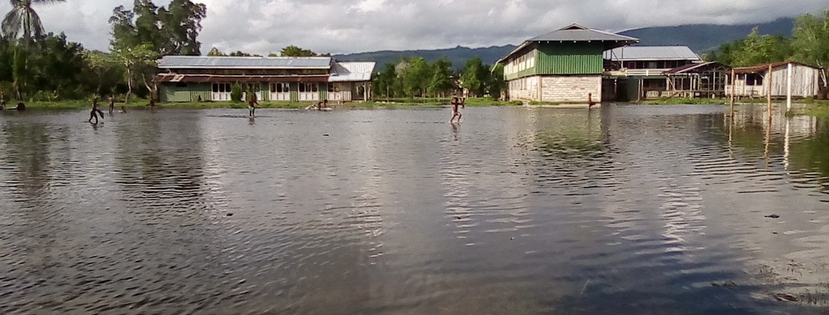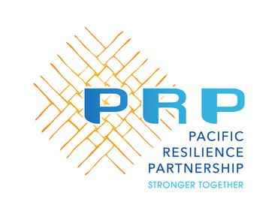

Date: 8 September 2022 3 PM to 4.10 PM Fiji Time
Disaster Risk Financing (DRF) Learning Series Virtual Learning Episode 3 - Absorbing the cost of disasters: risk retention instruments in the Pacific

Many Pacific governments must manage the cost of disasters using available public funds, especially in the aftermath of recurrent low-severity events. However sometimes it is challenging for Pacific Island Countries (PICs) to ensure that these national funds are adequately and timely resourced. It is not uncommon that a disaster hits a PIC before recovering from a previous one, which already reduced development gains and raised the costs of development.

The Disaster Risk Financing (DRF) Learning Series is organized and will be facilitated by the members of the Pacific Resilience Partnership (PRP) Technical Working Group on DRF. The third Virtual Learning Episode will explore which different risk retention instruments are available in the Pacific and how it complements other types of development and disaster risk financing instruments that PICs have access to. Representatives from three PICs will share their different experience with establishing retention funds and discussing the importance but also challenges in setting up and maintaining contingency funds as well as reserve funds.

Registration: https://bit.ly/3cBsiA8



