Call for Memberships
Transforming Communities for Inclusion (TCI)
Transforming Communities for Inclusion (TCI) is an independent global Organisation of Persons with Disabilities [OPD], focusing on the monitoring and implementation of all human rights, for persons with psychosocial disabilities. We are guided by the principles of the United Nations Convention on the Rights of Persons with Disabilities (UNCRPD), with a special focus on Article 19 (Living independently and being included in communities). Our aim is to mobilize persons with psychosocial disabilities and their organizations to advocate for inclusion within disability and development.
Who can apply
- Persons with psychosocial disabilities
- Organizations of persons with psychosocial disabilities run by themselves
- NGOs, INGOs, Cross-Disability Organizations, friends of TCI & technical support agencies who provide a range of support functions for the inclusion of persons with psychosocial disabilities in the development process
Types of Memberships
Individual Memberships for self-advocates – Click here to apply
Organizational memberships – Click here to apply

Our Interests & programs

Advocacy | Country Missions | CRPD Trainings & Capacity Building Programs | Small Grants | Fellowships | DPO Formations

“Let’s work together towards transforming communities for inclusion of persons with psychosocial disabilities in the development processes”

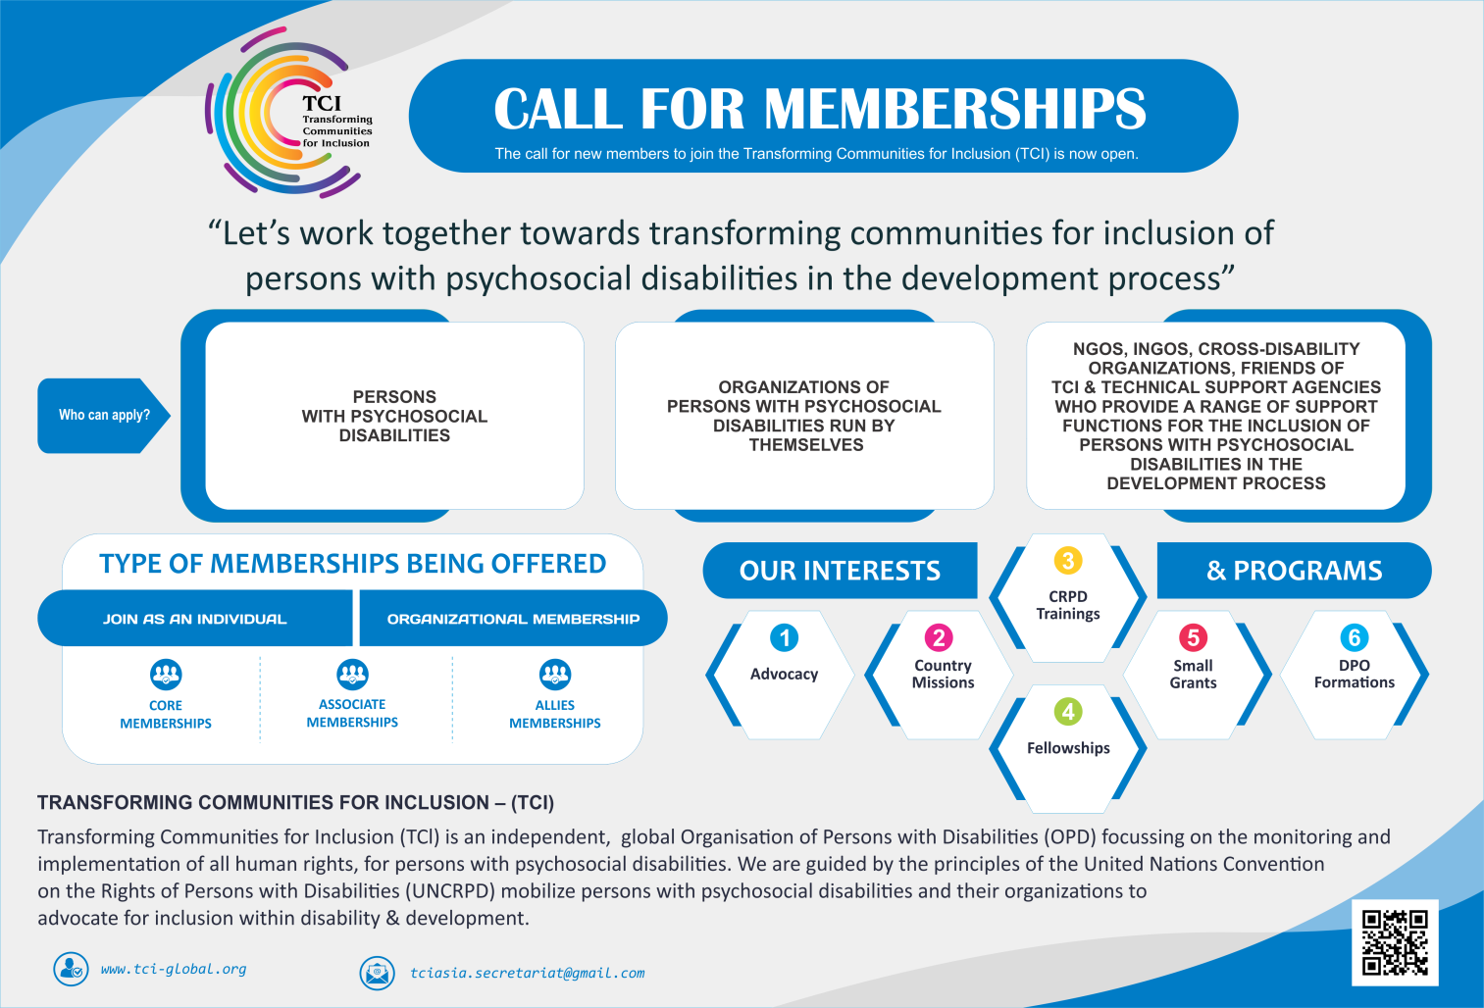
Figure 1 Information Flyer for TCI Memberships

Contact Details

Email: tciasia.secretariat@gmail.com
Website: http://www.tci-global.org/
The Bali Declaration: https://www.tci-global.org/bali-declaration/
#WhatWENeed: https://whatweneed.in/

Please feel free to disseminate the information widely within your networks

