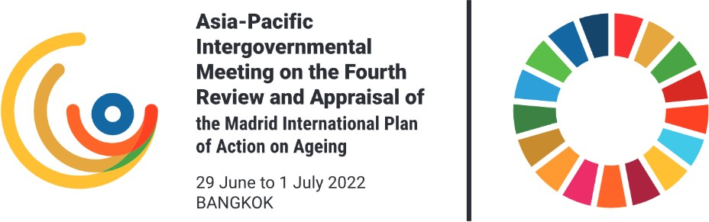

Fourth Stakeholder Consultation for the Asia- Pacific Intergovernmental Meeting on the Fourth Review and Appraisal of the Madrid International Plan of Action on Ageing - Pacific
Addressing all priority directions of MIPAA, as they relate to the Pacific

Wednesday, 8 June 2022 (14:00-16:00, Suva Time) Online (Zoom)

Introduction
CONCEPT NOTE

In accordance with GA resolution 76/138 and ECOSOC resolution 2020/8, the Economic and Social Commission for Asia and the Pacific (ESCAP), supported by regional partners, is organizing the Asia- Pacific Intergovernmental Meeting on the Fourth Review and Appraisal of the Madrid International Plan of Action on Ageing (MIPAA) from 29 June to 1 July 2022.

As part of this review and appraisal, ESCAP is organizing stakeholder consultations on the three priority directions of MIPAA: (a) older persons and development; (b) advancing health and well-being into old age; and (c) ensuring enabling and supportive environments. Prevalent and emerging issues – such as the impact of COVID-19, intergenerational solidarity, climate change, digital transformation, and the future of work – will be discussed throughout the consultations. Gender considerations will be

mainstreamed. The fourth stakeholder consultation will focus on all priority directions of MIPAA as they relate to the Pacific.

Main findings and recommendations of the consultations will be summarized in an information paper to be submitted to the Fourth Review and Appraisal of the Madrid International Plan of Action on Ageing in Asia and the Pacific. The objective of these consultations is to bring a bottom-up participatory approach of the review and appraisal of MIPAA at the regional level and identify challenges and opportunities of population ageing that transcend national boundaries from stakeholder perspectives.

Objectives of consultation
The purpose of the stakeholder consultation is to facilitate and expand collaboration and participation in the regional review and appraisal process, and in particular to elicit stakeholder experiences and views around the review objectives, namely:

  - Take stock of the overall progress of implementation of the priority issues to date
  - Identify key challenges, opportunities, gaps, and prevalent and emerging issues
  - Identify established and emerging good practices and lessons learnt
  - Identify resource requirements and capacity building needs
  - Formulate recommendations

Content and format
The consultation will consist of an opening followed by a plenary session. Issues that are of importance to the Pacific will be discussed as follows, and in accordance with the MIPAA priority directions:

- Older persons and development
- Advancing health and well-being into old age
- Ensuring enabling and supportive environments
- Emerging issues, COVID-19, digitalization, climate change

The consultation is a closed meeting and will not be recorded. In order to have open and frank discussions, the Chatham House Rule will be followed, which means that participants are free to use the information received but may not reveal the identity or the affiliation of the speaker(s), or of any other participant.

A summary note of the consultation will be drafted and made publicly available after the consultation. Registration will close on Tuesday, 7 June 2022 at 24:00 hrs. (midnight) (Bangkok time).

Participants
Participants in the stakeholder consultation will come from non-government organizations in the Pacific. Organizers will ensure that there is gender balance.

Please feel free to forward the invitation to colleagues and partners. Please remember that all participants need to register for the meeting by Tuesday, 7 June 2022 at 24:00 hrs. (midnight) (Bangkok time).

Expected outcomes and next steps
To ensure meaningful, inclusive, transparent and diverse participation by stakeholders with respect to reviewing progress towards all MIPAA priority direction, as well as discussion of prevalent and emerging issues (such as the impact of COVID-19, intergenerational solidarity, climate change, digital transformation and the future of work), with gender considerations to be mainstreamed.

A short summary note drafted by the co-organizers, to be posted on the ESCAP website and to inform the intergovernmental regional review and appraisal meeting.

Background
The Madrid International Plan of Action on Ageing, 2002 (MIPAA) was adopted by the Second World Assembly on Ageing, held in Madrid from 8 to 12 April 2002, and endorsed by the General Assembly in resolution 57/167 of 18 December 2002. It put forth a bold new agenda of “building a society for all ages”, which is more relevant today than ever. It focuses on three priority areas: older persons and development; advancing health and well-being into old age; and ensuring the existence of enabling and supportive environments.

Article 17 of MIPAA recognizes and highlights the importance of a whole-of-government and whole-of- society approach to its implementation, follow-up, review and appraisal:
“Governments have the primary responsibility for providing leadership on ageing matters and on the implementation of the International Plan of Action on Ageing, 2002, but effective collaboration between national and local Governments, international agencies, older persons themselves and their organizations, other parts of civil society, including non-governmental organizations and the private sector, is essential. The implementation of the International Plan of Action on Ageing, 2002, will require the partnership and involvement of many stakeholders: professional organizations, corporations; workers and worker organizations; cooperatives, research, academic and other educational and religious institutions; and the media.”

appraisal of MIPAA at the nation level, using a bottom-up participatory approach. These provide ideas and practical examples to be used by national Governments in carrying out whole-of-government and whole-of-society reviews and appraisals of MIPAA.

MIPAA has been reviewed at the global, regional and national levels three times since its adoption. The fourth regional and global reviews and appraisals are forthcoming in 2022 and 2023 (ECOSOC resolution 2020/8 and GA resolution 76/138). The General Assembly and ECOSOC have regularly followed up on population ageing and provided a strong mandate to the regional commissions “in assisting Governments, at their request, in the implementation, follow-up and national monitoring of the International Plan of Action on Ageing, 2002 …” (Article 18 of MIPAA).

Population ageing and the situation of older persons have also been addressed in other United Nations norm-setting documents at the global and regional levels, including the Programme of Action of the International Conference on Population and Development, the 2030 Agenda for Sustainable Development, the 2013 Asian-Pacific Ministerial Declaration on Population and Development and the Decade of Healthy Ageing. Most recently, the Secretary-General’s Our Common Agenda mentioned the urgent need for “intergenerational solidarity”.

Background documents
Madrid International Plan of Action on Ageing

Guidelines for review and appraisal of the Madrid International Plan of Action on Ageing

Engagement of civil society organizations and other stakeholders in the Asia-Pacific Intergovernmental Meeting on the Fourth Review and Appraisal of the Madrid International Plan of Action on Ageing

Additional information is available on the UN ESCAP dedicated website

