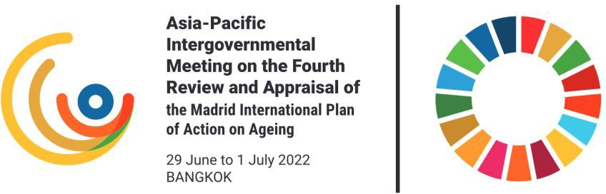

Fourth Stakeholder Consultation for the Asia- Pacific Intergovernmental Meeting on the Fourth Review and Appraisal of the Madrid International Plan of Action on Ageing - Pacific
Addressing all priority directions of MIPAA, as they relate to the Pacific

Wednesday, 8 June 2022 (14:00-16:00, Suva Time) Online (Zoom)
AGENDA (1 June 2022)

Time | Details
13:30 | Participants join Zoom meeting
14:00-14:30 | Welcome and opening session  Moderator: Mr. Bill Mitchell, Community Legal Centres, Australia  - MIPAA video (6 minutes)  - Keynote address: Mr. Mohammed Khan, Asia Pacific Forum on Families (APFAM) International, Fiji
14:30 -15:10 | Plenary discussion I  Moderator: Mr. Bill Mitchell, Community Legal Centres, Australia  - Older persons and development  - Advancing health and well-being into old age
15:10-15:15 | Break

15:15-15.55 | Plenary discussion II  Moderator: Mr. Bill Mitchell, Community Legal Centres, Australia  - Ensuring enabling and supportive environments  - Emerging issues, COVID-19, digitalization, climate change  Special presentation: Tilé Imo, Caxton Legal Centre, Brisbane and President of the Pasifika Lawyers Association QLD, Australia
15:55-16:00 | Closing and next steps  Moderator: Mr. Bill Mitchell, Community Legal Centres, Australia  Closing remarks: TBD  Ms. Sabine Henning, ESCAP





Follow us:

https://www.unescap.org/ | @unescap
@unitednationsescap | @united-nations-escap

