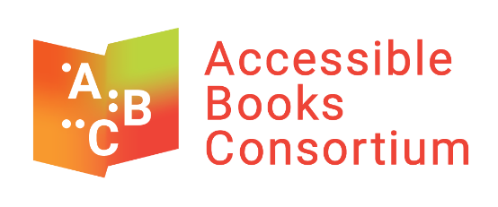

Accessible Books Consortium (ABC)
2021 Fellowship Application Form

Applicant Information

Please complete all fields.

Date:
Family Name:
First Names:
Gender:
Date of birth
(DD/ MM/YYYY):
Street Address (City, Country, Postal Code):
Phone number(s), including country code:
Email address:
Nationality (please indicate if you have more than one nationality):
Place and country of birth:

Languages Spoken

Place an X in the corresponding box
 | None | Basic | Intermediate | Advanced
English
Arabic
French
Russian
Spanish

Education

Please list the highest university degree you have obtained, or are in the process of completing:

References
Please provide the names of two references, with their titles, and telephone numbers (including country code), that we may contact.
1) Full Name and Title:
Telephone numbers (including country code):
2) Full Name and Title:
Telephone numbers (including country code):

Form, Cover Letter and CV

Please send the following documents via email to ABC.Fellows@wipo.int by Monday, March 1, 2021, before 6:00 p.m. Geneva time:

  - the fellowship application form with all fields completed; and
  - a covering letter, expressing your interest in the fellowship; and
  - a curriculum vitae (résumé).

