12 December 2019

***2020 Accessible Housing Forum***

**Rights & Inclusion Australia and ANUHD**

**Invite you to participate in our 2020 Forum**

The Australian Building Codes Board is undertaking a Regulatory Impact Statement (RIS) for potential minimum accessibility standards for housing, to be applied through the National Construction Code (NCC) as attached Project Timeline.

The Forum will provide an update on progress towards more equitable and accessible housing in Australia – and harmonising guidelines and standards.

**When Monday 20 April 2020 10am to 4pm**

**Where Standards Australia**

**20 Bridge St, Sydney NSW 2000**

**$50** (non-members) and **$25** for RIA/ANUHD members & welfare payment recipients

Registration by PayPal or St George Bank BSB 112 879 Account 410808862

*Real time captioning and AUSLAN interpreters will be available, the venue is accessible, and please advise any additional requirements.*

Further information is available at [www.riaustralia.org](http://www.riaustralia.org) or phone **02 6552 9333**



**Program**

**2020 Accessible Housing Forum**

**Standards Australia Sydney Monday 20 April 2020**

|  |  |  |  |
| --- | --- | --- | --- |
| **TIME** |  | **ACTION** | **SPEAKER** |
| 0930 | 30 | Registrations |  |
| 1000 | 15 | Welcome to Country  Opening | Local Aboriginal Land Council  Michael Fox R&IA |
| 1015 | 45 | Accessible housing, planning  BMF, AHRC and UN CRPD  Discussion | Sue Salthouse R&IA and  Jane Bringolf ANUHD |
| 1100 | 30 | Morning tea | Provided |
| 1130 | 60 | ABCB RIS status and NCC program  Discussion | Kieran O’Donnell  Senior Project Officer  NCC Innovation and Analysis  ABCB |
| 1230 | 90 | Lunch | Own arrangements |
| 1400 | 60 | Relationship between ABCB, RIS, LHA and AS4299  Discussion | Industry presenters  Alison Scotland  Standards Australia |
| 1500 | 45 | RIS discussion & recommendations | Facilitator  Sue Salthouse R&IA |
| 1545 | 15 | Summing up and 4pm close | ANUHD and RIA |

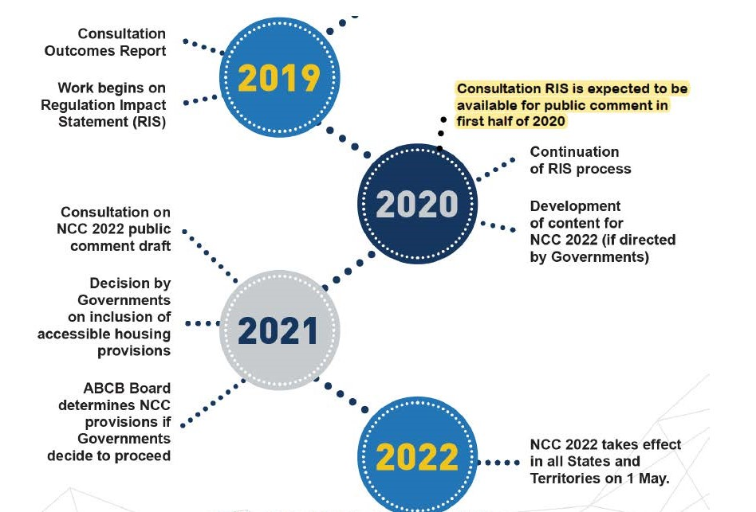

**ABCB Accessible Housing Project Timeline**