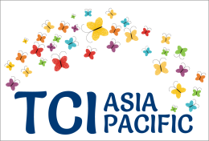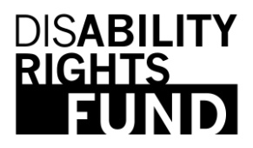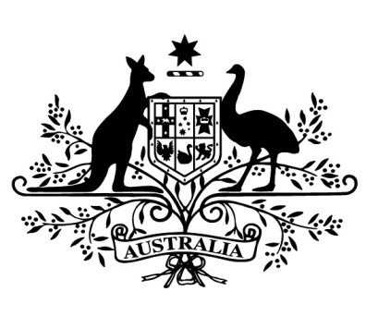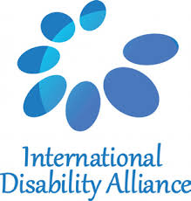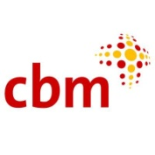

**Side Event at COSP 12, New York.**

**#WhatWENeed- Inclusion of persons with psychosocial disabilities, within Development**

**Date and Time: 10th June 2019, 3.00 PM - 4.15 PM, Room. C**

TCI AP, supported by the Disability Rights Fund, International Disability Alliance, Government of Australia, CBM Australia and the Open Society Foundation, is hosting a Side Event at COSP 12, #WhatWENeed

"#*What we need"* was an international campaign, for amplifying the voices of persons with psychosocial disabilities, around the International Mental Health Week, 2018. Transforming Communities for Inclusion Asia Pacific (TCI AP) will share with the participants, their learnings from *#WhatWENeed*. The side event invites partners, peers and participants to articulate *#WhatWENeed* to do, as regional and global stake holders within Disability Inclusive Development, towards the full inclusion of persons with psychosocial disabilities.

**Speakers:** Ms. Catalina Devandas, SR(Disabilities) Ms. Diana Samarasan Ms. JennyRosa Damayanti

Govt of Australia (TBC) International Disability Alliance (TBC) Ms. Bhargavi V Davar (TCI Asia Pacific)