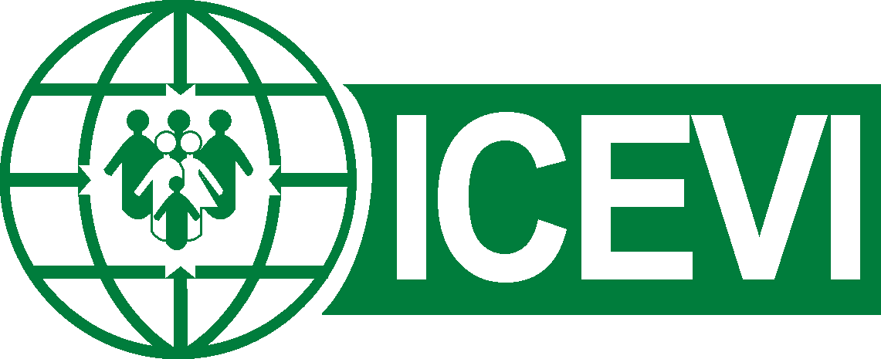
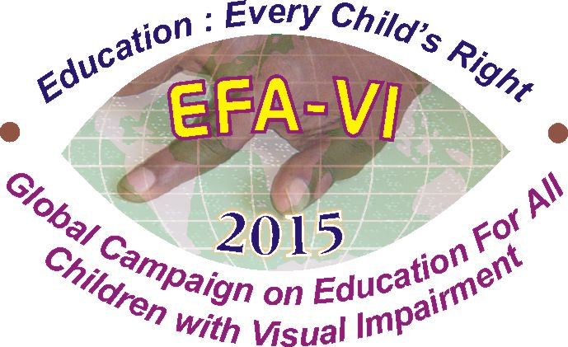

International Council for Education of
People with Visual Impairment
Please reply to : Dr Frances Gentle, President
The RIDBC Renwick Centre, Royal Institute for Deaf and Blind Children,
361-365, North Rocks Road, North Rocks, NSW 2151, AUSTRALIA
Phone : +61 2 9872 0808; Fax: +61 2 98731614
E-mail : frances.gentle@ridbc.org.au ; Web: www.icevi.org

24th May 2019
Subject: ICEVI promotes ratification of the WIPO Marrakesh Treaty
I write on behalf of the International Council for Education of People with Visual Impairment (ICEVI), to urge ratification of the WIPO Marrakesh Treaty and implementation of fair and balanced copyright laws.
ICEVI is a membership organisation with the Mission to promote access to inclusive, equitable and quality education for all people with visual impairment. ICEVI’s Mission is closely aligned with the United Nations Sustainable Development Goal 4, ‘ensure inclusive and equitable quality education and promote lifelong learning opportunities for all’. We strive to achieve our Mission and Goals through the work of the ICEVI global Executive Committee, regional and national ICEVI committees, and our partner members. Current priorities include the provision of technical and advocacy support in the field of education for children with visual impairment to government ministries, United Nations agencies, and the global education community.
Fundamental to realising SDG4 and the educational and employment potential of all children, is access to quality education services and programs. For children with visual impairment, this includes access to curriculum-based information and textbooks on the same basis as sighted children. Children with visual impairment require opportunities to create, read and share books and other cultural materials in accessible formats (e.g. large print, braille, audio, digital). However, in many countries, restrictive copyright laws have resulted in what is termed “the global book famine” by the World Intellectual Property Organization (WIPO).
WIPO estimates that only 1-7% of books are published in a format that can be read by the 285 million children and adults worldwide who are blind or visually impaired. WIPO stated:
Without books, journals and magazines, people are cut off from life. They cannot gain an education or participate fully in society. They cannot realize their full potential.
That is not just a loss to them – it is also a serious loss to the economies and societies they live in. (WIPO, 2016)
ICEVI urges national governments to address the global book famine by ratifying the WIPO Marrakesh Treaty and implementing fair and balanced copyright laws that facilitate information access across and within national borders. Furthermore, we encourage national governments to implement policies that require publishers to produce “born accessible” textbooks and other curriculum materials, that is, materials in formats that are useable directly from the publisher by children who are sighted or visually impaired.
In the spirit of cooperation and collaboration, we encourage national representatives of publishing industries, authors, libraries, copyright and disability associations, government departments, and accessible format providers to come together to build government, business and community awareness of accessible content and inclusive publishing.
The acquisition of education, learning and skills is essential in building human capital and national prosperity, and in enriching the lives of individuals by raising aspirations and promoting employment, earnings and health (World Bank, 2018). ICEVI is inspired by the United Nations’ vision of education as transformative to the lives of individuals, communities and societies, leaving no one behind.
We ask you to promote the national adoption of the Marrakesh Treaty, combined with changes, where needed, to national copyright laws, as an effective means of expanding the availability of copyrighted works to children with visual impairment or other print disabilities.
Sincerely yours,

Frances Gentle, AO, PhD
President, International Council for Education of People with Visual Impairment (ICEVI)

[The Marrakesh Treaty to Facilitate Access to Published Works for Persons Who Are Blind, Visually Impaired, or Otherwise Print Disabled (known as the WIPO Marrakesh Treaty), is an international agreement that was negotiated under the auspices of the World Intellectual Property Organization, a United Nations specialized agency.]

