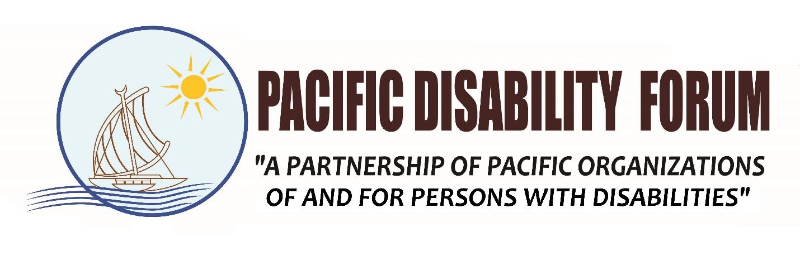**Terms of Reference**

***Research consultancy to support the Pacific Disability Forum (PDF) to synthesize the volume of good practices “Mainstreaming disability inclusion in the climate change and disaster risk reduction policies and programmes”.***

1. **Project background**

From September 2018 to February 2019, PDF in partnership with UNESCO called for the submission of good practices (case studies) in mainstreaming disability inclusion in the climate change and DRR policies and programmes.

The call for Submission aims to:

i. Document good practices of DPOs, Disability focal points, CSOs, governments and other stakeholders in the Pacific, in advocating for the mainstreaming of disability inclusion in national development framework focussing on climate change adaptation and mitigation.

ii. Based on the lessons learnt of the case studies, suggest guidelines for DPOs and disability focal points to better advocate for integrating the rights of persons with disabilities in the development framework, based on the collected good practices.

The call for good practices of mainstreaming disability inclusion extend to interventions by state and non-state actors in climate change adaptation and mitigation and disaster risk reduction. The good practices must be concrete examples of ways in which a disability lens and the perspective of persons with disabilities are incorporated in policies and programmes

1. **Purpose of the consultancy**

The consultant serves to edit and strengthen the texts of the submission, drawing key lessons learnt from the case studies and providing recommendations/guidelines for mainstreaming disability inclusion in climate change and disaster risk reduction policies and programmes. In particular, under the supervision and leadership of the AHP Regional Coordinator for the Pacific Disability Forum. The consultant is expected to:

* Edit the submitted texts and synthesizing the submitted case studies into a volume.
* Draw up key lessons learnt from the case studies and provide a set of recommendations/guidelines for mainstreaming disability inclusion in climate change and disaster risk reduction policies and programmes based on the case studies.

The assignment does not require the consultant to work full time during the length of the assignment, but only a limited number of working days per month. The consultant can work remotely, however, keeping close contact with the AHP Regional Coordinator at PDF.

1. **Deliverables**

The researcher is expected to submit the final volume of good practices with:

1. Case studies, and;
2. A set of guidelines for mainstreaming disability inclusion.
3. **Budget and payments**

The contract will be for a maximum of 15 days, over a period of two months. Remuneration will be at a per day rate of up to FJD 550 depending on the capability, knowledge and experiences of the person. Below is the payment schedule for the researcher:

1. **Effective date**

The consultancy contract will be from the 20th of May 2019 to 14th June 2019

|  |  |  |  |
| --- | --- | --- | --- |
| No. | Deliverables | Due Dates | Remuneration |
| 1 | Signing of TOR and contractual agreements | 20 May 2019 | 10% |
| 2 | Draft volume of good practices | 27 May 2019 | 40% |
| 3 | Quality checks and insert comments from UNESCO, PDF and its partners into the Draft volume | 3 June 2019 | 10% |
| 4 | Submit final volume of good practices | 14 June 2019 | 40% |

1. **Requirements**

* Minimum Master degree in social sciences;
* Professional background on social research;
* Excellent verbal and written communication skills in English;
* Availability for the field study visits, telephone, email or video-link discussion during the full duration of assignment;
* Experience in consultancy work in the area of inclusive disability development and/or climate change and disaster risk reduction in the Pacific is a major advantage.

1. **Expressions of interest**

Expressions of interest should contain the following information:

* Details regarding the consultant, including curriculum vitae, referees, past experience in this area of work, and demonstrated ability to meet deadlines and the requirements of this consultancy
* Availability
* Proposed consultancy fee

The expression of interest should be sent via email to [rcperu@pacificdisability.org](mailto:rcperu@pacificdisability.org) before 9th May 2019.The subject of the email should be labelled as **“EOI BEST PRACTICE - Climate Change and Disability Consultant”.**

**END**