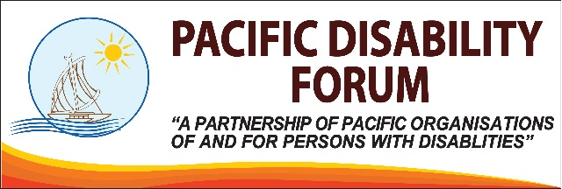24 January 2018 Press Release
IASC Guidelines on Inclusion of Persons with Disabilities in Humanitarian Actions, Pacific Consultation Workshop
The Pacific Disability Forum (PDF) in partnership with the United Nations Inter-Agency Standing Committee (IASC) Task Team on the Inclusion of Persons with Disabilities in Humanitarian Action currently conducting a regional Consultation Workshop for humanitarian actors in the Pacific. The workshop which is the first regional consultation undertaken by the IASC Task Team and first such regional meeting in the Pacific will be an opportunity for disabled people’s organisations (DPO), Governments, UN Agencies, CROP Agencies, and other humanitarian actors in the region to contribute to the development of a global guideline on the inclusion of persons with disabilities in Humanitarian Actions.
UN Resident Coordinator and UNDP Resident Representative Ms Osnat Lubrani highlighted that this meeting is critical for us to ensure that the Pacific voice is heard. She highlighted the need to ensure that responses to be local as possible and international as necessary.
She further reminded participants of the need to learn from each other and build each other’s strengths throughout the discussion.
“It is important to leverage each other’s strengths and contributions in a complementary approach”, said Ms Lubrani.
PDF CEO Mr Setareki Macanawai stressed the importance of this opportunity for persons with disabilities and humanitarian actors in the region.
“The next two days is an opportunity for us to tell our stories from the Pacific through this global process, and for us to talk to each other on how we can improve our policies and our process, funding and humanitarian work better and truly, genuinely inclusive of persons with disabilities”, said Mr. Macanawai.
The workshop will also be an opportunity for Pacific humanitarian actors to provide guidelines and tools that will ensure that humanitarian actions are inclusive of persons with disabilities.
IASC Workgroup on the Inclusion of Persons with Disabilities Co-Chair Mr Gopal Mitra said the guideline will be a set of tools that will ensure humanitarian actors to plan, design, implement and evaluate humanitarian actions which ensure full participation of persons with disabilities.
“This will also be a set of guidelines that will change practice in humanitarian sectors and make it more inclusive of persons with disabilities”, said Mr Mitra.
PDF acknowledges funding support from the Governments of Australia and New Zealand. The consultation will be from the 23 to 24 January, at the Tanoa International Hotel in Nadi.
For more information please email Simione Bula at infor@pacificdisability.org or call +679 8912653.

