# **Meet our speakers**

**, Sri Lanka**

Ms. Jayathma Wickramanayake was appointed as the UN Secretary-General’s Envoy on Youth in June 2017 at the age of 26. In this role, Jayathma works to expand the UN’s youth engagement and advocacy efforts across all four pillars of work – sustainable development, human rights, peace and security and humanitarian action – and serves as a representative of and advisor to the Secretary-General.

Originally from Sri Lanka, Ms. Wickramanayake has worked extensively on youth development and participation, and has played a key role in transforming the youth development sector in her home country.

Prior to taking up her post, Ms. Wickramanayake was instrumental in creating the movement for civic and political engagement of young people, especially young women in Sri Lanka named “Hashtag Generation”. Previously, she advocated for global youth development on an international level including as the first ever Sri Lankan Youth Delegate to the United Nations and as the youth lead negotiator and member of the International Youth Task Force of the World Conference on Youth 2014 where she played a critical role in mainstreaming youth in the Post-2015 Process and in the establishment of World Youth Skills Day.

## **Image of a man in his 30th**

## **Nyle DiMarco, USA**

As the first deaf contestant to **win *America’s Next Top Model* and *Dancing with the Stars*,** Nyle DiMarco has been breaking down barriers and winning over audiences since he burst onto the scene in 2014. Alongside successful television credits, DiMarco is currently producing and developing scripted and non-scripted programming, as well as consulting on disability inclusion and authentic representation.

Activism and philanthropy also play massive roles in DiMarco’s life. He has quickly become the face of not only the Deaf community but disabled people worldwide. As the founder of The Nyle DiMarco Foundation, he works tirelessly on bilingual education initiatives and aims to improve access to accurate information about early language acquisition. He is also an ally and influencer with the United Nations, further propelling his advocacy and tackling both education and accessibility under their 2030 Sustainable Development Goals.

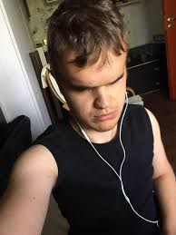

## **Diliyan (Dido) Manolov, Bulgaria**

Dido holds Bachelor in General Psychology and Master Degree in Organizational Psychology. He is currently a PHD student in Developmental psychology. Dido is a Cofounder and education officer of Vizioner Foundation - aimed at empowering persons with disabilities through skill acquisition and enhancement and former TV host. He currently works at private consultation practice for individual and organizational psychology at Center Albatross. He is also supporting UNICEF Bulgaria to develop national strategy for empowering the adolescents with disabilities. Dido is blind and he is a strong advocate for the rights of persons with disabilities and a champion for Social and Behavior Change.

## Young African woman smiling **Tobiloba Ajayi, Nigeria**

Tobiloba has over 10 years experience working with various organisations in the Disability Management sector in different countries.

She holds a degree in Law and was called to the Nigerian Bar in 2008. She also holds a Masters Degree in International Law. She started by working on Disability Policy as a member of the Nigerian Vision 20:20: 20 policy drafting team, and went on to work with various NGO’s in a quest to improving the lives of persons with disabilities.

In March 2017, she launched ‘The Let Cerebral Palsy Kids Learn Foundation to promote inclusive mainstream education for children with Cerebral Palsy in Nigeria. his was born out of a realization in 2016 during her Mandela Washington Fellowship, Professional Development Experience; that children with Cerebral palsy were being excluded from mainstream education by the school system in Nigeria.

To date, the project has provided support to 350+ children and their families and enabled about 75 of these children access inclusive education.

Each family under the project accesses continuous counselling, referrals, school placement supports and school readiness assessments. The project has also trained over 400 Teachers in its bid to address the knowledge and skill gap of mainstream classroom teachers to engage children with Cerebral Palsy in their classrooms.

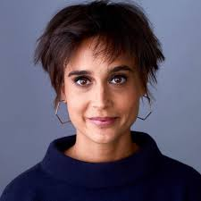Tobiloba is also a 3 time published author that believes strongly in the power of words to create a change perceptions and realities

**Lea Labaki, Belgium**

She is a member of the European Network of Users and Survivors of Psychiatry (ENUSP). Lea is a former Junior Researcher and Advocate in the Disability Rights Division at Human Rights Watch. Her recent work has included investigating barriers to education for children with disabilities in European Schools and abuses against children with albinism in Tanzania. She holds a Master’s Degree (cum laude) in Human Rights and Humanitarian Action from Sciences Po, Paris, and a Bachelor’s Degree (summa cum laude) in Political Science from Université Saint-Louis, Brussels.

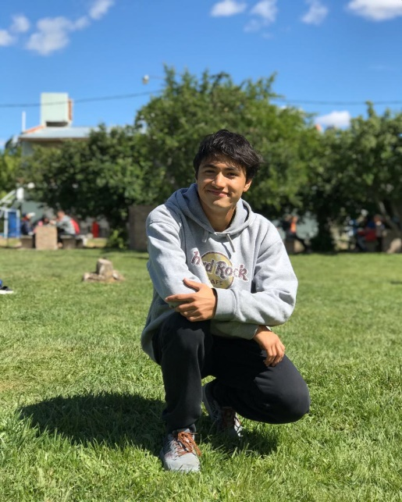 **Gabriel Heredia, Argentina (Photo will be available by COB)**

Gabriel is a 17 year old young Argentinian from Trelew, Chubut, who has Asperger Syndrome. Three years ago he started his life as an activist for the rights of people with disabilities, when he gave a talk at his school about Asperger Syndrome. In June 2019 he participates from the First Youth and Adolescents Forum on Inclusive Education, organized by META youth network in Buenos Aires, and since then he integrates the movement. He has been invited to different local events and radio shows to talk about Asperger Syndrome. In October 2019 he creates Asperger-Chubut League, together with other young people with Asperger Syndrome of the nearby provinces, to defend his rights and those of all the persons with disabilities.

## **Woman smiling Akiko Hart, UK**

Akiko is the Chair of the International Society for Psychological and Social Approaches to Psychosis UK ([ISPS UK](http://www.ispsuk.org/)), a Committee Member of the [English Hearing Voices Network](https://www.hearing-voices.org/) and the Hearing Voices Project Manager at [Mind in Camden](http://www.mindincamden.org.uk/). She has previously worked as the Director of [Mental Health Europe](https://mhe-sme.org/), and has a keen interest in the differences and overlaps in mental health provision in different national and cultural settings.

As part of her work at Mind in Camden, she helps set up and facilitate Hearing Voices groups and networks in a variety of settings, including the community, in-patient units, children and adolescent mental health services, prisons, secure units and Immigration Removal Centres. As such, one of her interests is the extent to which peer support can sit within statutory services and promote real change – and the challenges and limitations inherent in this.

She has written about and spoken on a range of topics at conferences across Europe and the US, including promoting alternatives in mental health, de-institutionalization and legal capacity.

## **Surya Sahetapy**

Surya Sahetapy is an Indonesian Deaf advocate; he stands for the rights of Deaf people in Indonesia. He is a student at RIT/NTID (Rochester Institute of Technology/National Technical Institute for the Deaf) for majoring in International-Global Studies. His goal is to work as the advisor for the Indonesian government to promote the rights of Deaf individuals and people with disabilities. His works with different organizations aimed to provide deaf and disability advocacy for stakeholders on dealing with deaf and disability in Indonesia. He actively campaigns for equality for people with disabilities especially in Indonesia, where he believes still has much room for improvement.