The Pacific Disability Forum is cordially inviting you to the launch of the Report on Disability and Climate Change in the Pacific: Findings from Kiribati, Solomon Islands and Tuvalu.

Tuesday, 30th August 2022 11: 00a.m- 1: 00p.m (FST), 9: 00a.m- 11a.m(AEST), 12: 00p.m- 2: 00p.m (NZDT), 1: 00a.m- 3: 00a.m (CEST) at The Grand Pacific Hotel, Suva, Fiji.
In-person/ Hybrid Meeting: Zoom Meeting

Register for the meting using the link below:
https://us02web.zoom.us/meeting/register/tZArcu6hqzkuE9X4Xub-q5p-CPO5QlWkFS0y

Sign Language Interpretation and Live Captioning will be provided.

Organized by the Pacific Disability Forum (PDF), supported by the Australia Pacific Climate Partnership Support Unit and funded by Australian Aid, Department of Foreign Affairs and Trade (DFAT).

Background:

In the Pacific, in situations of extreme weather events, there is growing evidence that persons with disabilities are not normally considered for preparedness and response activities due to the various barriers they encounter which include accessibility to information, services and infrastructure, lack of assistive devices, support services, social protection, discriminatory procedures and community based inclusive development which limits their effective participation in humanitarian work or accessing relief programs

A study was commissioned by PDF, supported by APCP Support Unit, and funded by DFAT on the Climate Change Impact on Persons with Disabilities in the Pacific: Kiribati, Tuvalu and Solomon Islands. Findings from the research will be presented by Pacific persons with disabilities.

Moderated by Ms. Sainimili Tawake, Advisor – Inclusive Development, Pacific Disability Forum (PDF).

The Disability and Climate Change Report will be launched by Mr. Iliesa Lutu, Senior Programme Manager, Australian High Commission, Suva, Fiji.
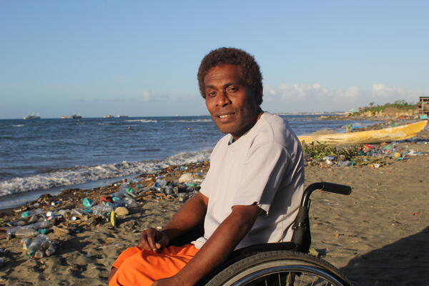
Panelists from PDF and Organizations of Persons with Disabilities in the Pacific:
Mr. Setareki Macanawai, Ms. Melvina Vua, Ms. Terubeimoa Nabutari, Mr. Molomolo Touaisi, Mr. Taupaka Tinilau, Mr. Davis Lua Bolana, Mr. Casper Joseph (TBC) with response from representatives of Regional Intergovernmental Organizations.



Picture: Person with physical disability by the sea. The beach has been battered with coastal inundation and pollution as an impact of climate change.

