
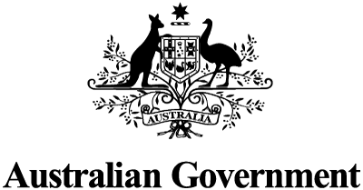
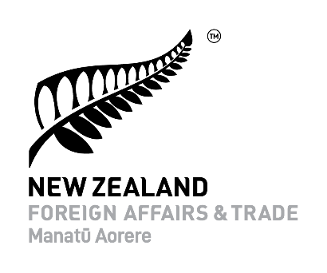
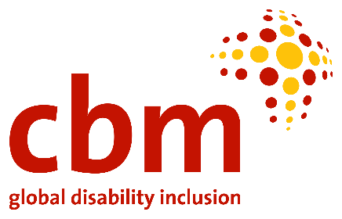

Building disability-inclusive and participatory societies: recovering stronger and better through economic empowerment and entrepreneurship in the Pacific.

Date:
Monday 13 June 6-7:15pm EST /
Tuesday 14 June 10-11:15am FST /
Tuesday 14 June 8-9:15am AEST

Promoting and building a disability-inclusive and participatory society is critical for the economic independence and well-being of persons with disabilities. As is clearly articulated in the CRPD, persons with disabilities must be given equal chances and opportunities to better themselves through employment and education, without fear of discrimination.

As part of the side event to the 15th session of the Conference of State Parties, a panel discussion will be held. In this panel event, hosted by the Government of Australia and the Pacific Disability Forum, speakers will examine the socio-economic impact of COVID-19 in the Pacific and discuss opportunities to recover stronger and better through decisive, sustainable interventions and innovations to economically empower people with disabilities.

Speakers:
- Andrea Cole, Director, Disability, Indigenous and Social Inclusion, DFAT
- Setareki Macanawai, CEO, Pacific Disability Forum
- Government of Fiji
- Asian Development Bank

Register for this panel discussion in the link provided below:

https://us02web.zoom.us/meeting/register/tZwsduCtpzguGd1wFc6shRWbfZXVXIf7tfx_

After registering, you will receive a confirmation email containing information about joining the meeting. (International Sign Interpretation is provided)

