
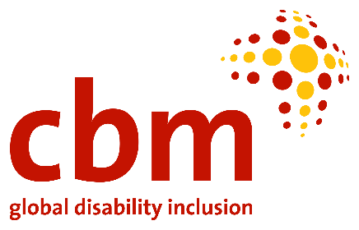
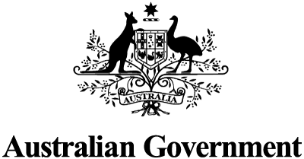


15th Conference of State Parties (COSP) to the Convention on the Rights of Persons with Disabilities (CRPD)

CONCEPT NOTE – PACIFIC SIDE EVENT

Date and Time: Monday 13 June 6.00 – 7.15pm (EST) / Tuesday 14 June 10.00 – 11.15 am (FST)
Location: Virtual event (Zoom)
Register for meeting here

The Government of Australia and the Pacific Disability Forum kindly invite delegates and civil society organisations attending the 15th Conference of States Parties to the CRPD, and other interested parties, to a panel discussion on the economic empowerment of persons with disabilities in the context of COVID-19 recovery in the Pacific.

Co-sponsors of the event are the New Zealand Ministry of Foreign Affairs and Trade, CBM Australia and CBM New Zealand

Panel format:
Australia will co-host this event with the Pacific Disability Forum - a constituency of 71 OPDs from 22 Pacific Island countries and territories. There will be three key speakers, followed by Q&A.

Theme: Building disability-inclusive and participatory societies: recovering stronger and better through economic empowerment and entrepreneurship in the Pacific.

Background
The COVID-19 pandemic has had a disproportionate impact on the lives of persons with disabilities. It has amplified and increased a range of barriers and inequalities faced by persons with disabilities globally. The Pacific region is no exception to this.

In particular, COVID-19 has increased the economic vulnerability of persons with disabilities. Many have suffered the dual impact of meeting increased costs of living with decreased income. People with disabilities have reported increased expenses, including groceries, health care and medicines, in addition to new expenses such as personal protective equipment. At the same time, people with disabilities have had less access to supports, affecting their ability to work and further marginalizing those who rely on carers and personal assistants for daily tasks or to remain connected to their communities. With most people with disability working in the informal sector, many have either lost or had reduced employment.

Organisations representing persons with disabilities throughout the Pacific region have made clear that the promotion of economic empowerment, entrepreneurship and livelihood activities are the key to recover better, quicker, and stronger from COVID-19.

In order to fully, equitably recover from the impacts of COVID-19, we will need to take a wide, coordinated approach, involving regional cooperation between governments, civil society organisations, donors and other development partners, multilateral institutions and persons with disabilities themselves.

Rationale
Promoting and building a disability-inclusive and participatory society is critical for the economic independence and well-being of persons with disabilities. As is clearly articulated in the CRPD, persons with disabilities must be given equal chances and opportunities to better themselves through employment and education, without fear of discrimination.

As we learn to live with COVID-19 and climate change related shocks and stresses, governments, the private sector and other partners have an opportunity to reassess and revise policies to ensure people with disabilities can fully and effectively participate in, and be included in, society. First and foremost, this means addressing the essential pre-conditions for inclusion: accessibility, assistive devices, support services, social protection, community-based inclusive development (CBID) and non-discrimination. Accessibility to the physical environment, transport, information and communications, and other services, ensures access for persons with disabilities on an equal basis with others. Assistive devices, support services and social protection are enablers, while CBID ensures inclusion and impact at community level, fostering bottom-up innovation and accountability. Enacting and enforcing legislation against all forms of discrimination on the grounds of disability in line with the CRPD, including on the right to work and ensuring reasonable accommodation, is crucial to ensuring such pre-conditions can be realised.

In this panel event, hosted by the Government of Australia and the Pacific Disability Forum, speakers will examine the socio-economic impact of COVID-19 in the Pacific and discuss opportunities to recover stronger and better through decisive, sustainable interventions and innovations to economically empower people with disabilities.

Program

Moderator and Opening Statement:

Andrea Cole, Director, Disability, Indigenous and Social Inclusion, Department of Foreign Affairs and Trade, Australia

Speakers:

Speaker 1 – Representative of the Pacific Disability Forum

Speaker 2 – Representative of the Disability Division, Ministry of Women, Children and Poverty Alleviation, Government of Fiji

Speaker 3 – Representative of the Asian Development Bank

END

