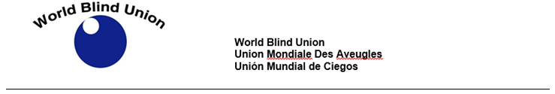

COVID-19: JOIN US FOR FACEBOOK LIVE SERIES!!

The World Blind Union (WBU) will be hosting a series of Facebook live sessions to advocate for inclusive response to COVID-19, beginning April 16.

The first session will be on Thursday April 16TH at 12 Noon EST.

The first session is titled: " Orientation and mobility, personal safety in time of Covid-19".

Speaker: Colin Wong, an O&M Instructor and Staff trainer currently working at Saavi Services for the Blind in Phoenix, Arizona. He holds a Masters in Guidance and Counseling with a National Orientation and Mobility Certification (NOMC).

Closed captioning will be provided. Questions are welcome throughout the sessions. Please email your questions to info@wbu.ngo

We will be using the hashtag #COVID19Disability

Join us through the World Blind Union Facebook page and tag us on Facebook as: @BlindUnion

