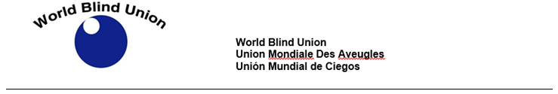

COVID-19: JOIN US FOR FACEBOOK LIVE SERIES!!

The World Blind Union (WBU) will be hosting a series of Facebook live sessions to advocate for inclusive response to COVID-19.

The next session will be on Wednesday April 22nd at 12 Noon EST.

The session is titled: "Home schooling, how to help our children in time of Covid-19".

Speaker: Melissa Riccobono. Melissa has a BA in Psychology and a Masters in Counseling Psychology, with an emphasis on school counseling. She has worked as an elementary school counselor and is currently the First Lady of the National Federation of the Blind, USA and a board member for the National Organization of Parents of Blind Children

Closed captioning will be provided. Questions are welcome throughout the sessions. Please email your questions to info@wbu.ngo

We will be using the hashtag #COVID19Disability

Join us through the World Blind Union Facebook page and tag us on Facebook as: @BlindUnion

