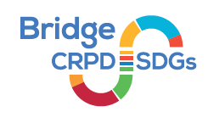



***Nothing about us without us* towards *leaving no one behind!***

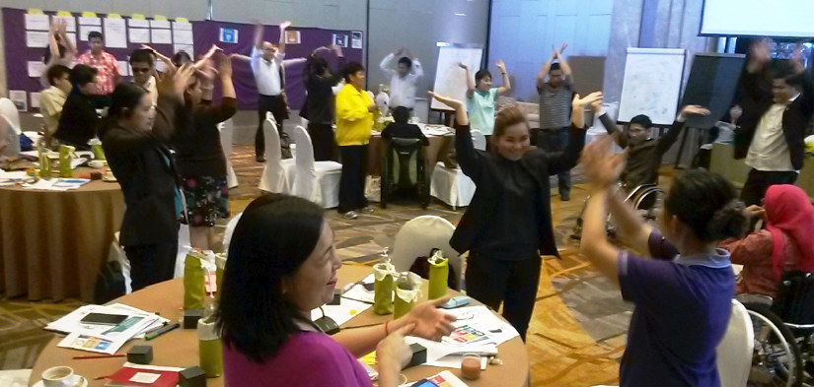***Our aim***

The Convention on the Rights of Persons with Disabilities (CRPD) sets obligations to ensure the effective realization of **all human rights for all persons with disabilities**. However, its implications are often not equally addressed for the diversity of persons with disabilities.

The ‘**Nothing about us without us**’ motto - which is reflected throughout the CRPD and central to the Bridge CRPD-SDGs Training Initiative - demands that persons with disabilities and their representative organizations are fully involved in decisions that concern them at **all levels**.

The need for well-resourced and well-informed OPDs (Organizations of Persons with Disabilities) is therefore rising.

The main aim of the Bridge CRPD-SDGs Training Initiative is to invest in global and regional OPDs to support capacity building of their national members to advocate for the achievement of the **Sustainable Development Goals** (SDGs) **for all persons with disabilities** in line with the **CRPD**.

***Our history***

In 2015, the International Disability Alliance (IDA) and the International Disability and Development Consortium (IDDC) developed the Bridge CRPD-SDGs Training Initiative.

It is a unique inclusive capacity development initiative designed to respond to the growing demand to equip persons with disabilities and OPDs to capitalize the 2030 Agenda. It also supports them to engage adequately with governments and other actors to shape policies & programs to be compliant with the CRPD.

***Our principles***

* By, for and with persons with disabilities
* Working cross-disability, with attention to intersectionality and underrepresented groups
* Inclusive, enabling environment & methodology
* Valuing participants’ expertise
* Collaborative quality assurance
* Peer accountability and learning
* Not for profit and open source material

***Differentiated trajectories***

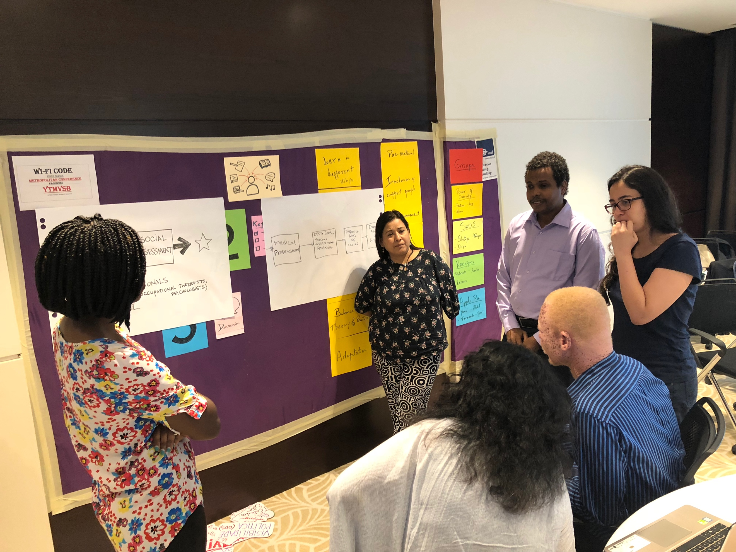The Initiative proposes a trajectory for trainees who wish to go further that may comprise:

1. **Training and advisory opportunities**
2. **Practical exposure** to UN mechanisms
3. A **Training of Trainers**
4. **Additional modules** as co-facilitators or participants in other cycles
5. **Fellowship** opportunities
6. **Mentoring** - advocacy, advisory, peer learning at local, national, regional and global levels

***Training of trainers***

A critical number of activists with disabilities, from different regions, is also prepared to respond to the increased demand for highly qualified trainers. They are equipped with skills to facilitate CRPD and SDGs related trainings, including Bridge modules.

***Quality criteria and development***

Implementing partners work through collaborative approaches to attain optimum quality and learning outcomes. This includes the establishment of task and facilitation teams, under a Partnership Protocol, validated by the Steering Committee.

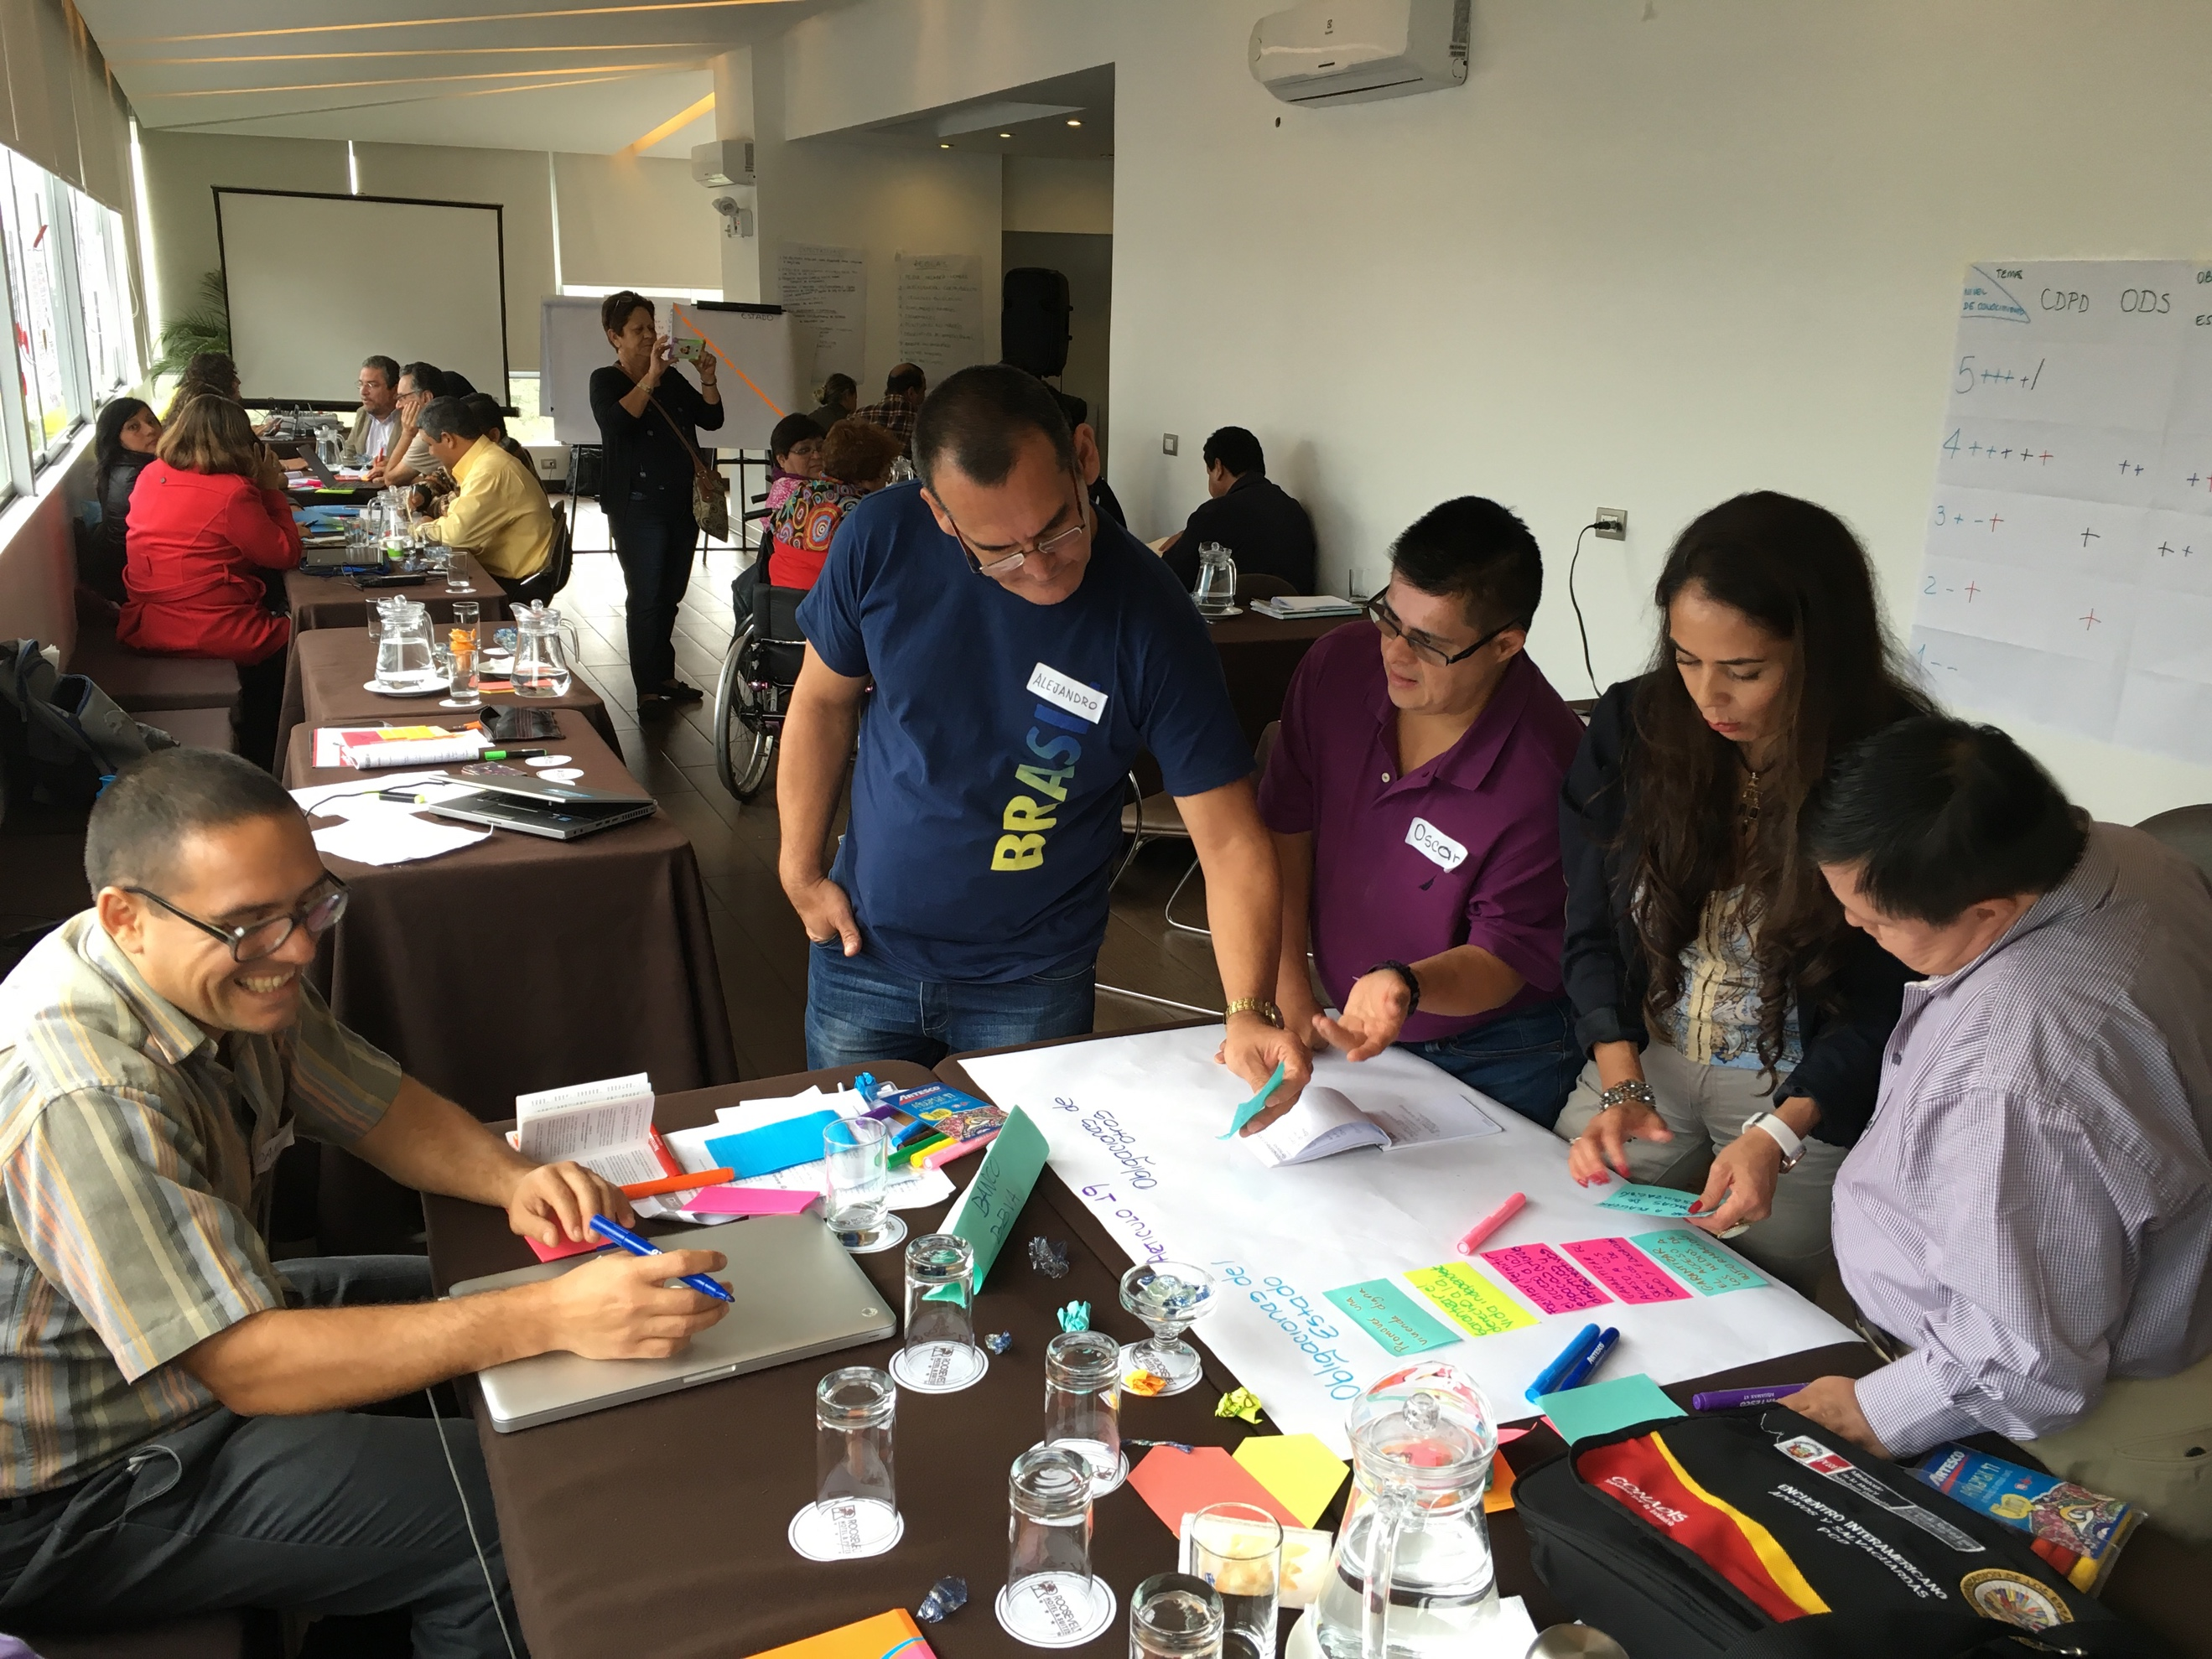***Curriculum***

***Module 1*** focuses on securing an in-depth understanding of the CRPD and analysing development from a CRPD perspective,

***Module 2*** further develops capacities to take action through different key policy areas including legal harmonisation, budgeting, data, to the use of UN monitoring mechanisms. The purpose is to create evidence for policy change.

A high-level policy exchange platform is also offered.

**Through assignments -** between both modules - participants:

(1) work with peers at country level to analyse the human rights and development context in their country,

(2) individually develop a draft policy brief analyzing a development issue, from a CRPD perspective.

**“*Bridge CRPD-SDGs Training Initiative is the most advanced example we know of inclusive training on the CRPD respecting diversity through differentiated approaches to accommodate different learning styles. Adequate attention to everyone leads to successful learning outcomes*”.**

**Vladimir Cuk**

**IDA Executive Director**

**The Bridge CRPD-SDGs training is a critical initiative seeking to ensure an effective, skilled and expert cohort of persons with disabilities are engaged in national and regional efforts to implement the SDGs and realise the CRPD.**

**Dominic Haslam**

**IDDC Chair**

**Contact us**

[bridge_platform@ida-secretariat.org](mailto:bridge_platform@ida-secretariat.org); Bit.ly/BridgeCRPD-Sdgs

**INFOGRAPHIC**

***Key figures 2015 - 2019***

700 people reached

92 countries

59% participants and facilitators are women

75% facilitators with disabilities themselves

40% participants and facilitators from underrepresented groups

***Upcoming cycles & Events***

2019

Module 2 MENA in Arabic

Module 1 West Africa in French

Module 1 Module South Asia + Laos

2020

Module 2 Tanzania in Swahili

Strategic meetings & evaluation

Module 1 West Africa in English

Workshop on CRPD compliance

African Portuguese speaking countries

National Bridge CRPD-SDGs cycles

Focus on adaptation of materials (Easy to read, Sign Language and audio versions)

***Bridge CRPD-SDGs training cycles***

**Global cycle:**

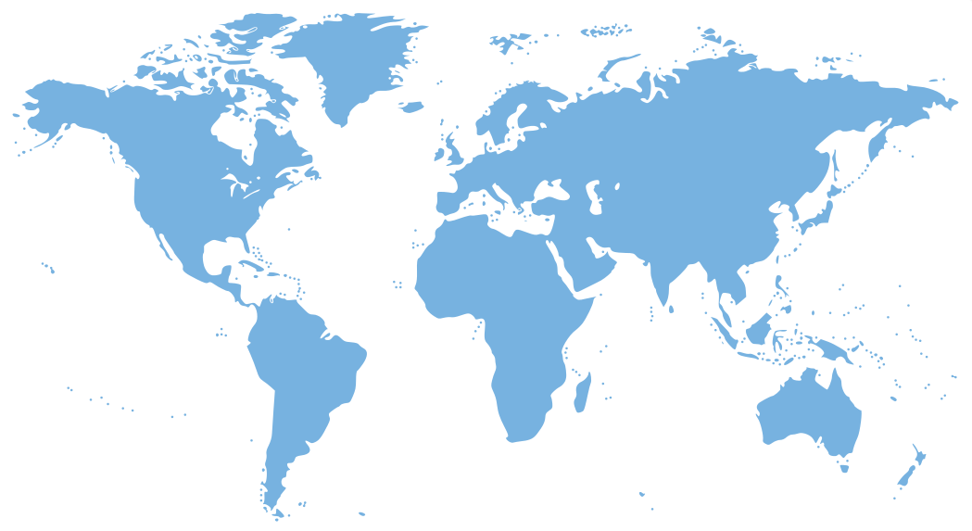

**MENA (30)**

2019 Module 3 on the CRPD Art 11 (English)

2016 to 2019 Training of trainers (English, French and Portuguese)

**Regional cycles:**

2015 to 2016 South East Asia (English with simultaneous interpretation)

2015 to 2016 Latin America (Spanish)

2015 to 2016 Great Lakes Africa (French)

2016 to 2017 Pacific (English with simultaneous interpretation)

2016 to 2017 East and Western Africa (English)

2018 to 2019 Middle East & North Africa (Arabic & English)

**National cycles:**

2015 to 2016 Indonesia/ Timor East (Bahasa & English)

2018 Uganda (English)

2019 to 2020 Tanzania (Swahili & English)