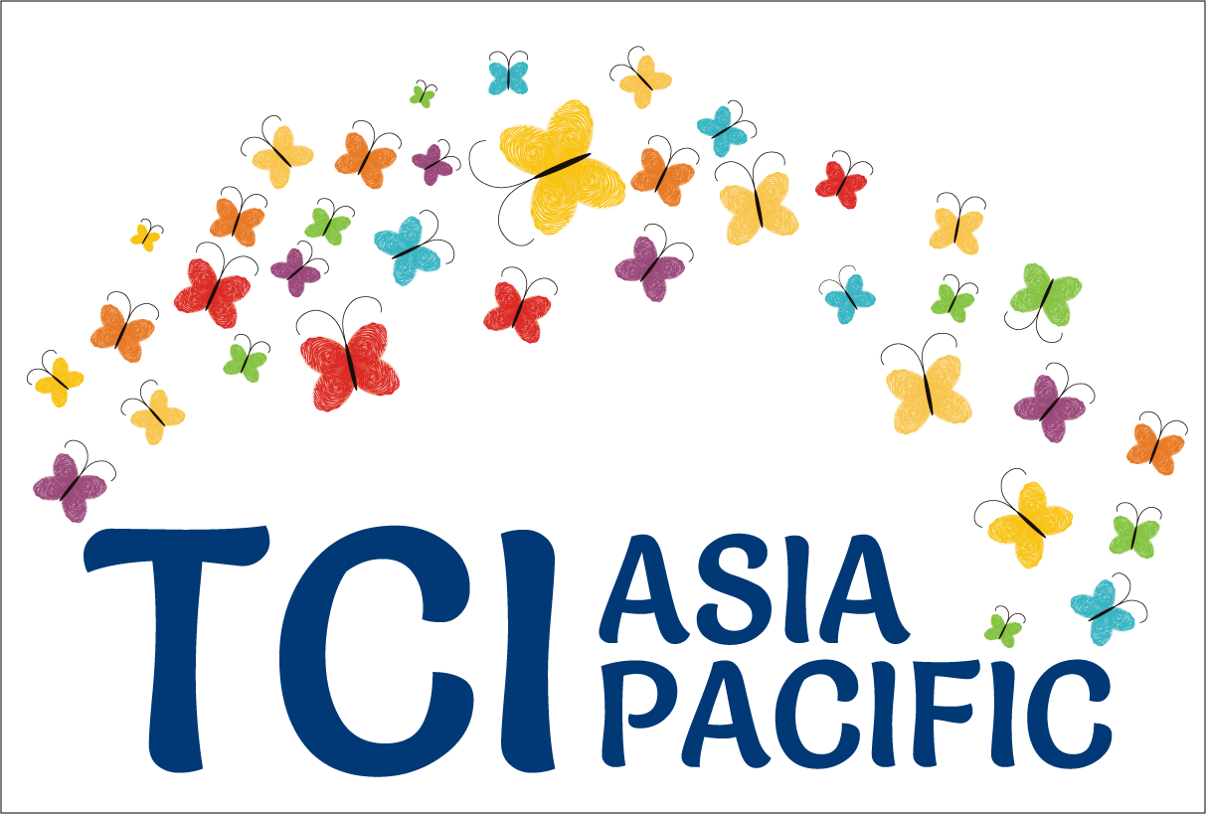

**Turning the tables:**

**The imperative to reframe the debate towards full and effective participation and inclusion of persons with psycho-social disabilities**

**Excerpt from “Galway-Trieste” conversations[1] - Part 2**

The United Nations Convention on the Rights of Persons with Disabilities has resulted in a "mental health momentum" being created among different sectors, including the medical sector. Persons with psychosocial disabilities, users and survivors of psychiatry, persons with "mad" identities, and various other identities thereof, met over several convenings, which are broadly called the "Galway-Trieste" conversations.

Organized groups from all regions of the world participated in these conversations at different points in time, to guesstimate where we are as a movement, as well as, what are the new advocacy agendas that we need to pursue. Also concerning, was the growth of "peer support" worldwide, and especially in the Global South, often led by medical professionals. Part I was published earlier [here](http://www.whatweneed.in/?p=844). This is the II part of reporting on those conversations, focussing on our concerns about the Global Mental Health Agenda.

Can "progressive thinking in mental health" bring about true human rights change and a paradigm shift?

***The Global Mental Health Agenda***

Mental health has become a recurrent theme of the global health agenda. The 2030 Agenda for Sustainable Development – an ambitious set of goals and targets that all 191 UN Member States have committed to achieve by 2030 – affirms that universal health coverage and access to quality health care are necessary to promote mental health and well-being.[2]Prevention and treatment of non-communicable diseases and promotion of mental health and well being, is one of its specific goals, famous by now as Goal 3.4. The Human Rights Council – the principal human rights political body of the UN – also adopted on 1 July 2016 a resolution on mental health and human rights, aiming to promote the realization of the human rights and fundamental freedoms of “persons with mental health conditions or psychosocial disabilities, including persons using mental health and community services”.[3]The Third Committee of the UN General Assembly discussed early this year, the adoption of a resolution to promote mental health and well-being in the framework of the 2030 Agenda. Most of these developments were substantiated on the increasing medical literature around the “global burden of disease attributable to mental, neurological and substance use disorders**”.[4]**

The Movement for Global Mental Health has led the global advocacy towards positioning access to mental health care as a global health priority. This network of individuals and organizations—mostly health care providers, activists, policymakers and researchers—aim to expand mental health care worldwide. In its initial call for action, published in 2007 in the first Lancet series on Global Mental Health, the Movement called the global health community, governments, donors, multilateral agencies and other mental health stakeholders, such as professional bodies and consumer groups, to scale up the coverage of services for mental disorders in all countries, but especially in low-income and middle-income countries.[5]

The Movement has gradually become an influential stakeholder shaping global discussions around mental health.[6]The Movement has been very effective in convening the support of different leaders and opinion builders in the fields of health and development, including Amartya Sen, former UN Secretary General Ban Ki-moon, former WHO Director-General Margaret Chan, the World Psychiatric Association, and other influential mental health professionals and organizations.

Moreover, the Movement had a significant impact in the development of two key WHO policies: the 2008 Mental Health Gap Action Programme (mhGAP) and the Comprehensive Mental Health Action Plan 2013–2020. The former proposes to “scale up services for mental, neurological and substance use disorders for countries, especially with low- and middle-income” while the latter aims to “promote mental well-being, prevent mental disorders, provide care, enhance recovery, promote human rights and reduce the mortality, morbidity and disability for persons with mental disorders”. Both documents share a biomedical approach to mental health and a priority focus on expanding mental health services. Moreover, the Mental Health Action Plan further calls for the adoption of mental health legislation to “codify the key principles, values and objectives of policy for mental health”. The World Bank has recently endorsed these efforts building the case for investing in mental health services.[7]

There is a strong convergence between the Global Mental Health Movement and trends in development with push for greater use of public private partnerships and innovative financing, with the involvement of pharmaceutical companies.

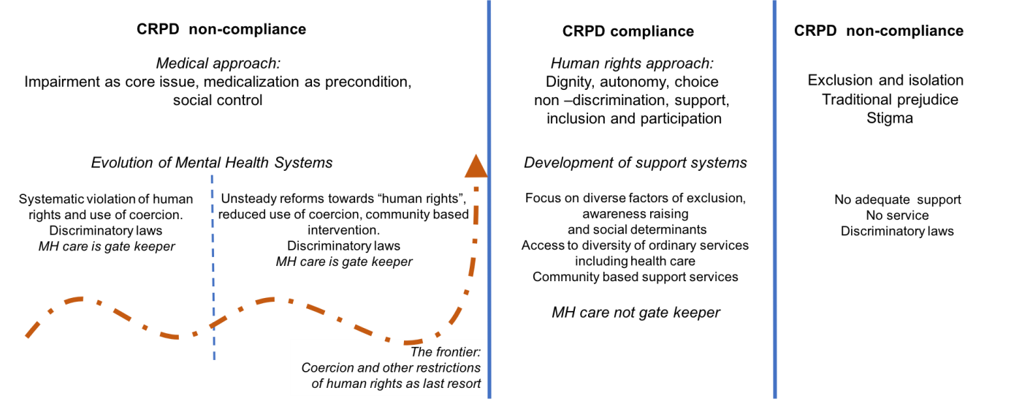While the Movement and its allies claim to be both “rights-based” and “evidence-based”, many authors have pointed out the shortfalls and contradictions of its proposal, including its allegiance to a biomedical model of psychiatry and its proximity with the pharmaceutical industry.[8]As Dainius Pūras has noted, there is growing evidence that psychotropic drugs are not as effective as previously thought, that they produce harmful side effects and that in the case of antidepressants, specifically for mild and moderate depression, the benefit experienced can be attributed to a placebo effect.[9] Furthermore, as previously discussed, the expansion of mental health services, strongly dominated by psychiatrists who believe access to treatment is the central issue also raises concerns about the

extent of human rights abuses and specifically the use of coercion.

Exchanges that took place in Galway and Trieste among other places, have shown that there is a widespread acknowledgement of human rights violations in mental health institutions and the growing recognition of the importance of community-based solutions, the importance of recovery and inclusion. However, the medical profession and governments are unlikely to part with the legal possibility of coercion, involuntary treatment, deprivation or restriction of legal capacity as last resort to prevent the individual from serious harm or preventing injury to others. As a result, the recovery approach is co-opted by mental health systems that do practice coercion.

As mentioned, the almost unanimous resistance from Member States to include clear mention on the prohibition of forced treatment and confinement in the otherwise very progressive 2017 resolution of the Human Rights Council on mental health and human rights is a good indicator of the state of play.

It is clear that with regards to persons with psychosocial disabilities unlike for some others the shift of paradigm away from the medical approach did not take place. The starting point is not “what needs to be done to ensure that persons with psychosocial disabilities enjoy their right to live independently and being included in the community” but rather what can be done to the person so that she/he fit in its environment. There is to a certain extent a negation of social determinants of health and of the impact of social barriers on exclusion. The issue of compliance with behavioral norms is central and is transfer from community social control to medical control, back to community control. The medical system becomes the gate keeper to recognition, exercise and enjoyment of many rights (medical expertise in relation to legal capacity, civil commitment, ability to stand trial, etc).

The debates are dominated by the situation of crises rather than far more widespread issues of isolation, withdrawal, trauma and victimization. Too little attention is paid to the barriers in society, the driving factors behind psychosocial and mental health issues such as violence, poverty, economic stress, the lack of community support to concerned individuals and their families.

It is fair to acknowledge that the shift of paradigm implies more complexity and co-ordination across sectors and that medicalization is in many ways a policy shortcut, leading to poor outcomes at significant economic costs.

**Declaring that,**

The following report is an embargo of many months on this work which TCI Asia Pacific takes the responsibility to disseminate it widely. TCI Asia Pacific has supported the meetings financially and led the initiative in many other ways. We thank the many organizations that attended the meetings, IDA, and the co-facilitators, Alex Cote and Alberto Vasquez.

**Continued in another blog piece, coming soon ….**

1. Different organizations and individuals were involved in these sustained dialogues supported by the International Disability Alliance and Open Society Foundation and inclusive of TCI Asia Pacific, ENUSP, PANUSP, USP Kenya, INTAR, MHE, WNUSP, a Latin American emerging network at the time of these conversations and others. Facilitation by Alexandre Cote and Alberto Vasquez.
2. A/RES/70/1, para. 26.
3. A/HRC/RES/32/18.
4. See, for example, Whiteford, Harvey A et al., *Global burden of disease attributable to mental and substance use disorders: findings from the Global Burden of Disease Study 2010*, The Lancet , Volume 382 , Issue 9904 , 1575 - 1586; Patel, Vikram et al., *Addressing the burden of mental, neurological, and substance use disorders: key messages from Disease Control Priorities*, *3rd edition,* The Lancet , Volume 387 , Issue 10028 , 1672 – 1685.
5. http://www.globalmentalhealth.org/about/aims/call-action
6. http://www.globalmentalhealth.org/about/history
7. Seth Mnookin, *Out of the shadows: making mental health a global development priority*, World Bank Group and WHO (2016): <http://documents.worldbank.org/curated/en/270131468187759113/pdf/105052-WP-PUBLIC-wb-background-paper.pdf>
8. See China Mills, Decolonizing Global Mental Health: The Psychiatrization of the Majority World (Routledge, 2014); David Ingleby, *How ‘evidence-based’ is the Movement for Global Mental Health?*, Disability and the Global South, 2014, Vol.1, No. 2, 203-226.
9. A/HRC/35/216, para. 19.