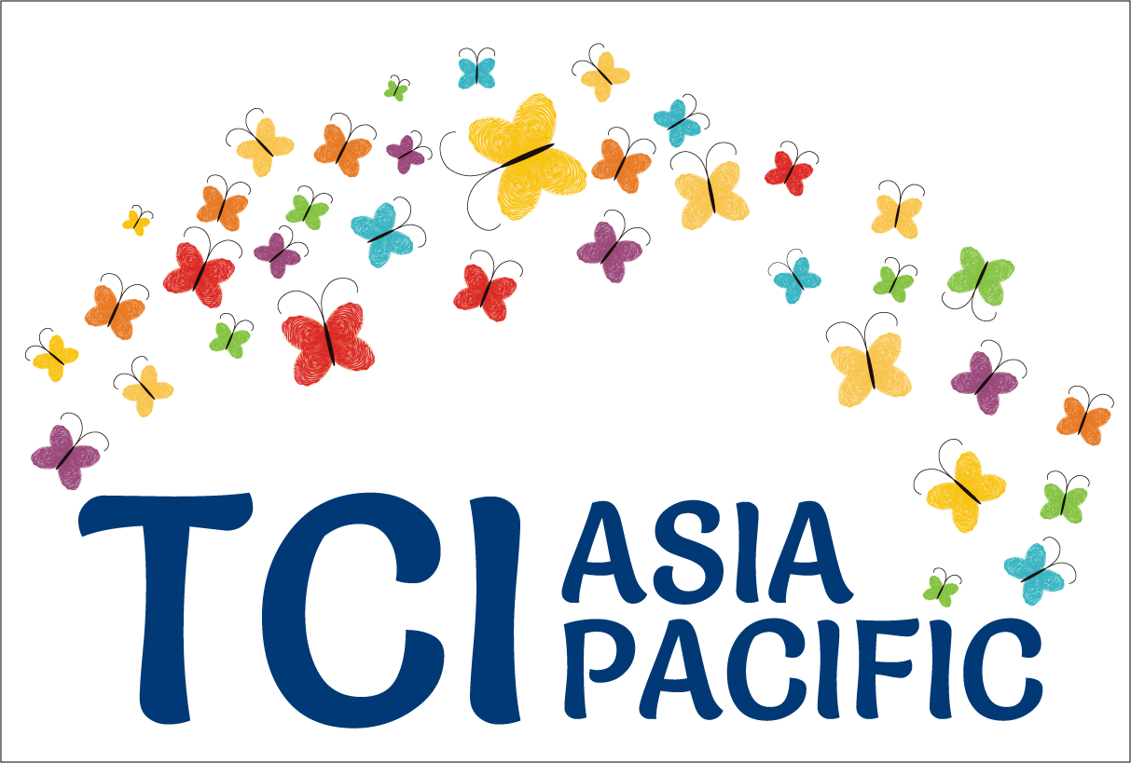

**Turning the tables:**

**The imperative to reframe the debate towards full and effective participation and inclusion of persons with psycho-social disabilities**

**Excerpt from “Galway-Trieste” conversations[1] - Part 3**

Actors and actor networks with influence as discussed in Part 2, have pulled the debate on Inclusion more towards "progressive mental health" rather than towards "Full CRPD compliance". There is a divide in the advocacy from Global North and the ones coming from the Global South as contexts have been historically and politically different. "Zero coercion" or "abolition of forced psychiatry", which are two variants of campaigns worldwide to end psychiatric oppression has meant differently to different actors (for example, the WHO) or nothing at all to some (for example, the UNDP).

Do we know those actors? Can we influence them? Are there common agendas for the movements of persons with psychosocial disabilities and neurodiversities, those with "mad" identities, those who are users and survivors of psychiatry, worldwide, to come together and speak with a unified voice?

This is the third piece on "Turning the Tables" and on reframing the debate.

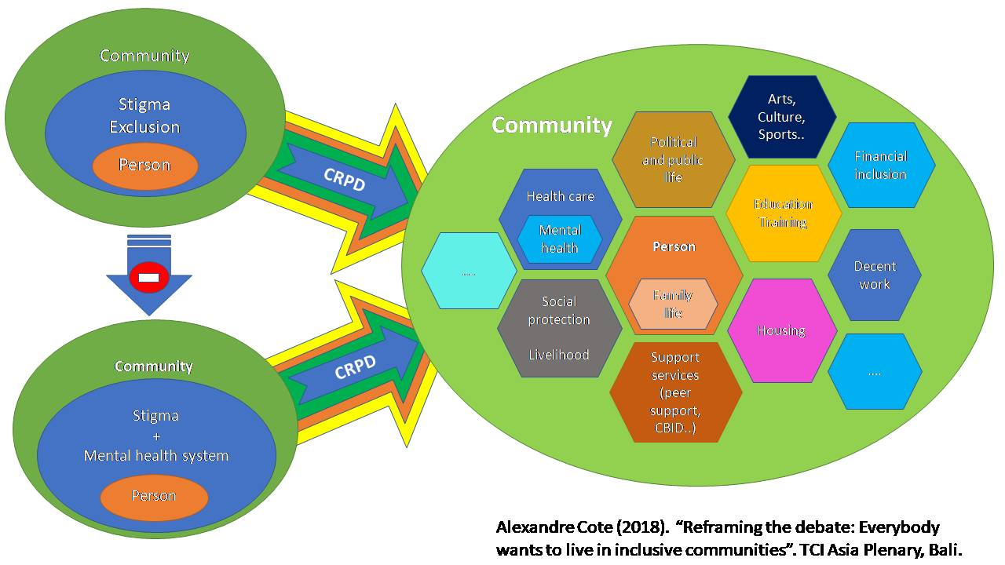

The diversity of situation between countries with or without developed mental health systems often related to their lower or higher country income status contribute to complicate advocacy. Along the lines of the debate on inclusive education, the emerging consensus is that whatever the starting point, the destination is the same – the development of contextually relevant, CRPD compliant support systems for full participation and inclusion.

Importantly, the shift of paradigm demands a holistic approach away from the biomedical model, but does not imply that health and mental health care are unimportant. They are essential but no more than, and not as precondition to, access to social protection, education, housing, employment, safety and adequate standard of living.

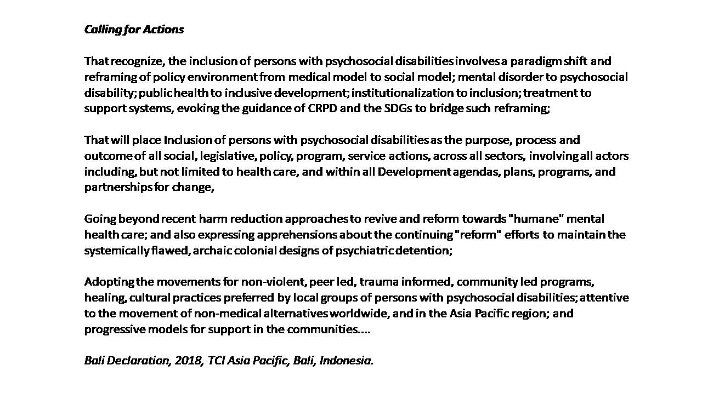

**Mapping key international organizations and global stakeholders**

In the Trieste workshop, the groups mapped different international organizations based on their perceived level of influence and perceived support to the shift of paradigm. Some are high on influence but may resist (WPA) or not promote or be aware of shift of paradigm needed for inclusion of persons with psychosocial disabilities. Some are low on influence but are strong on the shift of paradigm (INTAR).

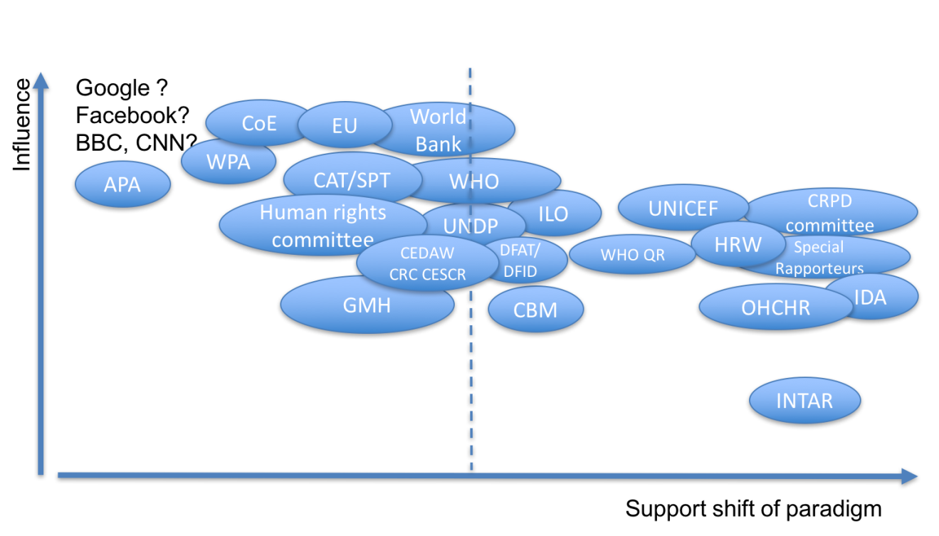

# **Some of the key factors to promote the shift of paradigm**

The avenues to promote shift of paradigm were discussed and several considered which mutually reinforce each other:

- Strengthening and disseminating evidence

- Strengthening and consolidating a progressive normative framework

- Shifting public opinion

- Reaching out to a broader range of stakeholders

***1. Strengthening and disseminating evidence on CRPD compliant social innovations and community-based interventions***

Around the world there is a growing number of good practices in CRPD compliant service delivery as demonstrated in the 2016 INTAR conference in Pune. But there is a lack of systematization in national policy, leading to poor scaling up/out.

Many effective approaches and services are not known yet outside of the core groups dealing with those issues. There is a lack of documentation and dissemination of those practices in authoritative academic and influential mainstream media.

An important element is to reframe the work done as a viable option on their own rather than as a complementary alternative to a main mental health system.

Some key elements identified were the need for:

* Documenting and systematizing good practices, including in the Global South
* Documenting and systematizing what does not work – challenging the evidence of traditional models and interventions
* Developing and disseminating relevant and strategic research questions that could inspire and frame academia’s work
* Complementing by testimony of people (evidence is not always enough)
* Building widely accessible repository of practices and literature reviews

In terms of transforming research and evidence for advocacy, several elements were also identified:

* Close alliances between academia, NGOs and DPOs
* Strategic definition of messages based on available evidence
* More collaboration and sharing, but taking into account the politics of knowledge creation and sharing

There was an emphasis on importance of building coalition and alliances with universities. There was also caution in ensuring that academicians do not set the agenda and frame the knowledge on their own acknowledging that there is today a big gap between academia and DPOs.

Above and beyond, all those **evidence needs to contribute to a new “source book” with policy options.** This implies an in-depth work of sorting and organizing existing practices.

***2. Strengthening and consolidating a progressive normative framework***

There are discrepancies in the development of the normative framework with resistance to CRPD shift of paradigm in some institutions: Subcommittee for Prevention of Torture, CAT and Human Rights Committee brings significant challenges as they do not even recognize the problem of discrepancies.

While the CRPD Committee has achieved a lot it does not have the same weight and direct normative power compared to the Human Rights Commission (HRC) for instance. In addition, change in the CRPD committee can weaken its stance. It is important to remain vigilant to committee related elections and work to ensure that it upholds and deepens its jurisprudence.

At the regional level, the negotiation of the Oviedo protocol within the Council of Europe raises significant concerns and illustrates the post CRPD conservative backlash.

There are still challenges on the best way forward. There is a need to try to engage in constructive dialogue with open Committee members especially Subcommittee for Prevention of Torture, CAT and Human Rights Committee and other law makers to engage and to present the issues and the evidence. In parallel, it is important to continue to raise issues related to persons with psychosocial disabilities through increased participation in review processes.

***3. Shifting public opinion***

Once again there is a contrasted picture. On the one hand, there is growing public awareness and discussion about mental health, which is breaking down stigma - including public figures who are sharing their experiences. Personal stories of persons with psychosocial disabilities can have an impact on raising awareness and changing attitudes.

On the other hand, there is still a powerful and negative association with mental health and violence, mass shootings which politicians tend to spin for short term electoral gains. The mental health framing of the gun control debates in the US or the aftermath of catastrophe like the 2015 suicide/crash of the German wings pilot in France are symptomatic of such trends.

In western, risk averse societies, a subtle and uncomfortable parallel in public opinion seems to have emerged, in the recent years, between risks related to persons with psychosocial disabilities and terrorism: the same use of the fear factor by politicians and media, the same anxiety of unpredictability and of the enemy within as well as the same acceptance of violation of human rights of some for the protection of most.

In parallel, in Global South notably in some African countries, cultural belief, such as those linking mental health issues to witchcraft, can also lead to very harmful practices.

There is also however little awareness of public opinion of the cost and poor outcomes of typical mental health policies or rather there is often a “voluntary ignorance” of the situation of people with psychosocial disabilities.

Shifting public opinion will require communication and media tactics that the movement has not yet been able to afford. The experience of "Mad in America" in debunking false evidence and making accessible existing knowledge for change is a good source of inspiration. However, it does not reach a broader audience.

There was exchange on the fact that the movement needs to move in a pro-active mode rather than a reactive mode, with a need to gather evidence and data, create material for public opinion and media, influencing middle class public opinion and combine direct lobbying along with awareness of families, religious leaders, and training of judges.

***4. Reaching out to stakeholders***

From all the exchanges, it appeared very strongly that in most regions, there is a need for a broader canvas than "mental health recovery". "Inclusion" seems to be that canvas, for example, by tackling work, livelihood, social protection and housing. This implies engaging with the cross-disability movement, the women's rights movement, the human rights movement, etc. which would be more empowering than focusing all energy only on dialogue/battle with mental health professionals. In Indonesia, for example, to address judicial concerns within the constitutional court, help was successfully sought from diverse groups.

**Declaring that,**

The following report is an embargo of many months on this work which TCI Asia Pacific takes the responsibility to disseminate it widely. TCI Asia Pacific has supported the meetings financially and led the initiative in many other ways. We thank the many organizations that attended the meetings, IDA, and the co-facilitators, Alex Cote and Alberto Vasquez.

1. Different organizations and individuals were involved in these sustained dialogues supported by the International Disability Alliance and Open Society Foundation and inclusive of TCI Asia Pacific, ENUSP, PANUSP, USP Kenya, INTAR, MHE, WNUSP, a Latin American emerging network at the time of these conversations and others. Facilitation by Alexandre Cote and Alberto Vasquez.