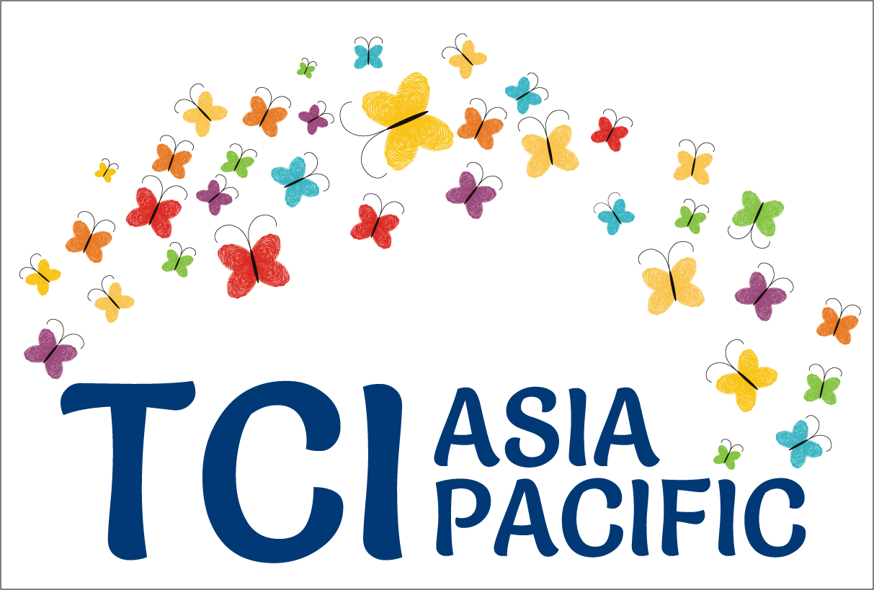

**Turning the tables:**

**The imperative to reframe the debate towards full and effective participation and inclusion of persons with psycho-social disabilities**

**Excerpt from “Galway-Trieste” conversations[1] - Part 1**

The UN Convention on the Rights of Persons with Disabilities (CRPD), adopted in 2006, represented a paradigm shift in relation to the rights of persons with psychosocial disabilities. The focus was no longer the right to health but achieving full and equal enjoyment of all human rights and fundamental freedoms by all persons with disabilities. In parallel to celebrating *the 10 years of the adoption of the Convention on the Rights of Persons with Disabilities* (CRPD), a global community of individuals and organizations of persons with psycho-social disabilities and neurodiversity, users and survivors of psychiatry, persons with "mad" identities" and cross disability allies took stock of the progress and challenges globally with regards to the *full and effective participation and inclusion of persons with psycho-social disabilities.*

Are our human rights being met? This article is a brief recap of those deliberations, run in 3 parts [2].

**Setting the context**

From the "Galway - Trieste" conversations, an overall picture emerged urging the movement of persons with psychosocial disabilities and their allies to review and consolidate their strategies at a global level and define a way forward. The starting point of these conversations was the acknowledgement that the global momentum on "mental health" generates great opportunities but also significant threats depending on the extent to which global, regional and national policy responses will be framed by the CRPD. There has been a sense of race against time as governments and various stakeholders are taking actions to tackle “the mental health crisis”.

* Indeed, the last years has witnessed contradictory trends: for example, the jurisprudence of the CRPD committee and groundbreaking reports of the Special Rapporteurs on the right to health on one hand and on the other hand, the pursuit of negotiation of the Oviedo protocol in Europe and proliferation of mental health laws in the Global South - all intrinsically at odds with the CRPD.
* Greater awareness about the CRPD but also simultaneous challenges by mental health professionals, academics, technical support agencies and the "user" movements supported by them that CRPD jurisprudence threatens to undermine critical rights for persons with psychosocial disabilities.
* Greater public awareness of mental health issues but also political spin of public opinion around the link between mental "illness" and public safety in the Global North.
* Few countries developed legal innovation to reach compliance with CRPD while many others adopted mental health legislation that do not.
* Growing evidence of community-based support systems and systems for supported decision making in resource poor settings as well as in other global contexts.

*The differences between low, middle and high-income countries have also been a source of debate and dialogue.* In many high income countries and countries in transitions, the focus has been on reducing the harm done by the widespread mental health system that is curtailing human rights. In lower income countries, the focus is on development of any possible community owned system to support persons with psychosocial disabilities. While emerging groups of persons with psychosocial disabilities focus on community inclusion, the trend among policy makers often leans toward development of mental health care systems, inspired by higher income countries. *The lack of a genuine shift of the paradigm is an issue everywhere.*

For instance, in Asia, with the convergence of the Global Mental Health agenda, States take action sourcing their policies from the typical mental health sourcebook and opinions of international experts which are most focused on psychiatry rather than on social inclusion. This leads to adoption of mental health legislations which are coercive[3]. A majority of mental health professionals, even some of the most progressive (and by extension the public authorities they advise), will not part with the legal possibility of coercion, involuntary treatment, deprivation or restriction of legal capacity as a last resort. Indeed, the debate around mental health is rarely about how to guarantee the full recognition and exercise and enjoyment of all human rights. It is rather about deeming some human rights’ restrictions as inevitable[4]. The Special Rapporteur on Health report calls *to confront the “global burden of obstacles” that has maintained the status quo in mental health*.

In addition, the *imbalance of powers between self-advocates and medical professionals/decision makers lead to negotiations whose outcomes will never be CRPD compliant***.** As long as psychiatry is given a “gate keeping” role with regards to rights of persons with psychosocial disabilities, true change won’t happen. As long as "mental health care" is at the centre of the discourse, the burden of proof is on persons with psychosocial disabilities to have to demonstrate that they are “capable” to exercise their rights.

Reflecting on the CRPD shift of paradigm, this led to efforts spearheaded by Transforming Community for Inclusion-Asia Pacific (TCI-Asia Pacific) to push to fundamentally realise the [Bali Declaration](http://www.whatweneed.in/?page_id=307).

*reframe the debate, by exploring the changes required across sectors, including a prohibition of coercion, to ensure support, full participation and inclusion of persons with psychosocial disabilities;* rather than focusing mostly on human rights violations linked with the mental healthcare systems. *Truly implementing the shift in paradigm means that support to inclusion and participation of the person in its diversity becomes the center of policy debates; rather than mental health and related care systems.*

Bali Declaration

# **Framing of "mental health" within the UN systems****[5]**

UN mechanisms such as UN Committee on the Rights of Persons with Disabilities and the Office of the High Commissioner on Human Rights have pointed out the need to ensure that mental health systems embrace a human rights-based approach, rooted in the CRPD calling to abolish all forms of coercion in mental health and the adequate provision of support to individuals. This is a departure from earlier approaches which focused more on mental health law and expanding and improving mental health services deemed the best ways to respond to the needs of persons with psychosocial disabilities. The influential 2005 WHO Resource Book on Mental Health, Human Rights and Legislation. However, evidence shows that mental health laws achieved the opposite, legitimizing coercion in mental health care. Having advocated for years on the importance of Mental Health laws, even the WHO has withdrawn these resources in recent times[6].

Full CRPD compliance means prohibition of coercion in mental health services, prohibiting any deprivation of liberty on the basis of disability, creating choice and upholding a universal application of free and informed consent. The CRPD Committee has repeatedly stated that States parties should repeal provisions which allow for involuntary commitment and treatment of persons with disabilities in mental health institutions based on actual or perceived impairments[7]. The Office of the High Commissioner for Human Rights (OHCHR) has echoed the views of the CRPD Committee, calling for a human rights-based approach to mental health[8]. The report stresses that persons with psychosocial disabilities – as well as other groups deemed as having a “mental health condition” are still disproportionately exposed to human rights violations in the context of mental health services. The Special Rapporteur (Health) has issued a *groundbreaking report calling for a paradigm shift on mental health services “based on the recurrence of human rights violations in these settings”.[9]*The reductionist medical paradigm is seen as one of the causes of the exclusion, neglect, coercion and abuse of people with intellectual, cognitive and psychosocial disabilities, persons with autism and *“those who deviate from prevailing cultural, social and political norms”[10].* Complementarily, the UN Special Rapporteur (Disabilities) while urging States to *“do away with non-consensual psychiatric treatment”*[11], has focused her work on promoting access to support to enable persons with disabilities to fully participate in their communities[12]. Devandas has stressed *that persons with psychosocial disabilities can benefit significantly from community support services, inter alia, by supporting people experiencing severe emotional distress and preventing coercion in mental health services.*The Special Rapporteur has also released reports on legal capacity[13] and another on deprivation of liberty[14]. Other special procedures and agencies are progressively adapting their standards to the CRPD, for example the "Working group on Arbitrary Detention"[15]. Also, see, efforts by the WHO on Quality Rights Initiative on humanizing mental health care based on human rights principles[16].

Building on the Special Rapporteurs’ Mr. Puras' report, the 2017 landmark Human Rights Council resolution on Mental Health and Human Rights acknowledges that the *Convention on the Rights of Persons with Disabilities laid the foundation for a paradigm shift in mental health*. It created the momentum for de-institutionalization and the identification of a model of care based on respect for human rights which addresses the global burden of obstacles in mental health, provides effective mental health and community-based services and respects the enjoyment of legal capacity on equal basis with others. In addition, the resolution calls upon all UN members states to abandon all practices that fail to respect the rights, will and preferences of all persons, on an equal basis, and that lead to power imbalances, stigma and discrimination in mental health settings. The resolution also urges *States to develop community-based, people-centered services and supports that do not lead to over-medicalization and inappropriate treatments, that fail to respect autonomy*, will and preferences of all persons. Yet, the Resolution *fails to include clear mention on the prohibition of forced treatment and confinement, due to almost unanimous resistance from Member States.*

While all these developments are extremely positive, *some treaty bodies and special procedures are still showing resistance to the new legal framework.* This is the case of the Human Rights Committee (CCPR), the Subcommittee on Prevention of Torture (SPT), and the former Special Rapporteur on Torture and Other Cruel, Inhuman or Degrading Treatment or Punishment, Juan Méndez. According to them, the existence of a disability cannot “in itself” justify a deprivation of liberty, but involuntary commitment and treatment would be lawful if it is necessary and proportionate, for the purpose of protecting the individual from serious harm or preventing injury to others[17]. Moreover, the need to transform psychiatry and mental health services has not been addressed at all.

**Declaring that,**

The following report is an embargo of many months on this work which TCI Asia Pacific takes the responsibility to disseminate it widely. TCI Asia Pacific has supported the meetings financially and led the initiative in many other ways. We thank the many organizations that attended the meetings, IDA, and the co-facilitators, Alex Cote and Alberto Vasquez.

**Continued in another blog piece, coming soon ….**

1. Different organizations and individuals were involved in these sustained dialogues supported by the International Disability Alliance and Open Society Foundation and inclusive of TCI Asia Pacific, ENUSP, PANUSP, USP Kenya, INTAR, MHE, WNUSP, a Latin American emerging network at the time of these conversations and others. Facilitation by Alexandre Cote and Alberto Vasquez.
2. Over a period of 18 months, through continuous discussion and several key moments (*INTAR global conference, November 2016, Pune; NUI summer school, June 2017- Galway; International Conference “The right to have (whole) life”, November 2017, Trieste; an evening meeting in Geneva, 2017; among others*)
3. The situation in Japan, China and Korea with heavy institutionalization and violation of human rights gives an indication of the danger of health care focused policies in contexts with growing fiscal capacities, but prone to favor social control.
4. The *almost unanimous resistance from Member States to include clear mention on the prohibition of forced treatment and confinement* in an otherwise very progressive 2017 resolution of the Human Rights Council on Mental Health and Human Rights is a good indicator of this state of play.
5. based on background paper for the dialogue in Galway NUI Summer school meeting, developed by Alberto Vasquez
6. *See* http://www.who.int/mental_health/policy/legislation/en/
7. Guidelines on Article 14 of the Convention on the Rights of Persons with Disabilities - The right to liberty and security of persons with disabilities (Adopted at the CRPD 14th Session (17 August-4 September 2015)
8. A/HRC/34/32.
9. A/HRC/35/21.
10. A/HRC/35/21, para. 8.
11. http://www.ohchr.org/EN/NewsEvents/Pages/DisplayNews.aspx?NewsID=16583
12. A/HRC/34/58.
13. A/HRC/37/56
14. A/HRC/40/54
15. A/HRC/30/37.
16. http://www.who.int/mental_health/policy/quality_rights/guidance_training_tools/en/
17. CCPR/C/GC/35, para. 19.