

2022

PACIFIC UPDATE

pixabay/pexels.com

TUESDAY 28 TO THURSDAY 30 JUNE
THE UNIVERSITY OF THE SOUTH PACIFIC LAUCALA CAMPUS, SUVA, FIJI

#PacificUpdate

SUPPORTED BY

2022 PACIFIC UPDATE – ORGANISING COMMITTEE
Photo: Ignacio Moya Coronado / Shutterstock.com

DEVELOPMENT POLICY CENTRE, ANU
Ryan Edwards, Deputy Director Beth Orton, Manager
Charlotte Bedford, Research Fellow Evie Sharman, Research Officer
The Development Policy Centre’s research on Pacific economic development and migration is part of the Pacific Research Program, a consortium led by the ANU Department of Pacific
Affairs, with the Development Policy Centre and the Lowy Institute. The Program is co-funded by the Australian Department of Foreign Affairs and Trade and the consortium partners’ parent bodies.

SCHOOL OF ACCOUNTING, FINANCE AND ECONOMICS, USP
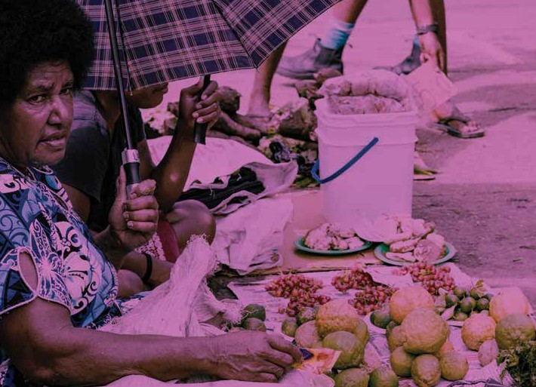Neelesh Gounder, Senior Lecturer Josephine Singh, Secretary

Supporting
Pacific solutions to Pacific challenges.
Building on decades of on-the-ground experience in the region, we are working together with leaders and changemakers across the Pacific Islands to amplify voice and accountability in decision making; advance women’s leadership on climate action and disaster management; enhance digital economic opportunities and cybersecurity; and counter trafficking in persons.

2022 PACIFIC UPDATE – PROGRAM

TUESDAY 28 JUNE

8.30am Registration
9.00am Welcome and opening plenary
Chair: Dr Neelesh Gounder, The University of the South Pacific
Welcome remarks
Professor Pal Ahluwalia, Vice-Chancellor, The University of the South Pacific (online)
Opening remarks
His Excellency Lionel Rouwen Aingimea, President of Nauru (online)
Where is the Pacific as we near the halfway point of the 2030 Agenda for Sustainable Development?
Alison Culpin, Social Statistics Advisor (SDGs), Pacific Community
10.15am Morning tea
10.45 am Keynote address
Hon Pat Conroy MP, Minister for International Development and the Pacific, Australian Government (online)
11.30am Panel 1: Gender equality
Chair: Nalini Singh, Fiji Women’s Rights Movement
Reporting on violence against women and girls: A critical discourse analysis of Pacific-based newspaper reporting
Kate Power, The University of Queensland
Tracking period poverty in Samoa –the case study of manufacture and distribution of reusable menstrual pads in Samoa
Doris Tulifau, Vineta Pisia, Ramona Boodoosingh, and Annika Lemisio, Brown Girl Woke (online)
Balance of Power: Shifting gender norms through localised political economy analysis
Mereani Rokotuibau, Jennifer Kalpokas Doan (online), Wilson Toa, Epeli Tinivata, and Peni Tawake, Balance of Power
1.00pm Lunch
2.00pm Panel 2: Aid effectiveness
Chair: Sarah Boxall, Pacific Private Sector Development Initiative
The impact of the COVID-19 pandemic on aid effectiveness: The case of Vanuatu
Morgane Rosier, University of Ottawa

2022 PACIFIC UPDATE – PROGRAM 2022 PACIFIC UPDATE – PROGRAM

Collaborative research to benefit industry and academia: Reflections on building a project
Aidan Craney, La Trobe University and Mema Motusaga (online), Samoan
Ministry for Women, Children and Social Development
Conducting impact assessments of foreign aid projects in the community: A perspective from Vava’u, Tonga
Edgar Haak and Naohiro Nakamura, The University of the South Pacific
3.30pm Afternoon tea
4.00pm Panel 3: Fiji economy
Chair: Ryan Edwards, Australian National University
Fiji’s debt crisis in the post COVID-19 recovery era
Sunil Kumar, Pacific Polytech, and Gyaneshwar Rao, The University of Fiji
Tourism and economic growth linkages: Economic responses and recovery in Fiji
Rukmani Gounder, Massey University
All in the same canoe: Impacts of cyclones on farmers’ and fishers’ livelihoods and income and strength of resilience in Vanua Levu, Fiji
Lau Viliamu Iese, The University of the South Pacific, Krishnan Narasimhan, Jennifer Cisse, Jennifer Philip, Elisabeth Holland, Giulio Masasso Paunga, Filipe Veisa, Jioje Fesaitu, Otto Navunicagi, Timoci Koliyavu, Rahul Prasad, Salote Nasalo, Anamaria Tagicakiverata, Ratu Tevita Rokolutu, Jyoti Mala, Adi Davila Talemaimaleya, Maluseu Tapaeko, Mesake Volau, Epeli Waqa, Sereana Rabalotu, Sioata Lota, Nasoni Roko, Christopher Ward, Isireli Qionimua
5.30pm Close
5.45pm Cocktail and kava reception, and visual arts exhibition
Oceania Centre for the Arts. Hosted by The Asia Foundation

WEDNESDAY 29 JUNE
8.30am Registration
9.00am Keynote address
Chair: Associate Professor Sandra Tarte, Acting Head of School for Law and Social Sciences, The University of the South Pacific
Rethinking poverty and household finance
Professor Jonathan J Morduch, Wagner Graduate School of Public Service at New York University, Executive Director of the Financial Access Initiative (online)
The Pacific post-pandemic: An economic update
Professor Stephen Howes and Huiyuan Liu, Australian National University
10.30am Morning tea
11.00am Panel 4: Economic recovery
Chair: Rup Singh, The University of South Pacific
Financing for social protection: Strategic pathways to sustainable investment in the Pacific Island countries and Timor-Leste
Charles Knox-Vydmanov, independent consultant, Nikunj Soni, independent consultant, Sinta Satriana, Pacific Partnerships for Social Protection Program, and Stephen Kidd, Development Pathways
An investigation into differentiated disaster risk and discussion of potential implications for insurance solutions: A case study in Fiji
Alexandra Dudley, United Nations University, and Reginald Singh, United Nations Capital Development Fund
Pacific Islands debt: financing post-COVID-19 recovery amid precarious sustainability
Roland Rajah and Alexandre Dayant, Lowy Institute
12.30pm Lunch
1.30pm Panel 5: PNG economy
Chair: Alexandre Dayant, Lowy Institute
Financial inclusion in Papua New Guinea: Neither a borrower nor a lender be Laura Nettuno, Vanderbilt University, and Martin Davies, Washington and Lee University
The determinants of excess reserves in the banking system of Papua New Guinea
Thomas Wangi, Australian National University
Chinese companies’ engagement in PNG
Huiyuan Liu and Sandra Kraushaar, The Asia Foundation, and Nikiunj Soni, independent consultant
3.00pm Afternoon tea
3.30pm Panel 6: Social protection
Chair: Kirstie Petrou, The World Bank
Tonga case study on skills development for the tourism and hospitality sector Semisi Taumoepeau, New Zealand Tourism Research Institute, and Anna Addison, Auckland Institute of Studies
Exploring the impacts of climate change: experiences of the vulnerable populations in Solomon Islands
Hensllyn Pwe’a-Boseto, Ecological Solutions Foundation
Natural disasters, community, and giving
Emilia Tjernström, Monash University, and Pike Stahlmann-Brown, Manaaki Whenua –Landcare Research
5.00pm Close
6.00pm Conference dinner (by invitation only)
Japan-Pacific ICT Centre Marquee. Hosted by Konrad Adenauer Stiftung

2022 PACIFIC UPDATE – PROGRAM 2022 PACIFIC UPDATE – PROGRAM

THURSDAY 30 JUNE – PACIFIC MIGRATION RESEARCH WORKSHOP
8.30am Registration
9.00am Opening plenary
Chair: Professor Stephen Howes, Australian National University
Future directions of the Pacific Australia Labour Mobility (PALM) scheme Carli Shillito, Assistance Secretary, Pacific Labour Policy and Engagement Branch, Department of Foreign Affairs and Trade, Australian Government
Mobile bodies in warming waters: climate futures for labour mobility in the Pacific
Associate Professor Yvonne Te Ruki-Rangi-O-Tangaroa Underhill-Sem, The University of Auckland
The future of labour mobility schemes in Vanuatu
Murielle Metsan Meltenoven, Ministry of Internal Affairs of Vanuatu, Gareth Priday, Action Foresight, and Anne-Sofie Gerhard and Marine Destrez, United Nations Development Programme Pacific
10.30am Morning tea
  - am Panel 7: Labour mobility in a changing region
Chair: Yvonne Te Ruki-Rangi-O-Tangaroa Underhill-Sem, The University of Auckland
Seasonal worker schemes in the Pacific through the lens of international human rights and labour standards
Angelica Neville, Sanushka Mudaliar and Carmen Voigt-Graf, International Labour Organization
Lessons from integrating labour mobility and climate change into a regional framework
Carmen Voigt-Graf, Sabira Coelho, and Angelica Neville, International Organization for Migration
The role of youth migration in transforming food systems in the Pacific: Current knowledge and critical gaps
Marisa Mitchell (1), Patrick Smallhorn-West (1, 2, 3), Jacqueline Lau (1, 2),
Philippa Cohen (1, 2), Andrew Song (4), Tiffany Morrison (1)
    - James Cook University, 2. WorldFish, 3. Wildlife Conservation Society, 4. University of Technology Sydney
1.30pm Panel 8: Maximising development impacts
Chair: Rochelle Bailey, Australian National University
The place premium: Evidence from three Pacific labour mobility schemes
Ryan Edwards and Nguyen Truong Toan, Australian National University
The role of remittance sending in connection to culture for the diaspora community
Vaoiva Ponton and Nicola Fa’avale, MANA Pasifika
Constraints and opportunities of decentralisation in labour mobility: Reflections on Papua New Guinea
Natasha Turia-Moka, Australian National University

3.00pm Afternoon tea
3.30pm Panel 9: Understanding social impacts
Chair: Mereseini Cawaru, Pacific Labour Facility
What happens to the learning outcomes of children left behind when parents work overseas? Evidence from Tonga
Vu Thu Trang and Daniel Suryadarma, Asian Development Bank Institute
Lost in space (and time): Transnational family life in the PALM Scheme
Matt Withers, Australian National University
The gendered and social impacts of labour mobility in Pacific Island countries
Kirstie Petrou, Ursula Casabonne, Matthew Dornan, and Dung Doan, The World Bank
5.00pm Conference close

12.30pm Lunch Note:
Bold text indicates the presenter/s where there is more than one author.
If no names are in bold text all authors intend to present.

Did you enjoy the conference?

We’d love to hear your feedback.

Please fill in our quick survey at https://www.surveymonkey.com/r/PacificUpdate

