Join with us to take actions together for a resilient Pacific!
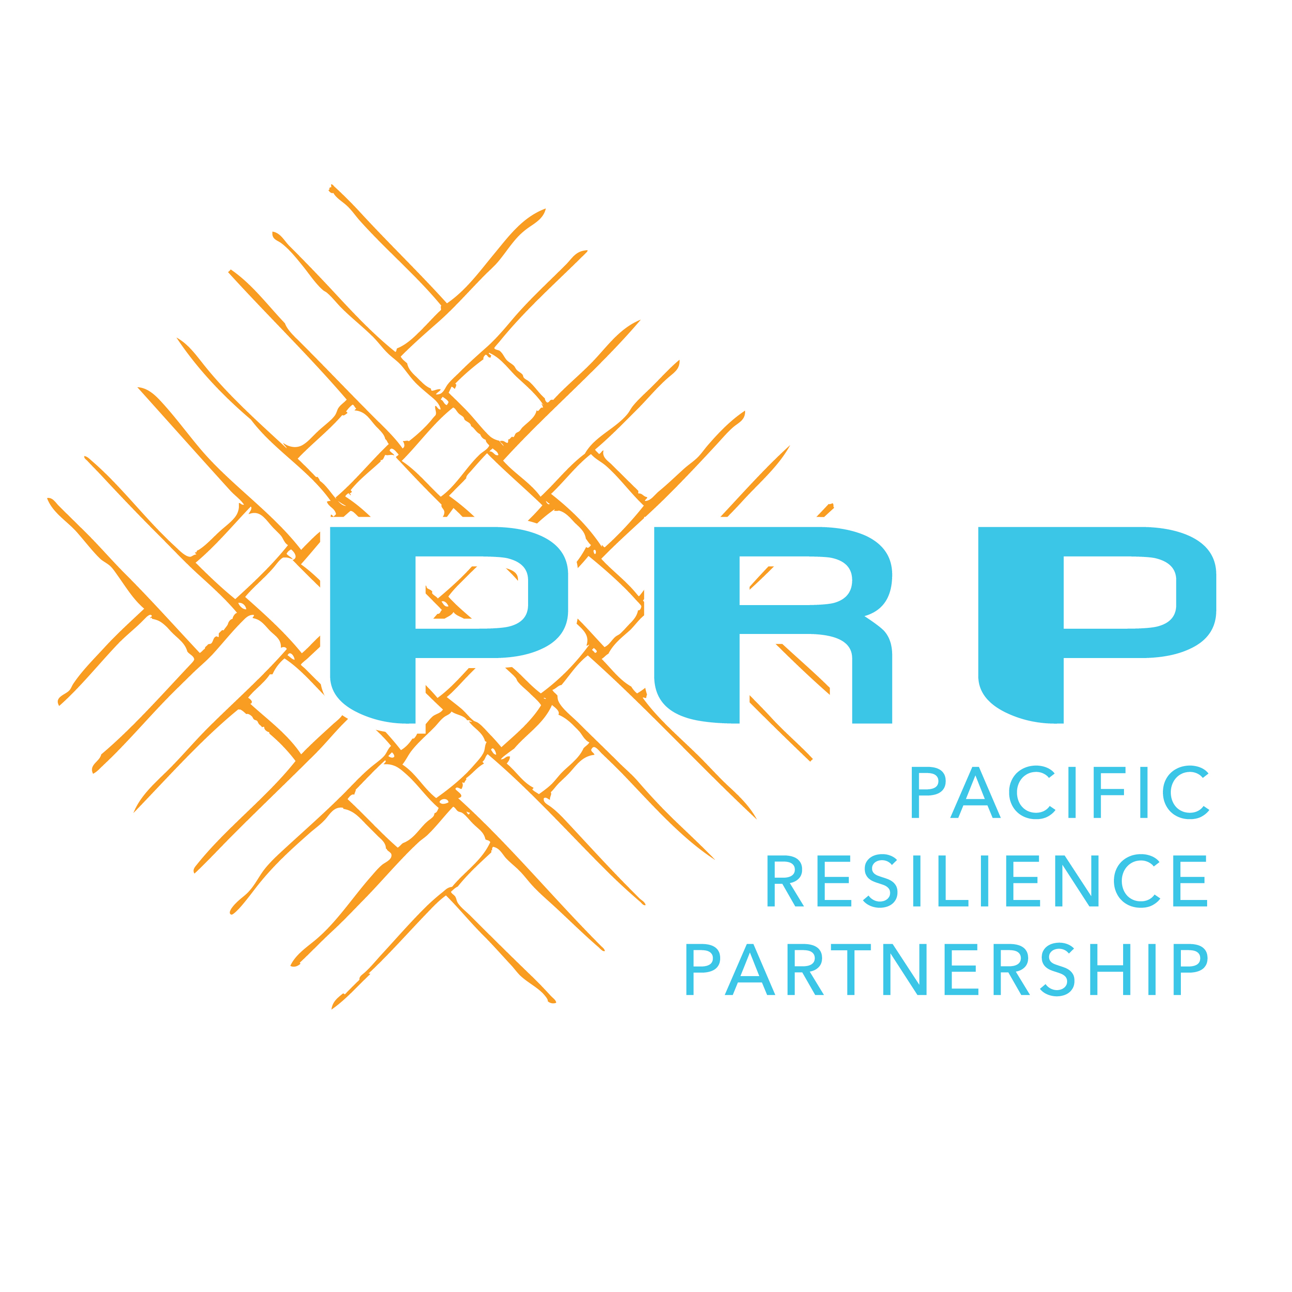
Stronger together
(www.resilientpacific.org)
Affiliation to the Pacific Resilience Partnership (PRP)
By affiliating with the Pacific Resilience Partnership (PRP), you are committing to the goals and principles of the Framework for Resilient Development in the Pacific (FRDP) for the efficient and effective delivery of resilient development activities in the region. You will also become part of a broad and inclusive partnership representing governments, civil society, private sector, academia, multilateral development banks, UN agencies and other development partners, that you can draw on for information sharing, networking and possible technical expertise.
Affiliation is open to all and this form should be completed by any entity interested in becoming part of the Partnership. An entity can for example be a government agency, private sector organisation, civil society organisation, regional and international organisation, academic institution, an existing network or partnership addressing some aspect of climate and disaster resilience building, climate and disaster programme or project.
I confirm that by affiliating, we support and promote the goals and principles of the FRDP: ☐ YES (required)

Part A - Applicant Details
Section 2 (required)
Name of entity to be registered
Category of entity (select only one) | ☐ Government, ministry, department, sub-national government  ☐ International organization, regional organization, development agency  ☐ Civil society, non-government organization  ☐ Private business, private sector organization  ☐ Academia  ☐ Initiative, programme, project (require additional information – go to section 3)  ☐ Partnership, network  ☐ Other (please specify):
Contact details (all information required): | Name:
Contact details (all information required): | Title: (e.g. Climate Change Advisor)
Contact details (all information required): | Email:
Contact details (all information required): | Phone

Section 3 Additional Information for Programmes/Projects only (all information required)
Phase the Programme or Project is up to (choose one) | ☐ In the Pipeline  ☐ In-progress  ☐ Less than 12 months remaining
Objectives (short answer text)
Outputs (short answer text)
Funding Source (short answer text)
Funding Timelines (short answer text)
Are there built in plans to extend and/or expand? Please explain (short answer text)

Part B: Contribution to the FRDP Goals and Principles
Section 4 (required)
Which FRDP Goals is your entity contributing to (select any)? |  | ☐ Goal 1: Strengthened integrated adaptation and risk reduction to enhance resilience to climate change and disasters
 |  | ☐ Goal 2: Low carbon development
 |  | ☐ Goal 3: Strengthened disaster preparedness, response and recovery
 |  | ☐ All Goals
How well are you aligned with the principles of the FRDP?
 | Yes | No | Unsure | Not applicable
Integrate and mainstream climate change and disaster risk management | ☐ | ☐ | ☐ | ☐
Strengthen and develop partnerships | ☐ | ☐ | ☐ | ☐
Protect human rights | ☐ | ☐ | ☐ | ☐
Prioritize the needs and respect the rights of the most vulnerable | ☐ | ☐ | ☐ | ☐
Integrate, advocate and support equitable participation of men and women | ☐ | ☐ | ☐ | ☐
Aim to alleviate poverty and hardship | ☐ | ☐ | ☐ | ☐
Incorporate ecosystem-based services and functions | ☐ | ☐ | ☐ | ☐
Advocate open and ready access to reliable sources of traditional and contemporary information | ☐ | ☐ | ☐ | ☐
Build on and help reinforce cultural and traditional resilience and knowledge | ☐ | ☐ | ☐ | ☐
Acknowledge and factor in a traditional holistic worldview | ☐ | ☐ | ☐ | ☐

Part C: The value-add your entity brings to the PRP
Section 5 (required): Describe how you could potentially add value to the Pacific Resilience Partnership to enhance its effectiveness to enable and support resilient development.
What would you bring to the partnership to enhance its effectiveness to enable and support resilient development?
________________________________________________________________________________________________________________________________________________________________________________________________________________________________________________________________________________________________________________________________________________________________________________________________________________________________________________________________________________________________________________________________________________________________________________________________________________________________________________

Part D: Options for Support that the PRP Taskforce can offer to Promote, Enhance or Drive your work
Section 6: Depending on the choice you select, it will take you to the section that outlines criteria that you can assess your agency against to justify the support you are seeking from the PRP Taskforce.
To give an idea of the potential options that the PRP Taskforce could offer as support to your entity (choose one) | ☐ Would you like the Taskforce to PROMOTE, CELEBRATE and PROMULGATE your work? (go to Section 7)
 | ☐ Would you like the Taskforce to ENHANCE, EXPAND and UPSCALE your work? (go to Section 8)
 | ☐ Would you like the Taskforce to DRIVE, DIRECT and ESTABLISH your work? (go to Section 9)

Section 7: Criteria to assess your entity for support from the Taskforce to promote, celebrate and promulgate your work
Criteria (minimum criteria required – must tick all to be eligible to this type of support)  Once you have completed this section, go to Section 10 to select type of support you are seeking | ☐ Well-aligned with the principles and goals of the FRDP
 | ☐ Well-governed and funded
 | ☐ Making a difference

Section 8: Criteria to assess your entity for support from the Taskforce to enhance, expand and upscale your work
Criteria (minimum criteria required – must tick all to be eligible to this type of support)  Once you have completed this section, go to Section 11 to select type of support you are seeking | ☐ Aligned with the goals of the FRDP
 | ☐ Seeking strategic support and advice to better align with the principles of the FRDP
 | ☐ Have potential to have a greater impact, including through improved governance or increased funding

Section 9: Criteria to assess your entity for support from the Taskforce to drive, direct and establish your work
Criteria (minimum criteria required – must tick all to be eligible to this type of support)  Once you have completed this section, go to Section 12 to select type of support you are seeking | ☐ Clearly going to contribute to the goals of the FRDP
 | ☐ Inclusive and based on an all-stakeholder approach
 | ☐ Seeking PRP taskforce assistance to ensure the initiative progresses

Section 10: How the Taskforce can PROMOTE, CELEBRATE and PROMULGATE your agency
Examples (please indicate type of support you are seeking)
Digital platforms (Information and links can be provided on the PRP website and through social media channels) | ☐
Case studies (Communication products can be developed to showcase great examples) | ☐
Advocacy (Members can use initiatives to give evidence of success and benefits of aligning with FRDP) | ☐
Taskforce Member engagement (Members may choose to become involved in the initiative) | ☐
Other (Please provide details if support required is not included in the above list) | ☐

SUBMIT FORM

Section 11: How the Taskforce can ENHANCE, EXPAND and UPSCALE your work
Examples (please indicate type of support you are seeking)
Taskforce Member engagement (Members that are willing and able to assist as individual experts or PRP representatives to engage with you) | ☐
Plenary (Taskforce to generate advice through plenary discussions) | ☐
Working Groups (Develop advice through existing working groups, or establish time-bound specific working groups) | ☐
Joint Support Unit (Task the joint support unit to provide assistance or transmit advice from the taskforce) | ☐
Other (Please provide details if support required is not included in the above list) | ☐

SUBMIT FORM

Section 12: How the Taskforce can DRIVE, DIRECT and ESTABLISH your work
Examples (please indicate type of support you are seeking)
Working Groups (Develop advice through existing working groups, or establish time-bound specific working groups) | ☐
Plenary (Taskforce to generate advice through plenary discussions) | ☐
Joint Support Unit (Task the joint support unit to provide assistance or transmit advice from the taskforce)) | ☐
Other (Please provide details if support required is not included in the above list) | ☐

SUBMIT FORM

