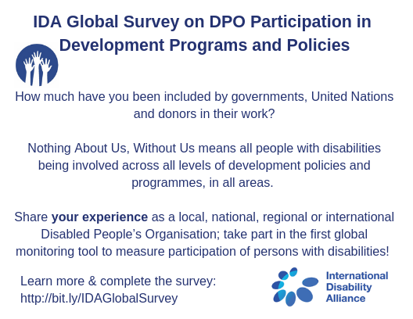

IDA 关于残障人组织（DPO）参与发展规划和政策的全球调查问卷

How much have you been included by governments, United Nations and Donors in their work?
你参与政府、联合国和资助方工作的程度如何？

Nothing about us, without us means all people with disabilities being involved across all levels of development policies and programmes, in all areas.
没有我们的参与请不要做和我们有关的决定意味着所有的残障人士在所有领域、所有层面都应该被纳入到发展政策和规划当中去。

Share your experience as a local, national, regional or international Disabled People’s Organisation; take part in the first global monitoring tool to measure participation of persons with disabilities!
分享你作为本土、国家、区域或国际的残障人组织（DPO）的经验，参与第一个监测残障人士参与程度的全球监测工具！

Learn more & complete the survey:
了解更多 & 填写问卷：

