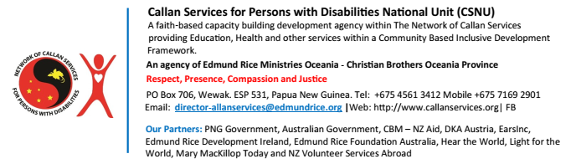

**MEDIA RELEASE**

Wednesday, 01 April 2020

**CALLAN SERVICES NETWORK COMMENDS THE NATIONAL GOVERNMENT FOR ITS QUICK RESPONSE TO THE THREAT OF COVID-19 PANDEMIC**

The Network of Callan Services today commended the national government for its quick response to slow the spread of coronavirus to save lives, and to save livelihoods.

Director of Callan Services for Persons with Disabilities National Unit (CSNU), Br Kevin Ryan congratulated the government on its pro-active and firm response to the threat of Covid-19 taking hold of the nation’s population. The Government through the National Department of Health (NDOH) and other relevant Departments has developed a preparedness and response plan that outlines the strategic components for managing a public health response to COVID-19. The plan considers priority actions to take in the event of community transmission.

While commending the government, Br Kevin recommended special provision to be applied to vulnerable people like persons with disabilities. “I call on all National, Provincial and District Authorities and other providers of services to address the needs of those with disabilities as Papua New Guinea continues to prevent and prepare for Covid-19.”

He highlighted the need for having persons with disabilities on Emergency Response Committees and directly involved in the development of prevention and response plans. “It is also important to have experienced providers of services to persons with disabilities, children and adults, involved in developing and implementing responses to the physical, emotional and spiritual needs of those in the community with disabilities.”

He highlighted the need for involvement of service providers to persons with disabilities: “This is critical in assisting to name the risks and needs of this group in our communities. Each disability group has unique needs in relation to inclusion and involvement in the prevention and response process,” he added.

Br Kevin offered the services of CSNU to assist relevant authorities to contact people with relevant knowledge, skills and experience across the country so that our country’s response to this crisis is fully inclusive and meets our own policy and UN related commitments to ‘leave no-one behind’.

Callan Services National Unit, a faith-based development NGO is the lead and coordinating agency in The Network of Callan Services which is the largest provider of services to children and adults living with disabilities in Papua New Guinea. It is a national, cross-disability Network that attempts to respond to the needs of people with all kinds of disability.

Authorised for Release:

**Br Kevin Ryan**

Director for Callan Services for Persons with Disabilities (CSNU)

For media enquiries, please contact Baeau Tai at [baeautai3@gmail.com/](mailto:baeautai3@gmail.com/) baeau.tai@callanservices.org or by phone on 71994536 /73861073

**Realising the Rights of Persons with Disabilities**