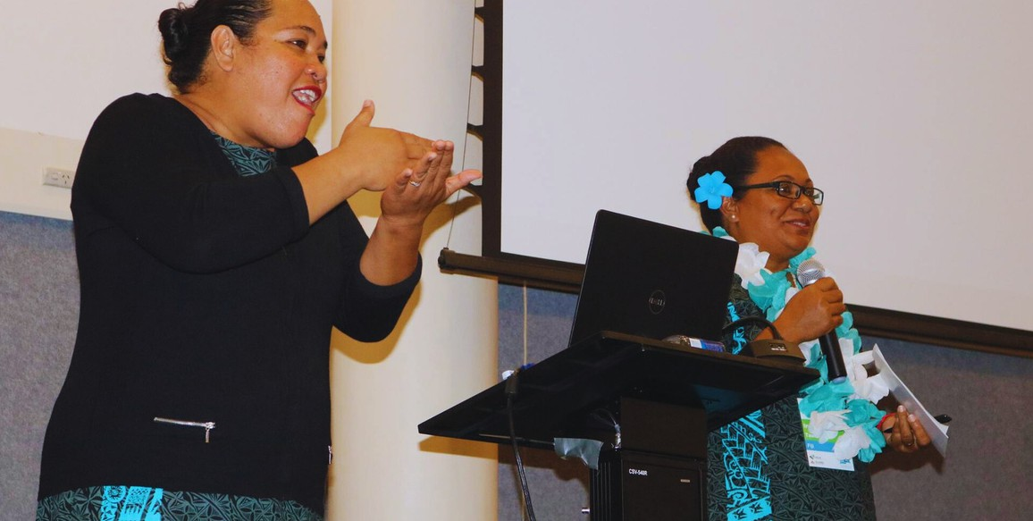
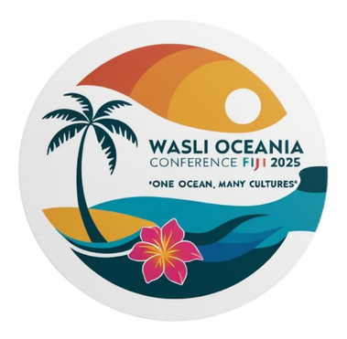

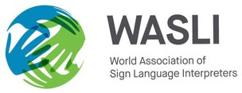
20 MAY 2025

Concept Note
WASLI Oceania Interpreters Conference

Presented by
WASLI Oceania

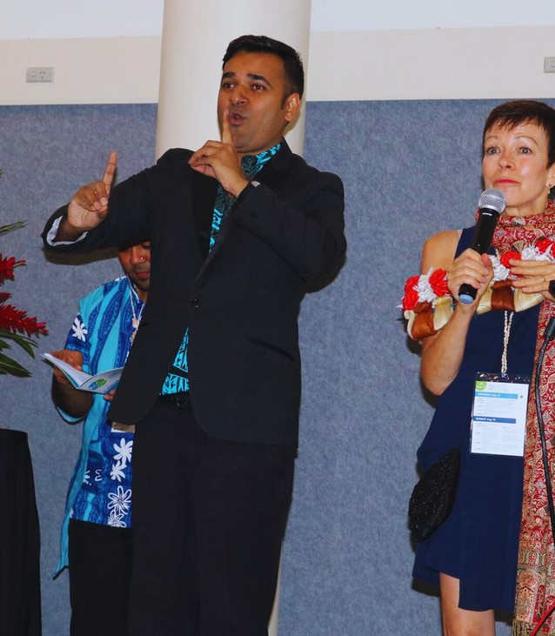
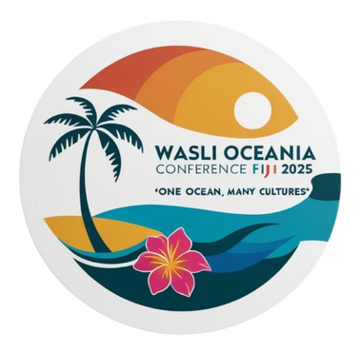
Table of Contents

3 | INTRODUCTION | 6 | FUTURE VISION
4 | BACKGROUND | 7 | BUDGET SUMMARY
5 | RATIONALE | 9 | CONTACT US
5 | CURRENT ACTIVITIES

Project: Strengthening Regional Interpreter Capacity through the WASLI Oceania Conference 2025
Conference Theme: One Ocean, Many Cultures

Introduction

The World Association of Sign Language Interpreters (WASLI) Oceania is a regional body operating under the umbrella of the global WASLI organization. Its purpose is to promote and implement WASLI’s vision and mission within the Oceania region, which includes Australia, New Zealand, and the Pacific Island countries.

WASLI Oceania is currently led by two Regional Representatives, elected every four years at the WASLI Conference. Under their leadership, an Advisory Group has been established, comprising representatives from Australia and New Zealand, including the current Regional Representatives. This structure is gradually expanding to include Presidents of National Sign Language Interpreting Associations from Pacific Island countries, further grounding our regional work in local voices.

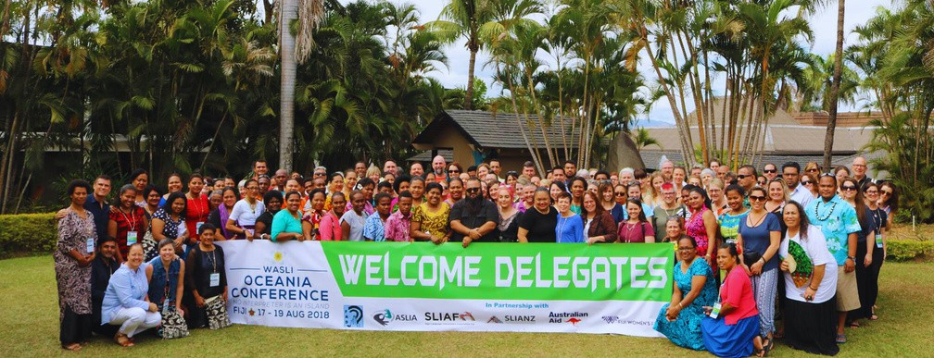
Additionally, a Regional Representatives Group has been formed, consisting of country representatives from across the Pacific. This group ensures that the diverse perspectives of the Pacific are represented at the WASLI Oceania level. Together, these teams coordinate efforts to strengthen interpreting practices, training, and collaboration throughout the region.

Background

The Core Purpose of Sign Language Interpreting Services

The fundamental purpose of sign language interpreting services is to ensure effective communication and equitable access to information and services for Deaf persons. Interpreters serve as a bridge between Deaf individuals and the wider hearing society, facilitating access to education, employment, healthcare, justice, and full participation in civic life. According to Article 9 (Accessibility) and Article 21 (Freedom of Expression and Access to Information) of the United Nations Convention on the Rights of Persons with Disabilities (CRPD), States Parties must take appropriate measures to ensure that persons with disabilities can access information, communications, and services on an equal basis with others, including the provision of sign language interpreters when necessary.

The WASLI Oceania Conference and associated training and networking events are grounded in this rights-based approach. These initiatives are not merely professional gatherings—they are a vital response to the call for access and inclusion. By building the skills and networks of sign language interpreters in the Pacific, we aim to directly contribute to fulfilling the rights of Deaf persons to access communication in their preferred language. This work upholds the vision of a region where Deaf individuals are empowered to participate fully in their communities, supported by competent, culturally sensitive, and well-trained interpreters.

WASLI Oceania aims to support and enhance the capacity of sign language interpreters and their associations across the region. Currently, there are no formal interpreter training programs available within the Pacific Islands.

Our key objectives include:
Supporting the establishment and registration of national sign language interpreting associations;
Encouraging these associations to become members of WASLI;
Facilitating the development of a recognized interpreter training program in partnership with an accredited university;
Connecting interpreters and organizations across the Pacific to foster mutual support and collaboration.

Two active sub-committees currently operate under WASLI Oceania:
Conference Sub-Committee – responsible for organizing the WASLI Oceania Conference, scheduled to take place from 26–29 August 2025.
Training Sub-Committee – delivering a 26-week online training program covering various aspects of sign language interpreting. This groundbreaking initiative, currently in its 21st week, has enrolled 40 interpreters from across the Pacific region. It is the first program of its kind in the Pacific and is being developed and delivered with the support of experienced trainers from New Zealand and Australia.

Rationale

The WASLI Oceania Conference 2025, themed One Ocean, Many Cultures, will be a pivotal regional gathering for sign language interpreters and stakeholders to reflect, celebrate, and collaborate. The event will be delivered in two parts:

Part One: A two-day pre-conference workshop designed exclusively for interpreters from Pacific Island nations. Facilitated by experienced trainers, including contributors to the current 26-week training program, this workshop will offer a rare opportunity for face-to-face learning and in-depth engagement with key aspects of sign language interpreting.
Part Two: The main conference, held over two subsequent days, will feature presentations from internationally recognised interpreters and prominent figures from the Oceania region. A special highlight will be the attendance of the WASLI President, who will serve both as a potential trainer in the pre-conference workshop and as a keynote speaker — a significant honour for our region.

A major milestone of the conference will be the graduation ceremony for participants of the 26-week training program — the first of its kind in the Pacific. This program has equipped interpreters with essential foundational and advanced skills, marking a transformative step toward raising professional standards in the region.

The conference will also:
Provide critical opportunities for networking, learning, and regional collaboration; Offer professional development through targeted workshops and presentations;
Highlight the partnerships between Pacific Island nations and developed countries such as New Zealand and Australia;
Promote the long-term vision of formally registering WASLI Oceania as a legal entity, thereby strengthening its institutional framework and enabling sustainable funding strategies.

Current Activities

  - Conference Planning: The Conference Sub-Committee, composed of dedicated volunteers, is actively coordinating the WASLI Oceania Conference scheduled for August 2025. This includes managing logistics, developing the program content, and building strategic partnerships to ensure a successful and impactful event.

  - Interpreter Training: The Training Sub-Committee is delivering a comprehensive 26-week online interpreter training program, designed to build core and advanced skills in sign language interpreting. The program will culminate in a graduation ceremony during the conference, taking place from 26–29 August 2025 — a milestone celebration for the region.

Future Vision

WASLI Oceania envisions a strengthened and sustainable future for sign language interpreting across the region. Our long-term goals include:
The establishment of a regionally recognized interpreter training program, delivered in partnership with an accredited university;
The formation and registration of national interpreting associations in each Pacific Island country;
Enhanced partnerships between Deaf communities and interpreters, fostering culturally responsive and community-led practices;
Stronger networks and collaboration with WASLI Global, Australia, New Zealand, and other international stakeholders;
The formal registration of WASLI Oceania as a legal regional entity, enabling access to sustainable funding, strategic partnerships, and institutional growth.

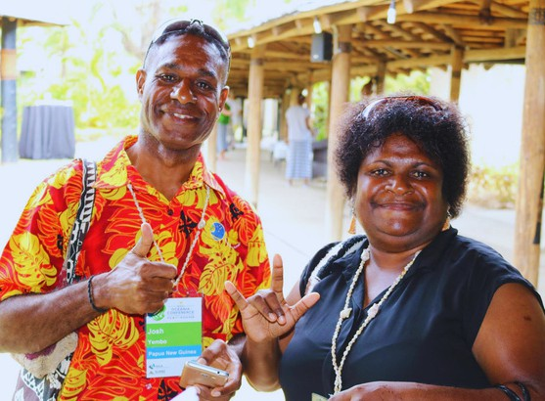
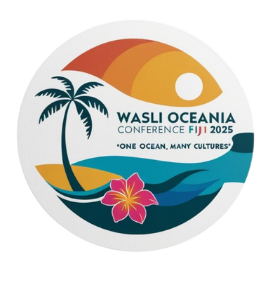
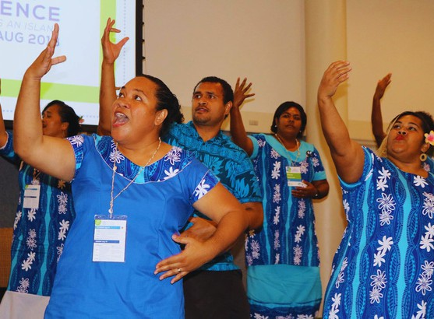

Budget Summary

We are seeking financial support to assist with the successful delivery of the WASLI Oceania Conference 2025. This vital event will bring together interpreters, Deaf leaders, trainers, and stakeholders from across the Pacific, Australia, New Zealand, and beyond.
Below is a breakdown of the estimated costs:
#

1.

2.
Details

Conference Venue

Conference Venue

Catering

Opening Night

Cultural Night

Merchandise

Presenters Gifts

Volunteer T- shirts
Unit Cost

$1,800

$105

$50

$20
Unit (Pax)

100

100

16

40 (2
piece each)
Unit
(day/nights)

4 days

4 days

1 night

1 night

2 days

2 days
Total

$7,200

$4,200

$2,500

$5,000

$500

$1,800
Comments

Inclusive of rooms + equipment

Morning tea, lunch, afternoon tea for conference days

Finger foods only for the opening night

Covers dinner

Gifts for conference presenters

Uniform for volunteers for 2 days

#

3.

4.
Details

Personnel

Interpreters

Accommodation

Per Diem

Marketing

Pull up banner + banner

TOTAL
EXPENSES
Unit Cost

$100

$349
doubles Superior

$220

$150 (pull up banner)
$300
banner
Unit (Pax)

10

6

6

3
Unit
(day/night)

2 days

5

5
Total

$2,000

$5,235

$6,600

$700

$73,535
Comments

Gift
vouchers for their service

3 rooms for
6 committee members

For Committee Members

2 pull up banners and 1 x long banner (3m x 2m)

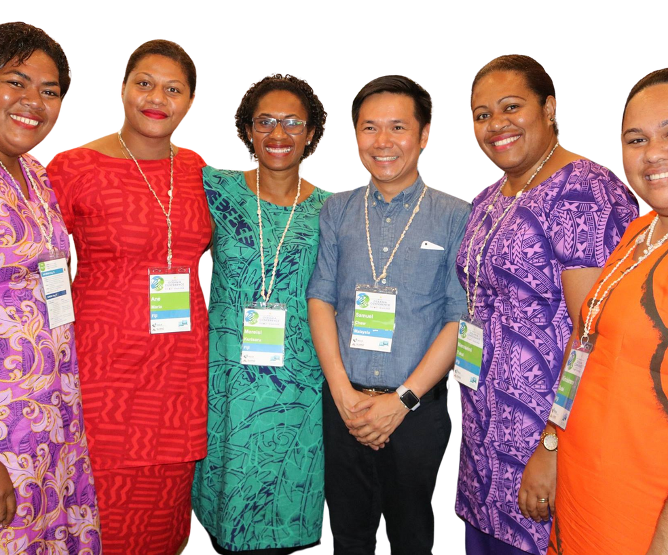
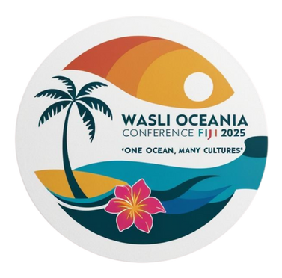
Contact us.
waslioceaniaconference2025.com  waslioceaniaconference@gmail.com
+679 8639789

