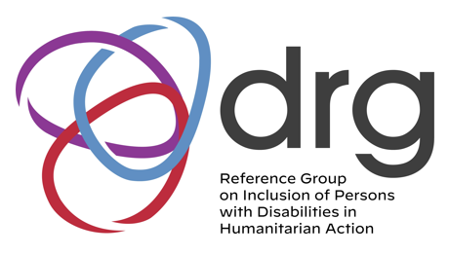
DRG OPD
Awareness Session

Theme Introduction to Humanitarian Action.
Session for OPDs in the Pacific

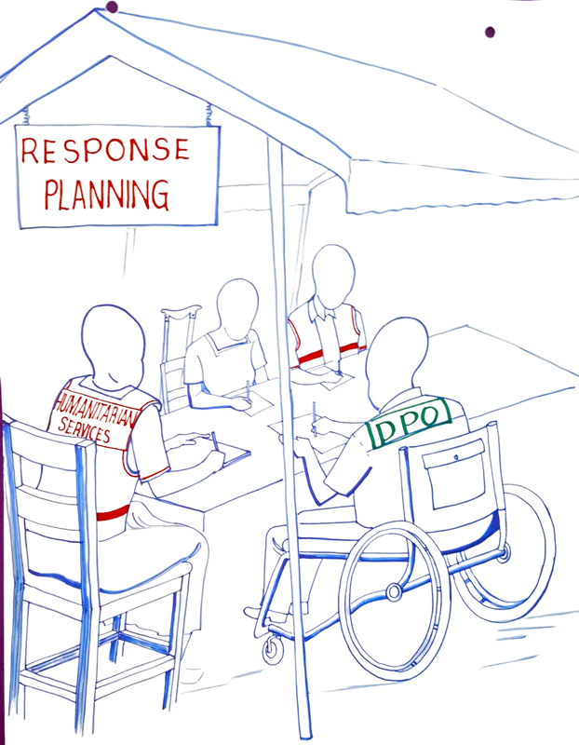
Session 1 Session 2

Friday 19th May
Friday 2nd June

1:00pm to 3:30pm (Fiji time)
9:00am to 11:30pm
(Philippines time)

Online Event

Register Here






