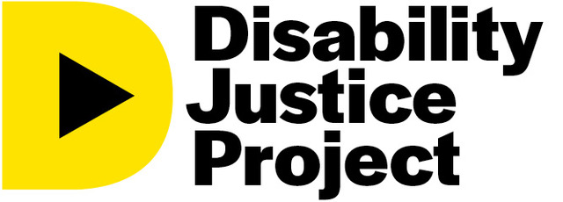

A global grassroots media network centering the voices of persons with disabilities
- What is the Disability Justice Project?
The Disability Justice Project (DJP) is a participatory media-making initiative whose mission is to challenge cultural narratives about disability by amplifying the voices and perspectives of persons with disabilities. The DJP is a strategic partnership between international documentary filmmaker and journalism educator Jody Santos and the Disability Rights Fund (DRF).
2. What is participatory media?
Participatory, or citizen, journalism is when impacted communities tell their own stories versus having an outside “expert” interpret and tell those stories for them. This new form of journalism is the result of increasingly accessible media technology and a greater emphasis on individual empowerment. This idea of “bottom-up” versus top-down media is critical to creating sustainable change that is both accepted and led by local communities. With distribution options ranging from livestreams to local screenings, video, in particular, has the capacity to support social movements like never before, and it is one of the most accessible forms of journalism today.
- What is the Disability Justice Project Fellowship?
Five fellows from OPDs (organizations of persons with disabilities)/DRF grantees from the Pacific Islands will be chosen for a two-week, in-person workshop on documentary storytelling in June 2023. They will receive a stipend of 500 U.S. dollars for participating and a certificate of completion at the end of the course. Trainings will be virtual. CART and International Sign will be provided. Storytelling kits, including video cameras, tripods, and mics, will be provided to participating fellows and will be the property of the sponsoring OPD. The media created will be published on a central Web site - the first platform of its kind dedicated to the global disability justice movement.
4. Who can apply to DJP?
Persons with disabilities from marginalized groups like women and Indigenous and LGBTQI persons from OPDs that are current DRF grantees can fill out our application. Please note that the application must be filled out jointly by the potential fellow and their sponsoring OPD.
5. What is required of the fellows and OPDs?
Fellows are expected to:
- Attend and complete the full fellowship program, which requires fellows to:
- Be available for two weeks in June to complete the workshop in person
- Complete three major assignments (two during the workshop and the final one on their own during the two weeks following)
- Be 18 years or older by January 1, 2023

- Be a staff member of DRF grantee organization for a minimum of one year.

- Have experience with writing or storytelling. This could include writing a report or policy brief or telling a story with video, audio, or print.

OPDs are expected to:
- Support the fellow and give them the appropriate time off to participate
in the workshop and complete assignments.

- Complete the section of the fellow’s application related to the sponsoring OPD.
- Be responsible for digital storytelling kits shipped to the fellow.

