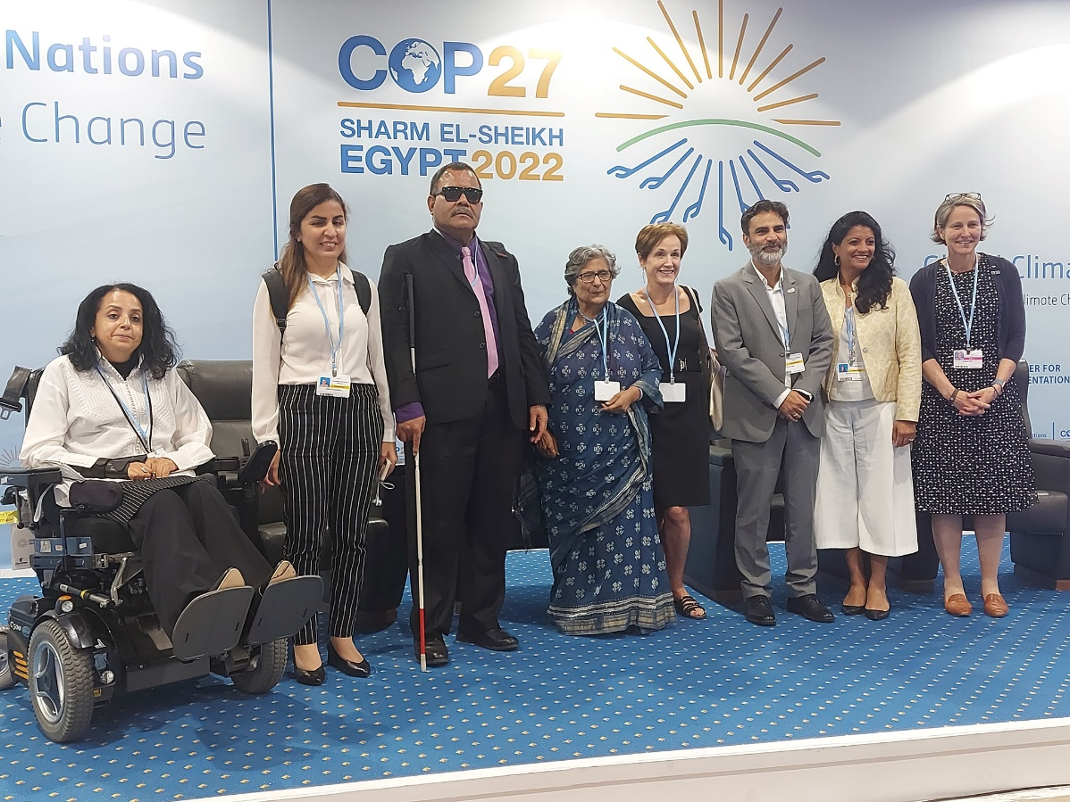
 |  | PDF Newsletter | January 2023 Volume 1
 |  | The latest news, views, and announcements from the Pacific Disability Forum
INSIDE
__
New year message from the Forum
An update on the month of January in the Disability Sector
__
International Updates
A look at the events in which PDF was represented
__
Regional Glance
A look at the work being implemented by PDF and its members

Message from the CEO
Greetings from the Pacific Disability Forum (PDF) and its members.
We begin the new year and continue the journey of an inclusive, equitable and resilient Pacific for all persons with disabilities. We also recognize that we need more than just the inclusion to realise our rights.
As reiterated by our Chief Executive Mr. Setareki Macanawai during the International Day for Persons with Disabilities last year, “Inclusion can take us to the table but it is equity that will transform and reconfigure the table to ensure our full and effective participation.”
This is a reminder to all of us as advocates, champions, OPDs as well as persons with disabilities as we are the custodians of and for the rights of persons with disabilities in the Region.

Disability Inclusion updates
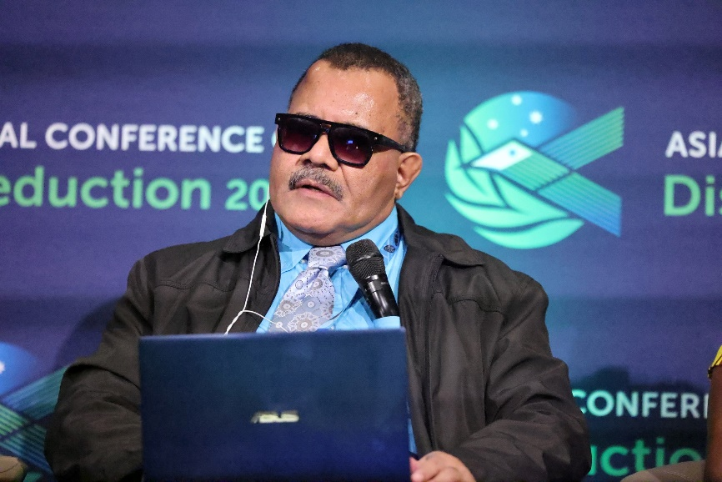  As we look to the work ahead of us, we call for all our Strategic partners, donors and members to join us this year at the 7th Pacific Regional Conference on Disability (PRCD) which for the first time will be held in partnership with the Pacific Islands Forum. It is envisioned that the 7th Regional Conference will bring the Organisations of Persons with Disabilities (OPDs) and Government focal points together along with our development Partners to discuss the progress on the implementation of the CRPD and SDG at the national as well as regional level. It will also identify key actions and way forward for the next few years.  The year 2023 is a year of change for many and at the Pacific Disability Forum and the whole Pacific Disability family in the region, we wholeheartedly welcome the new year and the new challenges that it brings along.  With the theme - “NOTHING WITHOUT US: Deepening partnership for an inclusive and Equitable Blue Pacific Continent for Persons with Disabilities”, the 7th PRCD will be held from Monday, 27th February 2023 – Friday, 03rd March 2023 in Fiji.  We look forward to your continued support and hope to see you there. |  |  | Sector farewells Stalwart    In beginning the new year, the Pacific disability movement lost one of her true sons, champion and advocate -Mr. Rakesh Chand who many will remember as a stalwart in the movement to ensure that all persons who are visually impaired in Fiji and the region were recognized.  Mr. Chand was employed for many years at Westpac Bank Fiji. His dedication and determination to his work showed and proved to everyone that persons with disabilities, with the right support can also excel in the mainstream work environment.

2022 in a glance
As we plan activities for the new year, we shall take a look at some of the major achievements and key highlights in 2022
Internationally
- For the first time ever, the Pacific Disability Forum took part in the COP 27 discussions. Represented by the Chief Executive Officer, Setareki Macanawai, the event provided a chance for disability inclusion in climate action to be advocated for on a large-scale internationally.
- The UN Human Rights Council were briefed on the concerted efforts by the Pacific Disability Forum and its strategic partners in ensuring a collaborative approach to the use of the Washington Short Set Questions or WGSS for data collection. Director Operations Laisa Vereti revealed that as a result of the collaborative efforts, 10 Pacific Island countries use the WGSS (6 questions) in their census whilst 4 other countries having a disability monograph. She further added that Fiji and Tuvalu are in the process of completing their Disability Monograph with 4 more Pacific Island countries (Solomon Island, Vanuatu, Marshall Island, FSM) to use the WGSS in their upcoming census.
- A delegation from PDF and OPDs took part in the Asia Pacific Ministerial Conference on Disaster Risk Reduction or APMCDRR. The Sessions focusing on disability inclusion and DRR well attended by participants with disabilities from Asia and Pacific countries. Mr. Macanawai served as moderator for the Partner Session focusing on “Why effective DRR cannot be achieved without partnering with organisations of persons with disabilities?” as well as serving as a panel member on Spotlight 3 with Session focusing on “Disability Inclusive DRR: How leadership of persons with disabilities is critical to an effective localisation agenda” Speaking on the learnings from the Event, the CEO stressed that there were not many opportunities to advocate/lobby Ministers from different governments as governments delegation were kept in a different level of the venue from the rest of the participants. However, he stressed that CSOs to advocate to governments to include CSO reps in their delegation.
- The Chief Executive of PDF, Mr. Setareki Macanawai has been named as a UNESCAP Decade Champion as well as one of the 10 Asia Pacific Champions of Disability rights. This is part of the UNESCAP High-level Intergovernmental Meeting on the Final Review of the Asian and Pacific Decade of Persons with Disabilities 2013-2022. This is where a final review of the implementation of the Decade was carried out. PDF was represented by Mr. Macanawai
- Participants and panelists at the 7th Global Partnership on DRR in Bali, Indonesia were once again reminded of the importance of contextualizing all early warning systems and messaging to ensure that persons with disabilities are not left out during disasters. The Pacific Disability Forum was represented by the Chief Executive - Setareki Macanawai, the Manager Humanitarian Resilience Development Unit - Katabwena Tawaka and Inclusive Development Advisor - Sainimili Tawake. The Chief Executive was a panelist in two sessions, the first being “Status, Gaps and Ways Forward - Thematic Perspective: Governance & Inclusive Early Warnings” and the second addressing “Mechanism for Social Protection and Local Recovery.”

- Pacific Women and women with disabilities took center stage at the Shifting the Power Coalition Regional Convening. The Regional Meet drew in women from Fiji, PNG/Bougainville, Samoa, Solomon Islands, Tonga, s well as from Vanuatu and Australia. Attended by PDF, the event allowed for women to come together to share their lived experiences, build networks and provide input to strategic partners such as PIFs and the Pacific Humanitarian Pathway on COVID19 (PHP-C) under the Biketawa Declaration.
- The Pacific Disability Forum was able to sign a further three-year funding with the Australian Government through their Department of Foreign Affairs and Trade (DFAT). This shows the confidence placed on the work being carried out by the Forum and its members in advancing the rights of persons with disabilities in the Region.
- On the same note, the New Zealand Government through their Ministry of Foreign Affairs and Trade (MFAT) showed their commitment to the role that PDF plays in the region as they entered into a multi-year funding arrangement with the Forum.
Regionally
- First ever Parametric Insurance for Persons with disabilities during a natural disaster. In partnership with the UN Capital Development Fund (UNCDF) which will be rolled out in Fiji, Tonga and Vanuatu. This scheme will assist persons with disabilities via an insurance package. It will be activated once a natural disaster affects any of the three chosen Project countries. Over 660 persons with disabilities in Fiji have become recipients of the Insurance scheme while this is expected to be rolled out in Vanuatu and Tonga in 2023.
- Due the various travel restrictions in place, the Pacific Disability Forum has realigned the work being undertaken in 2022 with support being provided to our member countries through a hybrid method whilst working closely with OPDs in Fiji to strengthen their capacity. In Fiji, a large scale COVID-19 Baseline survey carried out in the Northern Division in Fiji by PDF and OPDs in the country highlighted that a more concerted effort is needed on a national level to address disability at the grassroots. The survey also showed a vast gap in the level of accessibility and care shown towards persons with disabilities.
- Also undertaken during this period was the first of its kind baseline survey profiling of Persons with Intellectual disability by OPDs in country. The survey reaffirmed the important role that Social Protection plays in the lives of persons with disabilities. The Survey has shown that of the Participants who took part in the survey 70% are recipients of social Protection schemes offered by the Fijian Government. These schemes are in the form of Bus fare Concessions, Disability Allowance Schemes (DAS) as well as the Older Persons Pension Scheme. Social Protection is one of the six important pre-conditions that needs to be met to ensure the active and full participation of persons with disabilities in communities, planning as well as implementation work. If these pre-conditions are not realized, it will undermine inclusion of persons with disabilities of all ages in all sectors.
- For the first time ever, PDF has started work on bringing awareness on the different types of assistive devices available as well as understand its care and procurement process. This was the underlying theme as OPDs in Fiji underwent a two-day Assistive Devices Workshop. A major push for this is that many procurements of assistive devices are not within their systems, which can then be a risk for persons with disabilities as there is a lack or non-availability of the devices in the region. The expenditure or cost is then borne by the person with disability and their families. Further to this, it is also evident that there is a need to further the progress in discussion on a regional hub and back-up services as these products are not easily accessible or available in the Pacific region. Another Project which PDF is also working is the Accessibility Blueprint.
The Blueprint is the first of its kind for the Pacific and consists of Guidelines and Standards which will set standards for building as well as inclusion in terms of legislation. This is an integral part of the work which PDF is undertaking over the next five years as outlined in the Organisations Strategic Plan where PDF will strengthen partnership and advocate for policies and programs to create pre-condition for inclusion. It is envisioned that the Blueprint will be used by Government to ensure accessibility into the building codes and legislations. PDF is leading the development of an accessibility standard blueprint in partnership with the Pacific Islands Forum secretariat (PIFS).
- The Pacific Disability Forum together with the UN interagency Outcome Group 6 of the Disability Inclusion Strategy (UNDIS) team have worked tirelessly to ensure that persons with disabilities are able to access and utilize the services provided by the Agencies in the Pacific. In the first phase of collaboration, Access Audits by OPDs four Pacific Island countries were carried out in 11 buildings across the 4 countries with a total of 27 physical audits and 11 website accessibility audits conducted. This included 14 UN agencies in Fiji with 11 UN websites, 8 UN Agencies in the Solomon Islands, the UN Head office was physically audited in Tinga and in Vanuatu the OPDs physically audited 4 UN agencies.
- The Pacific Disability Forum has welcomed the move by the Fijian Government to set up a Special and Inclusive Education Working Group. This follows a three-day Inclusive Education Consultation organized by the Fijian Government and the Fiji Program Support Facility and attended by PDF Chief Executive Mr. Setareki Macanawai and Programme Officers Maria Miller and Sisi Coalala. Presently, Fiji has 17 special schools and there are a total of 386 mainstream inclusive schools in Fiji with 2, 295 students with disabilities in the country of which 836 are girls.

Upcoming Important dates:
Looking ahead in 2023, the important dates for the next three months are
- 7th PRCD – 28th Feb to 3rd March
- Zero Discrimination Day – 1st March
- International women’s days - 8th March
- World Down Syndrome Day – 21st March

For more information and updates on the work being done across the region, join us on our journey as we bring your lived stories from our members in the field, stories that impact the lives of persons with disabilities as well as advisories for all stakeholders through our social media platforms.
- Instagram @pacificdisability
- Twitter @PDFSec
- Facebook @Pacificdisability
- Or by going to our newly vamped and accessible website www.pacificdisability.org
You can also reach us at the Secretariat, which is based in Suva Fiji
- Pacific Disability Forum | Ground Floor, Kadavu House, Victoria Parade
- GPO Box 18458 Suva, Fiji
- Phone (landline): (+679) 7730200, 3312008

