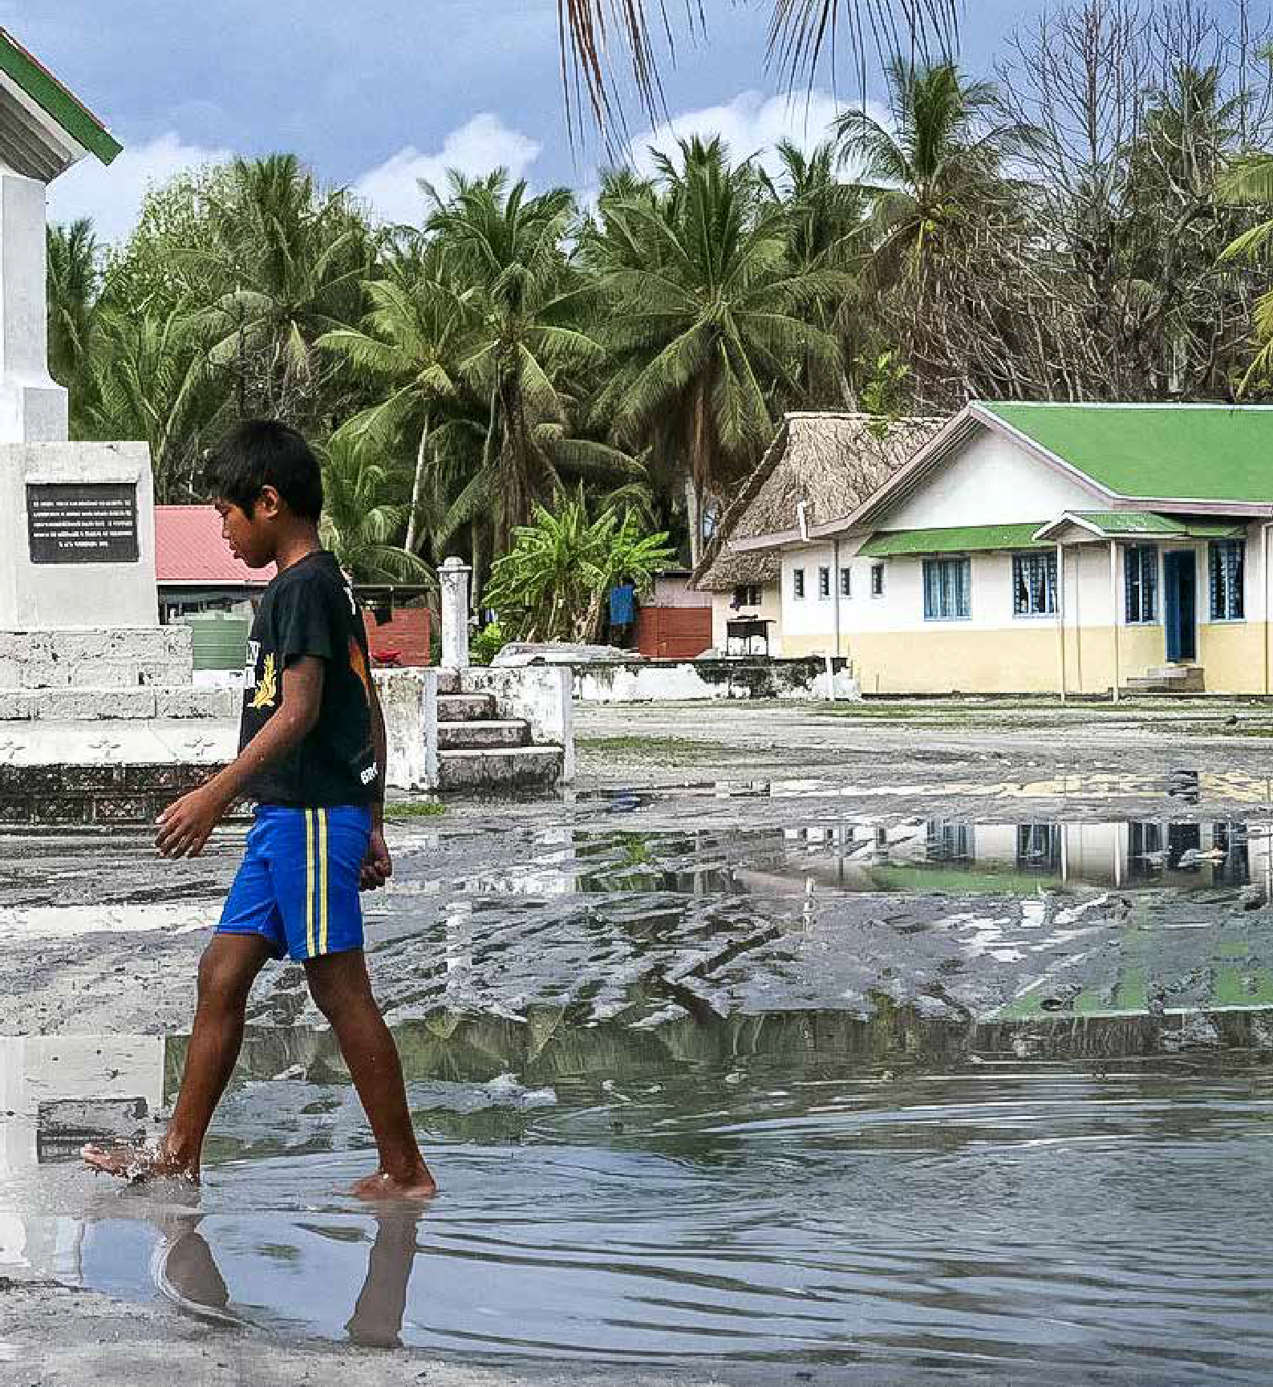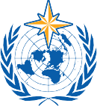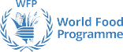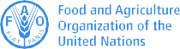

2020 STATE OF CLIMATE SERVICES

RISK INFORMATION AND EARLY WARNING SYSTEMS

CLIMATE RISK & EARLY WARNING SYSTEMS

JOINT OFFICE FOR CLIMATE AND HEALTH

Lead authors and contributors (in alphabetical order):

Contents

Report Editorial Board (WMO):
Johannes Cullmann, Maxx Dilley, Paul Egerton, Jonathan Fowler, Veronica F. Grasso, Cyrille Honoré, Filipe Lúcio, Jürg Luterbacher, Clare Nullis, Mary Power, Anthony Rea, Markus Repnik, Johan Stander.
Contributors:
Agence Française de Développement (AFD): Nadra Baubion, Guillaume Bouveyron, Philippe Roudier Adaptation Fund (AF): Saliha Dobardzic, Alyssa Maria Gomes
Climate Policy Initiative (CPI): Baysa Naran, Morgan Richmond
Climate Risk and Early Warning Systems (CREWS) Secretariat: John Harding, Maria Lourdes K. Macasil
Food and Agriculture Organization of the UN (FAO): Keith Cressman, Beau Damen, Ana Heureux, Catherine Jones, Hideki Kanamaru, Lev Neretin, Samuel Mulligan, HangThiThanh Pham, Sören Ronge
Group on Earth Observations (GEO): Jesús San-Miguel-Ayanz (European Commission, Joint Research Centre, Global Wildfire Information System lead), Steven Ramage, Sara Venturini
Green Climate Fund (GCF): Joseph Intsiful
Global Environment Facility (GEF): Aloke Barnwal, Fareeha Iqbal
International Federation of Red Cross and Red Crescent Societies (IFRC): Tessa Kelly, Kirsten Hagon
Risk-informed Early Action Partnership (REAP): Montserrat Barroso, Helen Bye, Emma Louise Flaherty, Jesse Mason, Jonathan Stone
United Nations Office for Disaster Risk Reduction (UNDRR): David Stevens, Rahul Sengupta United Nations Development Programme (UNDP): Gregory Benchwick, Benjamin Laroquette
World Bank Group (WBG) and Global Facility for Disaster Reduction and Recovery (GFDRR): Anna-Maria Bogdanova, Daniel Kull, Melanie Kappes, Alexander Mirescu
World Food Programme (WFP): Montserrat Barroso, Katiuscia Fara, Giorgia Pergolini World Health Organization (WHO) – WMO Climate and Health Office: Joy S. Guillemot
World Meteorological Organization (WMO): Valentin Aich, Assia Alexieva, Alexander Baklanov, Mathieu Belbeoch, Dominique Berod, Etienne Charpentier, Estelle de Coning, Amir Delju, James Douris, Ilaria Gallo, Sarah Grimes, Joy S. Guillemot, Abdoulaye Harou, Peer Hechler, Anahit Hovsepyan, Ata Hussein, Geunhye Kim, Hwrin Kim, Jochen Luther, Vanessa Mazarese, Jean-Baptiste Migraine, Samuel Muchemi, Petra Mutic, Rodica Nitu, Wilfran Moufouma Okia, Patrick Parrish, Taoyong Peng, Timo Proescholdt, Lars-Peter Riishojgaard, Hugo Remaury, Michel Rixen, Paolo Ruti, Robert Stefanski, Oksana Tarasova.
Project coordination (WMO): Maxx Dilley, Veronica F. Grasso, Cyrille Honoré, Tom Idle, Filipe Lúcio, Nakiete Msemo. WMO gratefully acknowledges the financial contributions from Agence Française de Développement and the Climate Risk and Early Warning Systems Initiative.
Graphic design: Design Plus.

WMO-No. 1252
© World Meteorological Organization, 2020

The right of publication in print, electronic and any other form and in any language is reserved by WMO. Short extracts from WMO publications may be reproduced without authorization, provided that the complete source is clearly indicated. Editorial correspondence and requests to publish, reproduce or translate this publication in part or in whole should be addressed to:
Chair, Publications Board
World Meteorological Organization (WMO)
7 bis, avenue de la Paix Tel.: +41 (0) 22 730 84 03
P.O. Box 2300 Fax: +41 (0) 22 730 81 17
CH-1211 Geneva 2, Switzerland Email: publications@wmo.int ISBN 978-92-63-11252-2
NOTE
The designations employed in WMO publications and the presentation of material in this publication do not imply the expression of any opinion whatsoever on the part of WMO concerning the legal status of any country, territory, city or area, or of its authorities, or concerning the delimitation of its frontiers or boundaries. The mention of specific companies or products does not imply that they are endorsed or recommended by WMO in preference to others of a similar nature which are not mentioned or advertised. The findings, interpretations and conclusions expressed in WMO publications with named authors are those of the authors alone and do not necessarily reflect those of WMO or its Members.

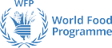
This publication has been issued without formal editing.

Introduction 4
Photo: Erik Witsoe
Executive Summary 5
Needs 7
Trends 10
What does an end-to-end multi-hazard early warning system (MHEWS) look like? 11
Data and methods 13
Status: Global 14
Status: Africa 21
Status: Asia 22
Status: South America 23
Status: North America, Central America and the Caribbean 24
Status: South-West Pacific 25
Status: Europe 26
Status: Small Island Developing States (SIDS) 27
Status: Least Developed Countries (LDCs) 28
Case Studies 29
Investment 43
Gaps 45
Recommendations 46
Annex 47

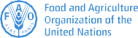
CLIMATE RISK & EARLY WARNING SYSTEMS


Empowered lives. Resilient nations.






JOINT OFFICE FOR CLIMATE AND HEALTH

Executive Summary
Photo: Espen Bierud

Between 1970 and 2019, 79% of disasters worldwide involved weather, water, and climate-related hazards. These disasters accounted for 56% of deaths and 75% of economic losses from disasters associated with natural hazards events reported during that period.2 Over the last 10 years (2010-2019), the percentage of disasters associated with weather, climate and water related events increased by 9% compared to the previous decade – and by almost 14% with respect to the decade 1991-2000.3
Photo: Michael Gordon
- There is insufficient capacity worldwide to translate early warning into early action – especially in LDCs. Africa faces the largest gaps in capacity. For example, while capacity in Africa is good in terms of risk knowledge and forecasting, the rate of MHEWS implementation overall is lowest in comparison with other regions and warning dissemination is particularly weak. Just 44 000 people in 100 000 in Africa are covered by early warnings in countries where data are available.

In 2018, the Conference of the Parties serving as the meeting of the Parties to the Paris Agreement at the 24th Conference of the Parties to the United Nations Framework Convention on Climate Change (UNFCCC) called on the World Meteorological Organization (WMO) through its Global Framework for Climate Services (GFCS) to regularly report on the state of climate services with a view to “facilitating the development and application of methodologies for assessing adaptation needs”. An analysis by the WMO and the Food and Agriculture Organization of the United Nations (FAO) in 2019, of Nationally Determined Contributions to the Paris Agreement, showed that the majority of countries highlighted disaster risk reduction (DRR) as a top climate change adaptation priority. DRR is also a top priority in all National Adaptation Plans (NAPs) submitted to UNFCCC to date.

Seamless climate services can help to address these priorities in both the short- and the long-term, by giving decision-makers enhanced tools and systems to analyse and manage climate risks, both under current hydrometeorological conditions as well as in the face of climate variability and change. Early warning systems are a key proven measure for effective disaster risk reduction and adaptation.

While the COVID-19 pandemic has generated an international health and economic crisis from which it will take years to recover, it is crucial to remember that climate change continues to pose an on-going and increasing threat to human

Extreme weather and climate events have increased in frequency, intensity and severity. Vulnerable people in countries with weaker disaster preparedness systems are facing the greatest risks. For instance, cyclone Harold formed off the Solomon Islands in early April 2020, made landfall in Vanuatu, and then moved to Fiji and Tonga. The combination of COVID-19 and the cyclone made it much more difficult to respond to both crises. The pandemic disrupted supply routes for disaster response, and many people moved into evacuation centres where social distancing was almost impossible, raising risks of increasing the numbers affected by the pandemic.

COVID-19 has revealed important vulnerabilities that have culminated in a global emergency. The most vulnerable have been hit the hardest. Recovery from the COVID-19 pandemic is an opportunity to move forward along a more sustainable path towards resilience and adaptation.1

This report identifies where and how governments can invest in effective early warning systems that strengthen countries’ resilience to multiple weather, water and climate-related hazards. Being prepared and able to react at the right time, in the right place, can save many lives and protect the livelihoods of communities everywhere.

Prof. Petteri Taalas,
The situation is particularly acute in Small Island Devel- oping States (SIDS) and Least Developed Countries (LDCs). Since 1970, SIDS have lost US$ 153 billion due to weather, climate- and water-related hazards – a significant amount given that the average gross domestic product (GDP) for SIDS is US$ 13.7 billion.4 Meanwhile, 1.4 million people (70% of the total deaths) in LDCs lost their lives due to weather, climate and water related hazards.

As climate change continues to threaten human lives, ecosystems and economies, risk information and early warning systems5 (EWS) are increasingly seen as key for reducing impacts of these hazards. The majority of Parties to the United Nations Framework Convention on Climate Change (UNFCCC) (including 88% of LDCs and SIDS) that submitted their Nationally Determined Contri- butions (NDCs) to UNFCCC have identified EWS as a top priority.

Underpinned by a global observing system and a network of operational centres run by WMO Members, a people-centred multi-hazard early warning system (MHEWS) empowers individuals and communities threatened by hazards to act in sufficient time and in an appropriate manner to reduce the impacts of hazardous weather, climate and water related events. As this 2020 State of Climate Services Report shows, however, many nations lack MHEWS capacity and financial investment is not always flowing into the areas where investment is most needed.

  - Data provided by 138 WMO Members (including 74% of LDCs and 41% of SIDS globally) show that just 40% of them have MHEWSs. One third of every 100 000 people in the 73 countries that provided information is not covered by early warnings.

  - In countries that do operate MHEWSs, warning dissemi- nation and communication is consistently weak in many developing countries, and advances in communication technologies are not being fully exploited to reach out to people at risk, especially in LDCs.
- All weather, hydrological and climate services rely on data from systematic observations. However, observing networks are often inadequate, particularly across Africa, where in 2019 just 26% of stations reported according to WMO requirements.

- Despite annual tracked climate finance reaching the half- trillion-dollar mark for the first time in 2018,6 adaptation finance is only a very small fraction (5%). Available information for tracking hydro-met finance flows is insufficiently detailed to support a full analysis of the degree to which it supports EWS implementation, as is the information needed for tracking socio-economic benefits derived from early warnings.

The report makes six strategic recommendations to improve the implementation and effectiveness of EWSs worldwide:

- Invest to fill the EWS capacity gaps, particularly in LDCs, in Africa and in SIDS.
- Focus investment on turning early warning information into early action, through improved communication and preparedness planning.

Ensure sustainable financing of the global observing system that underpins early warnings, and ensure that financing covers all segments of the EWS value chain.
- Track finance flows to improve understanding of where resources are being allocated in relation to EWS imple- mentation needs .
- Develop more consistency in monitoring and evalua- tion to better determine EWS effectiveness.
- Fill the data gaps particularly from SIDS, by improving countries’ reporting on climate information and EWS capacity.

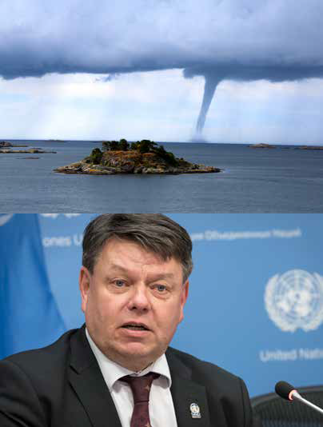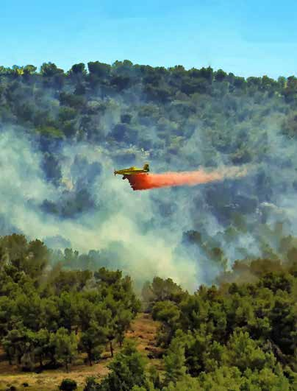lives, ecosystems, economies and societies that will continue for decades to come. The COVID-19 pandemic demonstrates how climate variability and change can interact with societal vulnerabilities to create new, heightened levels of risk.

1 UN Comprehensive Response to COVID-19, 2020.

4

Secretary-General,
WMO

  - WMO, Atlas of Mortality and Economic Losses from Weather, Climate and Water Extremes (1970-2019), forthcoming.
  - International Federation of Red Cross and Red Crescent Societies (IFRC), World Disasters Report, expected publication date: October 2020.
  - unohrlls.org
  - In 2017, Member States of the United Nations agreed on the definition of an early warning system as “an integrated system of hazard monitoring, forecas- ting and prediction, disaster risk assessment, communication and preparedness activities, systems and processes that enables individuals, communities, governments, businesses and others to take timely action to reduce disaster risks in advance of hazardous events” (UN General Assembly A/RES/71/276).
  - Climate Policy Initiative (CPI), 2019.

5

WMO and partners, through the Global Framework for Climate Services (GFCS), report annually on the state of climate services with a view to “facilitating
the development and application of methodologies for assessing adaptation needs”.7 Climate services provide science- based and user-specific information relating to past, present and potential future climates8 helping countries make better
and informed decisions in climate-sensitive sectors and thus generate both substantial economic benefits and sustainable development.

Needs

Early warning systems (EWS) are a top adaptation priority in 88% of the Nationally Determined Contributions (NDCs) to the Paris Agreement submitted by LDCs and SIDS

NORTH, CENTRAL AMERICA AND THE CARIBBEAN

› Disaster Risk Knowledge

AFRICA
EUROPE

› Detection, Monitoring, Analysis and Forecasting
› Disaster Preparedness and Response

ASIA

› Disaster Risk Knowledge
› Detection, Monitoring,

› Detection, Monitoring, Analysis and Forecasting
› Disaster Preparedness and Response

SOUTH AMERICA

› Disaster Risk Knowledge
› Detection, Monitoring, Analysis and Forecasting
› Warning Dissemination

› Disaster Risk Knowledge
› Detection, Monitoring, Analysis and Forecasting
› Warning Dissemination and Communication
› Disaster Preparedness and Response
Analysis and Forecasting
› Warning Dissemination and Communication
› Disaster Preparedness and Response

SOUTH-WEST PACIFIC

and Communication
› Disaster Preparedness and Response

EWS needs, as indicated in NDCs and NAPs.
Source: Nationally Determined Contributions (NDCs), WMO 2020
› Disaster Risk Knowledge
› Warning Dissemination and Communication
› Disaster Preparedness and Response

  - CMA 1/decision 11.
  - The Global Framework for Climate Services (GFCS) defines climate services as “Climate information prepared and delivered to meet users’ needs” (WMO, 2011).

EWSs have received increasing local, national, regional and international attention and are well recognised as a critical component of national disaster risk reduction (DRR) efforts, due to their effectiveness in saving lives and minimising losses from hazard events and adapting to climate variability and change. EWSs are prominent in the Sendai Framework for Disaster Risk Reduction 2015-2030, the Paris Agreement and the United Nations (UN) Sustain- able Development Goals. The Sendai Framework, adopted by 187 countries at the 2015 Third United Nations World Conference on Disaster Risk Reduction has, among its seven targets, one target (G) that calls for increased availa- bility of, and access to MHEWS.

  - WMO analysis of NDCs, 2020.
Photo: Red Charlie

88% of LDCs and SIDS that submitted their NDC to the Paris Agreement identified EWS as a top priority. All NAPs prepared to date mention EWSs. Parties’ NDCs mentioned the need for EWSs to support them in their adaptation efforts in agriculture and food security (46%), health (30%), and water management (24%) sectors9. The UNFCCC Warsaw International Mechanism for Loss and Damage highlights EWSs as a key measure for averting loss and damage associated with adverse effects of climate change.

Since the vast majority of disasters are triggered by hydro-meteorological hazards, weather, climate and hydrological services provided by National Meteorological and Hydrological Services (NMHSs) and their partners are critical for achieving the goals and targets of these frameworks and for effective adaptation through the implementation of NDCs and NAPs.

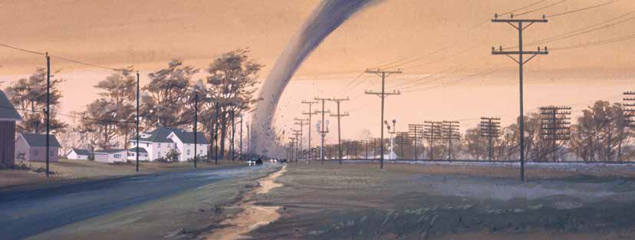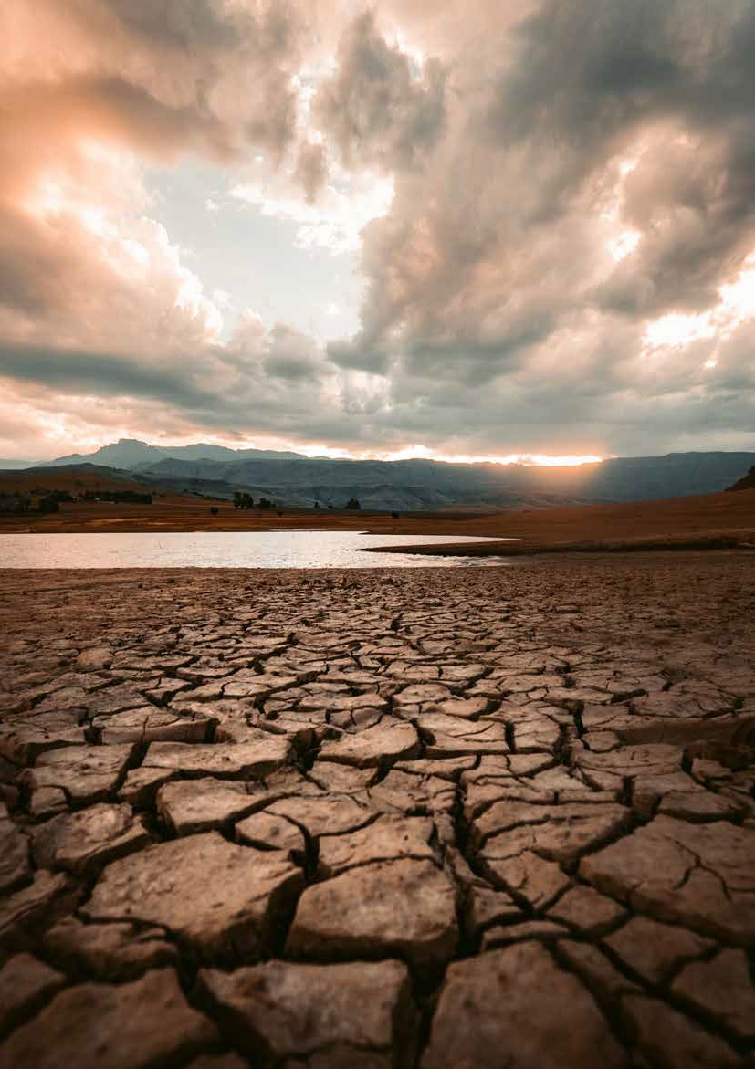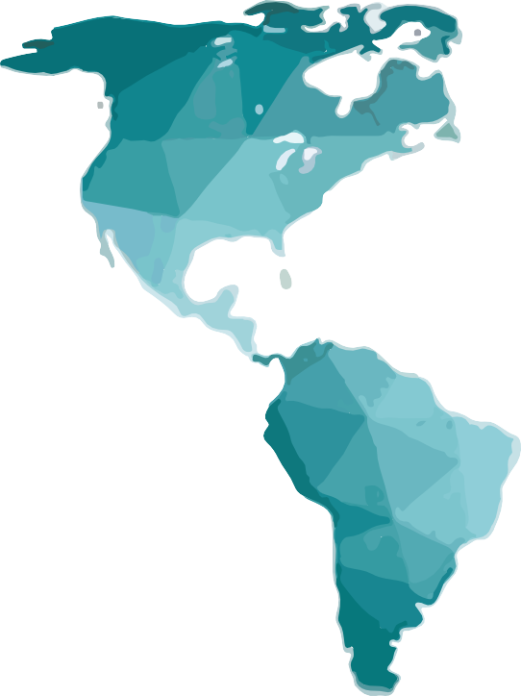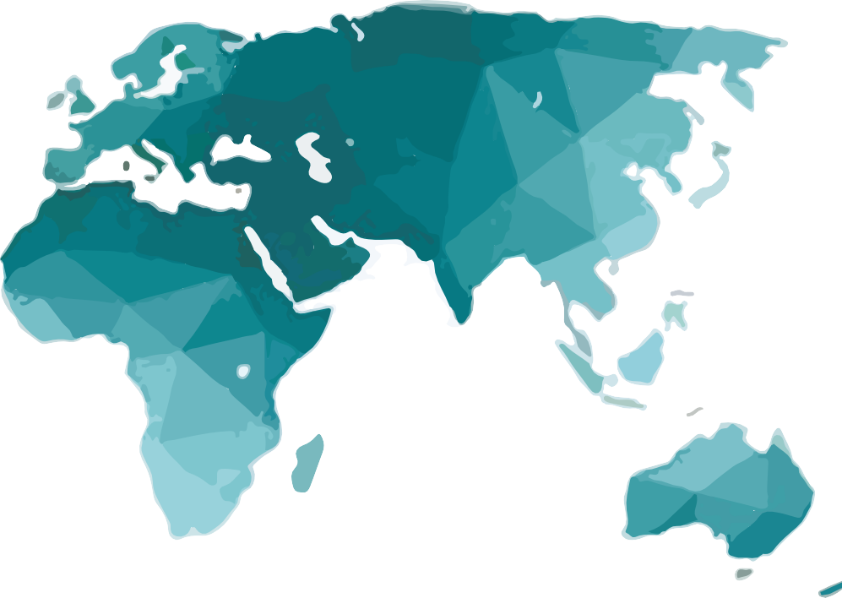
6 7

Poland Hungary
Slovakia
Latvia Estonia
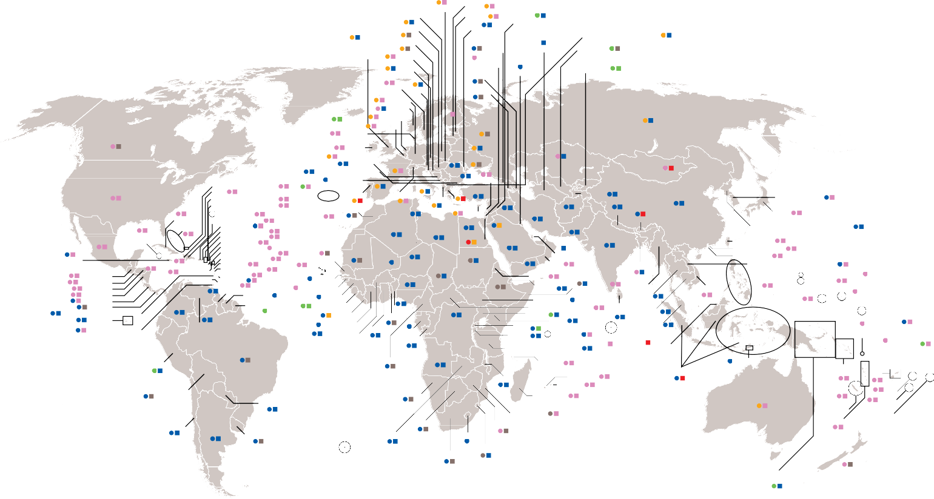Republic of Moldova

Syrian Arab Republic

Republic of North Macedonia

United Kingdom of Great Britain and Northern Ireland (the)
Croatia
Slovenia Czech
Republic
Georgia Palestine
(West Bank)
Azerbaijan
Turkmenistan Uzbekistan

Kuwait Kyrgyzstan

Sweden

Austria

Armenia

Canada

Iceland
Denmark Ireland
Germany Norway Netherlands
Belgium

Finland

Lithuania Belarus

Russian Federation

Luxembourg
Ukraine
Kazakhstan

Bulgaria Bosnia and Herzegovina
Montenegro
France

Romania Serbia

Lebanon
Mongolia

United States of America
Turks and Caicos Islands Haiti
Sint Maarten (Dutch part)
Azores (PRT)

Portugal
Spain

Switzerland
Italy

Albania Greece
Turkey

Tajikistan

China

Republic of Korea

Cayman

Cuba Bahamas
Saint Martin (French Part)
Bermuda (UK) Dominican Republic
Puerto Rico Virgin Island (UK)

Canary Islands (ESP)
Morocco

Algeria
Tunisia

Libya

Cyprus

Egypt

Iraq Jordan

Saudi
Iran, Islamic Republic of
Afghanistan Pakistan

Nepal

Bhutan

Japan

Democratic People's Republic of Korea

Jamaica
Mexico
Islands

Belize
Virgin Island (US)
Anguilla (UK) Saint Barthélemy
Antigua and Barbuda
Guadeloupe (FRA)

Senegal

Mauritania

Mali

Niger
Israel
Arabia

Qatar

India
Taiwan (China) Hong Kong (China) Macao, China

St Kitts and Nevis
Saint Lucia
Dominica
Sudan
Oman
Yemen
Bangladesh
Lao People's Democratic Republic
Marshall

Guatemala El Salvador Honduras
Montserrat Martinique (FRA)
Barbados Grenada
Cabo Verde
Gambia
Guinea-Bissau

Nigeria
Chad
Eritrea Djibouti

Somalia

Myanmar

Viet Nam

Philippines
North Mariana Island Guam (US)
Islands

Nicaragua Costa Rica Panama
St Vincent and the Grenadines Ecuador

Colombia

Venezuela,
Guyana
Suriname French Guiana
Guinea Sierra Leone
Liberia
Côte d’Ivoire

Benin Togo

Democratic
Ethiopia
South Sudan
Central African Republic Uganda
Kenya

Sri Lanka
Thailand
Cambodia Malaysia

Micronesia, Federated States of
Tuvalu

Tokelau (NZL)

Trinidad and Tobago
Bolivarian Republic of
Burkina Faso
Ghana
Gabon Congo
Republic
of the
Rwanda
Burundi
Seychelles

Maldives
Wallis and Futuna (FRA)
American
Samoa (US)

Peru

Brazil

Cameroon
Congo

Angola
Tanzania, United Republic of

Comoros

La Reunion
Brunei
Darussalam

Indonesia

Timor-Leste

Solomon Islands
Kiribati Samoa
Fiji
French Polynesia

Bolivia, Plurinational State of

Paraguay

Namibia
Malawi
Mauritius Madagascar

Australia

New Caledonia

Niue Tonga

Chile

Argentina

Uruguay

Botswana
Zambia Lesotho

South Africa
Mozambique Zimbabwe

Kingdom of Eswatini

Papua New Guinea

Vanuatu

New Zealand
Cook Islands

Top hazard for number of deaths Top hazard for economic losses (Source: CRED)
Flood Extreme


temperature

Wildfire Drought Storm Landslide





Figure 2: Map of deadliest and most costly weather, water and climate related hazards for each country (Source: WMO analysis of 1970-2019 data from the Emergency Events Database of the Centre for Research on the Epidemiology of Disasters, CRED)

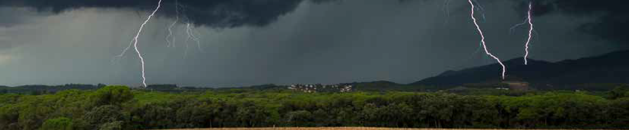Weather, water and climate hazards generate the majority of hazard-related loss and damage, especially in LDCs and SIDS
Trends
Photo: Alejandro Lopez Barajas
What does an end-to-end multi- hazard early warning system (MHEWS) look like?

Between 1970 and 2019, 11 072 disasters have been attributed to weather, climate and water related hazards, involving 2.06 million deaths and US$ 3 640 billion in economic losses. Disasters involving weather, water and climate hazards constitute 79% of disasters, 56% of deaths and 75% of the economic losses involved in all disasters related to natural hazard events reported over the last 50 years (Figure 3).10

While the average number of deaths recorded for each disaster has fallen by a third during this period, the number of recorded disasters has increased five times and the economic losses have increased by a factor of seven. Over the last 10 years (2010-2019), the percentage of disasters associated with weather, climate and water related events increased by 9% compared to the previous decade – and by almost 14% with respect to the decade 1991-200011. This trend is a combination of increased exposure to hazards, an increase in population in exposed areas, changes in hazard frequency and intensity, and improved documentation of the occurrence of hazard events and associated losses.

Since 1970, SIDS have lost US$ 153 billion due to weather, climate and water related hazards – a significant amount given that the average GDP for SIDS is US$ 13.7 billion. Storms were the deadliest and most costly hazard events for SIDS.12
Meanwhile, 70% of deaths reported over the period 1970-2019 occurred in LDCs. Droughts were the deadliest and floods the most costly hazard events in LDCs since 1970.

CATALOGUING OF HAZARDOUS WEATHER, CLIMATE, WATER AND SPACE WEATHER EVENTS
Many countries routinely document losses and damage associated with hazardous events. Hazardous events and their characteristics are often documented in a non-standardized manner, however.

To improve standardization of hazardous event charac- terization, the 18th World Meteorological Congress in 2015 approved the WMO methodology for cataloguing hazardous weather, climate, water, and space weather events. This methodology ensures that each event is recorded with a unique identifier, a standardized event designation, start and end times, spatial extent, and the capability to link events to larger scale phenomena, as well as the linking of cascading events. Currently, 19 WMO Members are using this methodology on a pilot basis. The unique identifier provides a means of linking events with any associated damages and losses.
A people-centred EWS empowers individuals and communities threatened by hazards to act in a timely and appropriate manner to reduce the possibility of personal injury and illness, loss of life and damage to property, assets and the environment. “A Multi-Hazard Early Warning System (MHEWS) addresses several hazards and/or impacts of similar or different types in contexts where hazardous events may occur alone, simultaneously, cascadingly or cumulatively over time, and takes into account the potential interrelated effects. A MHEWS with the ability to warn of one or more hazards increases the efficiency and consistency of warnings through coordinated and compatible mecha- nisms and capacities, involving multiple disciplines for updated and accurate hazard identification and monitoring for multiple hazards”.13

The five components of WMO good practice guidance on MHEWS14 are:

- disaster risk knowledge, including hazard, exposure and vulnerability;
- detection, monitoring and forecasting the hazards;
- warning dissemination and communication;
- preparedness to respond; and
- monitoring/evaluation of the results.

This report focuses on these five components of MHEWS, providing an overview at global and regional levels, including of the status of the observations on which MHEWS depend.

MHEWSs depend on a worldwide network of operational centres run by WMO Members. These centres, at national, regional and global levels, operationally exchange the data and products needed every day to provide the services for applications related to weather, climate, water and environment, including MHEWS. This operational network, called the WMO Global Data Processing and Forecasting System (GDPFS), is composed of global centres,15 Regional Specialized Meteorological Centres,16 nine Regional Climate Centres (and three network RCCs) and National Meteorological and Hydrological

Total = 11 072 disasters Total = 2 064 929 deaths Total = US$ 3640.1 billion
4% 6% 5%
35%
44%
6%
0%
34%
39%
2%
9%
16%
4% 7% 3%
31%
54%
1%
Services (NMHSs) (Figure 4). Specialized regional centres on tropical cyclones forecasting (6), marine meteorological services (24), sand and dust storm forecast (2) and International Civil Aviation Organization (ICAO) volcanic ash advisory centres (9) complement the work of these global and regional centres.

Observations are collected from a multitude of individual surface- and space-based observing systems owned and operated by a plethora of national and international agencies. Through the combination of the Global Observing System and Global Telecommunication System, billions of observations are obtained and exchanged in real time between WMO Members and other partners every single day.

At the national level, NMHSs are using data and products received from the GDPFS and other sources to generate tailored products for policy and decision making at national level. These products are

Number of reported disasters

1970-1979 711

1980-1989 1410

1990-1999 2250

2000-2009 3536

2010-2019 3165
Number of reported deaths

1970-1979 556k

1980-1989 667k

1990-1999 329k

2000-2009 329k

2010-2019 185k
Reported economic losses in US$ billion

1970-1979
175.4

289.3
852.3

942.0

1980-1989

1990-1999

2000-2009

2010-2019 1381
then disseminated to users and stakeholders to ensure people and communities receive warnings in advance of impending hazardous events. Once the warning is issued, it is essential that people under- stand the risks, respect the national warning service and know how to react to the warning messages. Education and preparedness programmes play a key role. It is also essential that disaster manage- ment plans include evacuation strategies that are well practiced and tested. People should be well informed on options for safe behaviour to reduce risks and protect their health, know available evacu- ation routes and safe areas and know how best to avoid damage to and loss of property. The system must also reside in an enabling environment which incorporates good governance, has clearly defined roles and responsibilities for all stakeholders, is adequately resourced and has effective operational plans such as standard operating procedures.

Drought Extreme temperature Flood Landslide Storm Wildfire

Figure 3: Distribution of (a) number of disasters (b) number of deaths, and (c) economic losses by main hazard type and by decade, globally.

  - WMO, Atlas of Mortality and Economic Losses from Weather, Climate and Water Extremes (1970-2019), forthcoming.
  - IFRC, World Disasters Report, expected publication date: October 2020.
  - Including tropical storms, and cyclones (hurricanes, typhoons).

  - United Nations (2016). Report of the Open-ended Intergovernmental Expert Working Group on Indicators and Terminology Related to Disaster Risk Reduction (OIEWG) (A/71/644), adopted by the General Assembly on 2 February 2017 (A/RES/71/276).
  - Multi-hazard Early Warning Systems: A Checklist, WMO, 2018.
  - 13 Global Producing Centres for Long-Range Forecast (GPCLRFs), 4 Global Producing Centres for Annual to Decadal Climate Prediction (ADCP) and three Lead centres and nine World Meteorological Centres.
  - RSMCs includes 12 RSMCs with geographic focus and more than 40 additional centres with thematic focus. More details.

Data and methods
Global Center
Regional Center
Global Observing System

WMO collects data on risk information and EWS implementation based on a framework (Annex, Table 1, page 47) developed by WMO and the United Nations Office for Disaster Risk Reduction (UNDRR) for monitoring implementation of end-to-end, people-centred EWS in the context of the Sendai Framework – Target G.17 While Sendai Framework reporting covers geological, hydrological, meteorological, climatological, extra-terrestrial, biological and technological hazards and environmental degradation, the scope of this current report is restricted to hydro-meteorological hazards only.

NMHS
This report assesses WMO Members’ progress in the implementation of MHEWS, overall and disaggregated into five components, and by the number of people per 100 000 served by EWSs.

Table 1 in the Annex to this report shows the five components of an MHEWS. These five components constitute the value chain of an end-to-end MHEWS. The bottom row of Table 1 contains a set of indicators for calculating the degree to which each component is being imple- mented. Member capacity in each MHEWS component area is calculated as a percentage of indicators in the bottom row of Table 1 satisfied out of the total number of indicators for that component, with the exception of the fourth component, which is the percentage of local governments in the country having a plan to act on early warnings. WMO Members provide data on all of the above indicators through the WMO Country Profile Database.

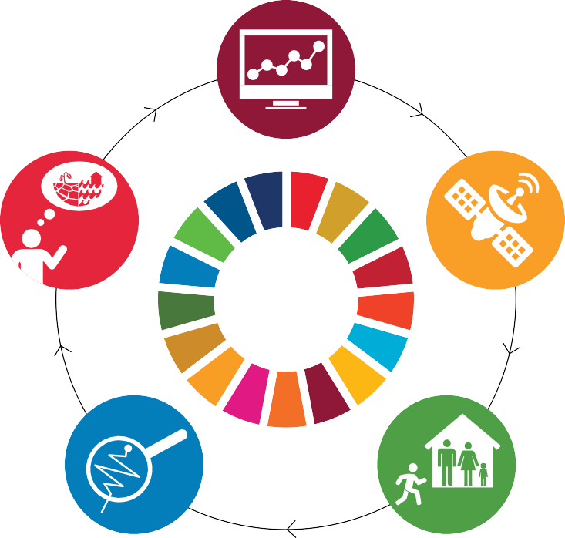Data are currently available for 138 (72%) out of 193 WMO Members including from 74% of the world’s LDCs and 41% of SIDS. In the analysis which follows, missing data is indicated as ‘NA’. Data on the number of people per 100 000 covered by early warning systems are avail- able only for 73 countries. Regional profiles presented in the report reflect the profiles of the countries which have provided data, which is important for the interpretation of the results.
Preparedness at all levels to respond to the warnings received
Monitoring and Evaluation of socio-economic
benefits
Dissemination and communication,
by an official source, of authoritative, timely,
accurate and actionable warnings and associated information on likelihood and impact
OUTCOMES
Disaster risk knowledge based on the systematic collection of data and disaster risk assessments
Detection, monitoring, analysis and forecasting
of the hazards and possible consequences

Missing data is an important consideration for interpreting the graphics on MHEWS imple- mentation and implementation of the individual MHEWS value chain components throughout the report. Readers in particular should focus on two aspects of these graphs:

    - the ratio of yes/no implementation to missing data which provides a metric for gauging what is known (within the limit of data accuracy) and what is not known due to lack of data.
    - the ratio of “yes” implementation to “no” implementation, which provides a metric of the degree of implementation among countries for which data are available. WMO is contin- uing its efforts to improve both data availability and accuracy.

Additional data sources include the Sendai Monitor, the WMO Integrated Global Observing System (WIGOS) Data Quality Monitoring System and WMO Observing Systems Capability Analysis and Review Tool (OSCAR) database.

Case studies provided by report contributors highlight how climate information and early warning contribute to improved socio-economic outcomes. Each case study showcases a real-world EWS that is operational at country or regional level, explaining how the system works and the associated benefits.

Figure 4: Global Data Processing and Forecasting System, composed of a worldwide network of operational centers operated by WMO Members, at global, regional and national levels, and its contribution to the components of the MHEWS value chain.
  - Target (G), one of the seven targets of the Sendai Framework, refers to substantially increasing the availability of and access to multi-hazard early warning systems (MHEWS) and disaster risk information and assessments by 2030. The Sendai Framework indicators and their current methodology is available in theTechnical Guidance Notes (Pages 155-176).

Status: Global
Photo: Yoda Adaman

One third of every 100 000 people is still not covered by early warnings. Early warning is insufficiently translated into early action.

Globally, only 40% of WMO Members report having a MHEWS in place. UNDRR data show that this percentage decreases to 36% when biological, technological hazards and environmental degradation are also taken into consid- eration.18 In the countries providing data, just 6.5 out of 10 people on average are covered by early warnings (Figure 5).19
There are many successful cases of EWS used across various hazards and regions, as the case studies in this report show. Shortcomings persist, however, especially when it comes to the elements further along the EWS components value chain, with lower capacity for good communications, preparedness and response and monitoring and evaluation (Figure 6). To cite some statistics illustrative of the various components of the EWS value chain:
113 Members participate in the World Weather Informa- tion Service20 of WMO, a platform for sharing authoritative forecasts from Members. Out of those 113, 72 Members participate in regional warning platforms in Asia and Europe. Only 61 Members implement quality management

warnings, to better understand and anticipate the likely human and economic impacts due to severe weather. There have been notable improvements in communicating potential impacts as a result. Only 75 WMO Members (39%) indicated that they provide IBF services, however. And only 12 Members reported to have conducted socio-economic benefit studies in the past 10 years and provided valid refer- ences to such studies.

65 000 in 100 000 people are covered by early warnings

32%
40%

MHEWS

28%
Yes No NA

100
90
80
70
60
50
40
30
20
10
0

55%

45%

54%

46%

61%

39%

56%

44%

55%
74%
90%

45%
26%
10%

WHAT IS THE COMMON ALERTING PROTOCOL (CAP)?
The CAP is an international standard format for emergency alerting and public warning. It is designed for ‘all-hazards’ and for ‘all media’ (sirens, cell phones, faxes, radio, television, various digital communication networks based on the Internet, etc.). With CAP-based alerting, an alert sender activates multiple warning systems with a single trigger, reducing cost and complexity.22

THE SUB-SEASONAL TO SEASONAL (S2S) PREDICTION PROJECT IS BRIDGING THE GAP BETWEEN WEATHER AND CLIMATE
Many management decisions in disaster risk reduction, agriculture, water and health fall into the S2S time range. This time scale has long been considered a “predictability desert,” however, and

systems for the provision of meteorological, hydrological
and climate warning services, mainly in Europe.
84% of Members provide forecasting and warning services for flood and drought. 64 Members are covered by WMO Flash Flood Guidance System (FFGS). Currently the system benefits about 3 billion people around the world by providing operational forecasters and disaster management agencies with real-time informational guidance products pertaining to the threat of small-scale flash flooding.
Only 49% of WMO Members provide products and services (through TV, SMS, web app, etc.) – and of these, only 24%
Figure 5: Members that reported having a MHEWS in place, as a percentage of 193 WMO Members.

100
 | 38% |  | 37% |  | 51% |  | 55% |  | 52%
 | 38% |  | 11%
 | 9% |  | 11% |  | 51% |  | 55% |  | 52%
 | 52% |  | 52% |  | 49% |  | 55% |  | 14%
 |  |  |  |  |  |  | 13% |  | 14%
 |  |  |  |  |  |  | 32% |  | 35%

90
80
70
60
50
Yes NA

Figure 7: Percentage of WMO Members that report using the indicated communications channels for disseminating EW-related products and services (across 193 WMO Members).

24%
Yes No
forecasting for this range has received much less attention than medium-range and seasonal prediction. The WMO S2S project brings the weather and climate communities together to tackle the challenge of forecasting the S2S timescale and harnessing the shared and complementary forecasting experience and expertise of these communities. This is helping
to create more seamless weather/climate prediction systems and more integrated weather and climate EW services.

use the Common Alerting Protocol (CAP) for disseminating 40
warnings (Figures 7 and 8). Only 26% of LDCs and 38% of
SIDS use web applications and/or social media. 30
20
67% of Members have an established DRR governance mechanism and 66% of NMHSs are part of those mecha- 10
24%
52%
NA

nisms. Just 32% of local governments have a plan to act on 0
early warnings, however.
It is becoming urgent for more countries to make the transi- tion from focusing only on the accuracy of hazard-based forecasting to also identifying the potential impacts as part of a forecast. Impact-based Forecasting21 (IBF) is an evolu- tion from communicating “what the weather will be” to

Yes

No NA
Figure 8: Warnings delivered using the Common Alerting Protocol (CAP) format, as a percentage of 193 WMO Members.

“what the weather will do”, to more effectively trigger early action based on the warnings. Through IBF, some NMHSs are going beyond producing accurate forecasts and timely
Figure 6: WMO Member capacities across the MHEWS value chain globally, by component, calculated as a percentage of functions satisfied in each component area, across 193 WMO Members.

- UNDRR analysis based on Sendai Framework Monitor data as of April 2020.
- According to 73 WMO Members that provided data.
- worldweather.wmo.int
- WMO Guidelines on Multi-hazard Impact-based Forecast and Warning Services (2015, WMO-No. 1150). Harrowsmith, M., et al. 2020. The Future of Forecas-

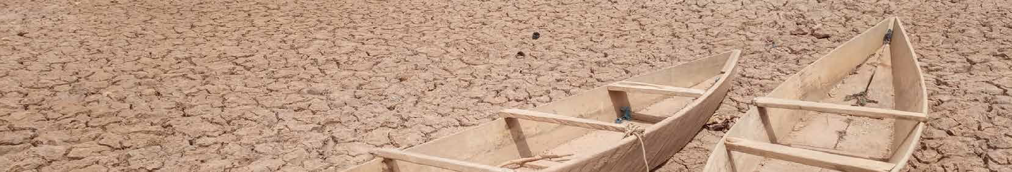ting: Impact based Forecasting for Early Action Guide. Red Cross Red Crescent Climate Centre – UK Met Office.

14
- www.wmo.int

15

Status: Global

REGIONAL OVERVIEWS IN RELATION TO THE GLOBAL AVERAGE

Africa and South America23 are the regions with the weakest MHEWS capacities, especially with regards to the number of Members with a MHEWS in place (Figures 9 and 10) – and specifically when it comes to warning dissemination and communication (Africa) and preparedness and response capacities (South America) (Figure 11).

LDCs have the lowest percentage of people covered by early warnings (Figure 10). As most LDCs are in Africa, that region has the lowest number of people covered by warnings, with 6 out of 10 people not covered (Figure 10). The use of CAP for warning dissemination is also the lowest in Africa as compared to other regions. Africa also lags behind other regions in the area of monitoring and evaluation of EWS-related outcomes and benefits. LDCs, especially in Africa and SIDS, stand out for their weak early warning capacities, particularly when it comes to warning dissemination and communication (Figure 11).

AFRICA
17%
30%
53%

Yes No NA
Capacities in the South West Pacific, which includes many SIDS, are higher than the global average in all MHEWS component areas in countries where data are available. LDC SIDS are signif- icantly under reported, however. Further work is needed to improve countries’ reporting on climate information and EWS capacity, especially from SIDS, to obtain a complete picture.

Global Africa Asia
74%
59%
36%
75%
MHEWS
63%
87%
38%
South America
North America, Central America and Caribbean
South West Pacific Europe
Figure 9: Percentage of Members that reported having a MHEWS in place, by region.

N. AMERICA & CARIBBEAN
32%
59%
9%
Yes No NA
0

Disaster risk Knowledge

Detection, monitoring, analysis and forecasting

Warning dissemination and Communication
10 20
30 40
50 60
70 80
90 100

Yes No NA
25%
33%
42%
35%
44%
21%

Yes No NA

ASIA



SOUTH AMERICA



Yes No NA

Yes No NA
32%
50%
18%
45%
41%
14%

- Low % MHEWS
in Africa, South America and LDCs

- Low EWS
coverage in Africa, LDCs

SW PACIFIC


EUROPE
Preparedness and response

Monitoring and
evaluation

Global
28%
23%
49%
Africa
Asia
South America
North America, Central America and Caribbean

SIDS
26%
59%
16%
LDCS
South West Pacific Europe
SIDS
LDCS

Yes No NA


Yes No NA
Figure 11: Percentage of functions comprising each component of the MHEWS value chain in place per region and for LDCs and SIDS for all countries for which data are available.

Figure 10: Overview of percentage of WMO Members with MHEWS and coverage (by 100.000 people) per region and for LDCs and SIDS.

- WMO Members.


Status: Global

OBSERVATIONS AS A FUNDAMENTAL PRE-REQUISITE FOR RISK INFORMATION AND EWS

All weather and climate services rely on data from system- atic observations. Such observations are fundamental to understand the current state of the global to local weather and climate, as well as expected future changes. Observa- tion systems must be reliable and accurate and sustained on a long-term basis, therefore, as recognized in Articles 4 and 5 of the United Nations Framework Convention on Climate Change.24 The monitoring of Essential Climate Variables25 in the atmosphere, in oceans and on land is key to understanding climatic changes and related risks and challenges in the long term. A subset of the comprehensive surface and upper-air network stations that monitor atmos- pheric parameters used for weather forecasting serve as climate monitoring stations as well.
Despite their fundamental importance, observing networks are often inadequate. Data26 on surface reporting show clear geographical gaps in Africa, the South-West Pacific, South America and Antarctica (Figure 12). For upper-air stations, proportionally even fewer stations are reporting.

In 2019, WMO Members adopted the concept for a Global Basic Observing Network (GBON) which defines the obliga- tion of WMO Members to implement a minimal set of surface-based and upper-air observing stations. GBON, and a systematic observation financing facility under development by WMO and partners, are intended to help Members address existing gaps in observing systems which will contribute to improved EWS.

% 100
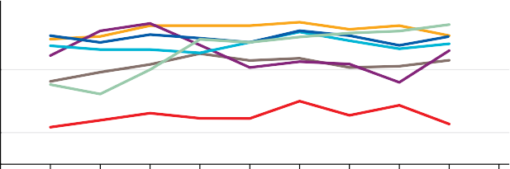80

60
40
20
0
2010 2011 2012 2013 2014 2015 2016 2017 2018 2019 2020

Africa Asia South America South West Pacific North America, Central America and Caribbean Europe Antarctic Observing Network (ANTON)
Figure 13: Percentage of dedicated surface stations reporting according to GSN requirements for the different WMO regions (2011-2019).

% 120
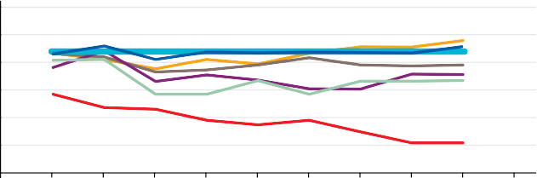
100
80
60
40
20
0
2010 2011 2012 2013 2014 2015 2016 2017 2018 2019 2020

Africa Asia South America South West Pacific North America, Central America and Caribbean Europe Antarctic Observing Network (ANTON)
Figure 14: Percentage of dedicated upper-air stations reporting according to GRUAN requirements for the different WMO regions (2011-2019).

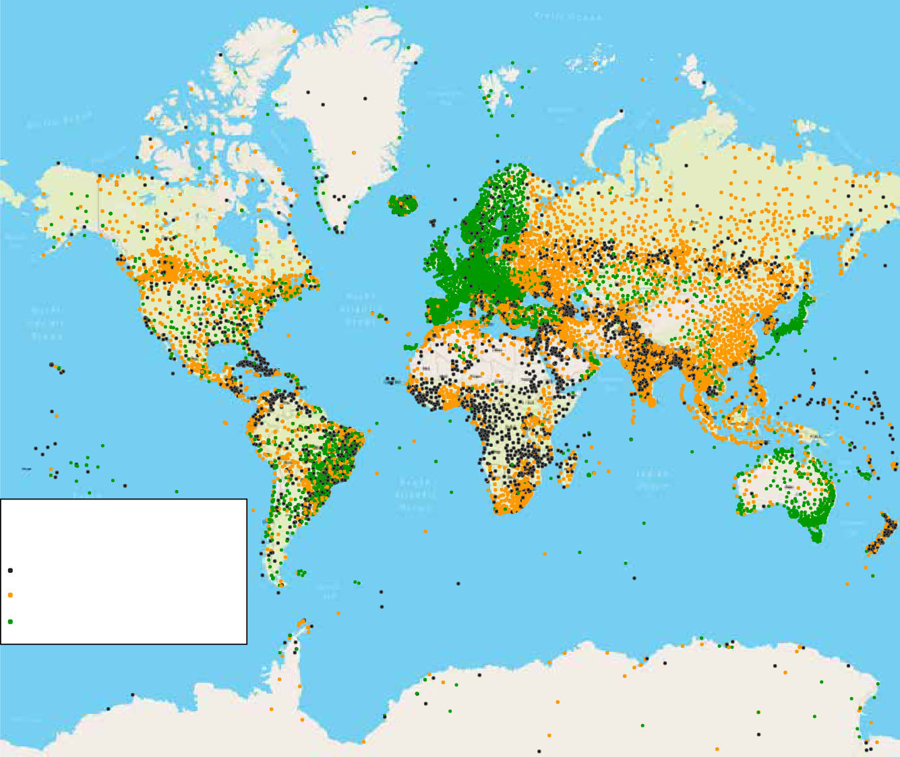The monitoring of the Global Climate Observing System (GCOS) Surface Network (GSN) shows, in general, a similar status to that of the more extensive GBON network. In 2019, just 26% of African GCOS GSN stations reported according to the agreed requirements, a trend which has not changed since 2011 (Figure 13). In 2019, African GCOS surface network stations show the lowest performance, with 35% of the stations non-operational.
Received surface observations 01-06/2019
Silent: no message Availabillity issues: < 80% Normal: ≥ 80%

For upper-air observations, the GCOS Upper-Air Network (GUAN) provides a baseline for monitoring the climate. While the numbers remain relatively stable for all other regions, the number of fully reporting African stations (red) decreased from 57% in 2011 to 22% in 2019 (Figure 14). This very poor, and not improving, performance is mainly associ- ated with the necessary funding required to operate and maintain an upper-air station. On a technical level, commu- nication with the station to establish the cause of the poor performance continues to be a challenge and often means that relatively simple issues for which technical solutions are readily available can go unaddressed for long periods.


Observations of the oceans are not only key to under- standing processes within the oceans, but also for predicting the weather and climate globally, given, the oceans’ role in absorbing heat and modulating process for weather and climate prediction. The Global Ocean Observing System (GOOS) includes a large diversity of 800027 mobile, fixed and ship-based observing platforms. Among these multi- disciplinary networks, the atmospheric pressure is only measured by 25% of the system. The ship-based radio- sonde programme is unfortunately marginal today and limited to the northern hemisphere with only a few ships reporting.
The ocean subsurface is well sampled with the global array of 4,000 profiling floats, now expanding in depth and the number of biogeochemical variables covered. Ships repeated lines, moored buoys, and even animal-borne sensors complement this subsurface observing system. Large regional gaps are persistent in the high latitudes for all variables and systems. Overall GOOS is supported by 85 Members, but 90% of the system is supported by only eight Members.

Observations of freshwater are crucial in many ways for climate services and early warning, since water is the basis for almost all aspects of society, economy and ecosystems. Despite this importance, the exchange of hydrological data for rivers, lakes, groundwater, soil moisture and other relevant hydrological components is particularly weak in developing countries. 66% of hydrological observing networks in the developing world are in a poor or declining state and only 9% of the networks are considered to be ‘adequate’.28

For the cryosphere, some parameters, such as global observations, are currently improved and the network of the WMO Global Cryosphere Watch (GCW) is in a devel- oping phase. Increases in data availability can be seen for snow depth data globally, as more data providers make their data available under the GCW framework. More data exists but is currently not accessible due to restrictive data policies of individual countries. Significant gaps between data collection and sharing also exist for sea ice observa- tions and efforts are underway through GBON to tackle this issue.

Figure 12: Reporting surface stations against the WIGOS baseline for January to June 2019. Black dots show stations that do not report at all, orange dots indicate stations with reporting < 80%, green dots indicate compliance with the baseline (≥ 80%.).

- UNFCC.
- Essential Climate Variables.
- WMO Integrated Global Observing System (WIGOS) Data Quality Monitoring System (WDQMS) accessed on 11 June 2020.

- JCOMMOPS database.
- World Bank: Assessment of the State of Hydrological Services in Developing Countries, 2018.

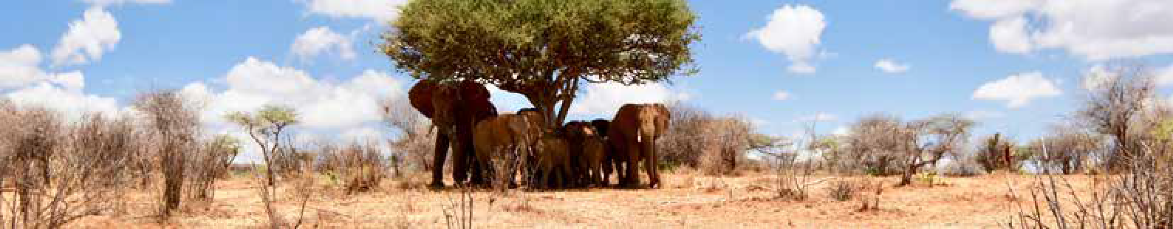Status: Global

Status: Africa
Photo: Robert Marchant

THE MOST VULNERABLE ARE THE HARDEST HIT – COVID-19 IMPACTS

Large parts of the observing system, such as its satellite components and many ground-based observing networks, are either partly or fully automated. Automated systems are expected to continue functioning without significant degra- dation for periods from up to several weeks to much longer. But as the COVID-19 pandemic persists, missing repair, maintenance and supply work, and missing redeploy- ments, will become of increasing concern for some of these systems.

Some parts of the observing system are already affected. Most notably the significant decrease in air traffic has had a clear impact.29 Aircraft-based observations and measure- ments of ambient temperature and wind speed and direc- tion are a very important source of information for both weather prediction and climate monitoring. Meteorological measurements taken from aircraft have plummeted by an average 75-80% compared to normal, but with very large regional variations; in the southern hemisphere the loss is closer to 90%.
Surface-based weather observations are in decline, especially in Africa and parts of Central and South America where many stations are manual rather than automatic (Figure 15).30 Africa and South America are also the regions that face the largest EWS capacity gaps generally.

The ocean observing system has been severely affected by the pandemic, in ways not seen before.31 COVID-19 restrictions meant that 90% of the normal flow of data from commercial ships has stopped. It is estimated that 30-50% of moorings will be negatively affected by the pandemic, and some have already ceased to send data, according to GOOS data.

The most vulnerable countries are paying the highest price. As WMO Secretary-General, Professor Petteri Taalas said in May 2020, “the impacts of climate change and the growing amount of weather-related disasters continue. The COVID-19 pandemic poses an additional challenge and may exacerbate multi-hazard risks at a single country level. Therefore, it is essential that governments pay attention to their national early warning and weather observing capaci- ties despite the COVID-19 crisis”.
Over the past 50 years, drought has accounted for 95% of hydro-met hazard-related deaths across Africa. Between 1970 and 2019, 1,692 reported disasters in Africa resulted in the loss of 731,724 lives and economic damage of US$ 38 billion.32 Although disasters in connection with floods were the most prevalent (60%), drought has led to the highest number of deaths, accounting for around 95% of all lives lost to weather, climate and water-related disasters in the region. Severe droughts in Ethiopia in 1973 and 1983, in Mozambique in 1981, and Sudan in 1983 was associated with the majority of deaths. Storms and floods, however, led to the highest economic losses (71% of the total economic losses recorded in 1970-2019). A signifi- cant increase of 52% in economic losses was recorded during the last decade 2010-2019, compared to the period 1970-2009, mainly due to floods, drought and storms.

Over the last 50 years, 35% of deaths related to weather, climate and water extremes occurred in Africa, while the region accounts for just 1% of global disaster-related economic losses.

Overview of EWS capacities
Based on data from 46 countries (87% of the region), Africa faces numerous capacity gaps. The data cover 88% and 86% of LDCs and SIDS in the region, respectively. Just 30% of Members reported having a MHEWS in place and 44 000 in 100 000 people are covered by early warnings in countries where data are available (Figure 16). While capacity is good in terms of risk knowledge and forecasting, the rate of MHEWS implementation overall is lower than in other regions. Preparedness, and monitoring of benefits are particularly weak (Figure 17). Only 11% of Members in Africa are using the Common Alerting Protocol (CAP).

Early warnings have to bridge the last mile gap to reach the most in need. While capacities in disaster risk knowledge and forecasting are relatively well advanced in Africa, there is a need to make this information actionable and acces- sible. The data point to the need to strengthen MHEWSs in the region in order to better link information to action.
Given the increasingly complex nature of risk and impacts, there remains substantial scope for improvement, even in the disaster risk knowledge component. The changing dynamics of hazards, vulnerability and exposure dictate the need for a new way to conceptualize risk: as systemic, or emergent from complex and non-predictable interactions between human and non-human systems. Sub-Saharan Africa in particular faces a complex and evolving disaster risk profile in which efforts at disaster risk reduction (DRR) occur in a challenging context of persistent technical and financial capacity constraints.33

44 000 in 100 000 people are covered by early warnings
17%
30%
MHEWS
53%

Yes No NA

Figure 16: Members that reported having a MHEWS in place, as a percentage of the total number of WMO Members in the region (53).

100
 | 25% |  | 27% |  | 60% |  | 45% |  | 44%
 | 18% |  | 17%
 | 57% |  | 56% |  | 60% |  | 25% |  | 23%
 | 57% |  | 56% |  | 40% |  | 25% |  | 23%
 |  |  |  |  |  |  |  |  | 33%
 | 57% |  | 56% |  | 40% |  | 30% |  | 33%

90
80
70
60
50
40
30
20
10
0

Yes No NA

Figure 17: EWS capacities in Africa, by value chain component, calculated as a percentage of functions satisfied in each component area, across 53 WMO Members in the region.

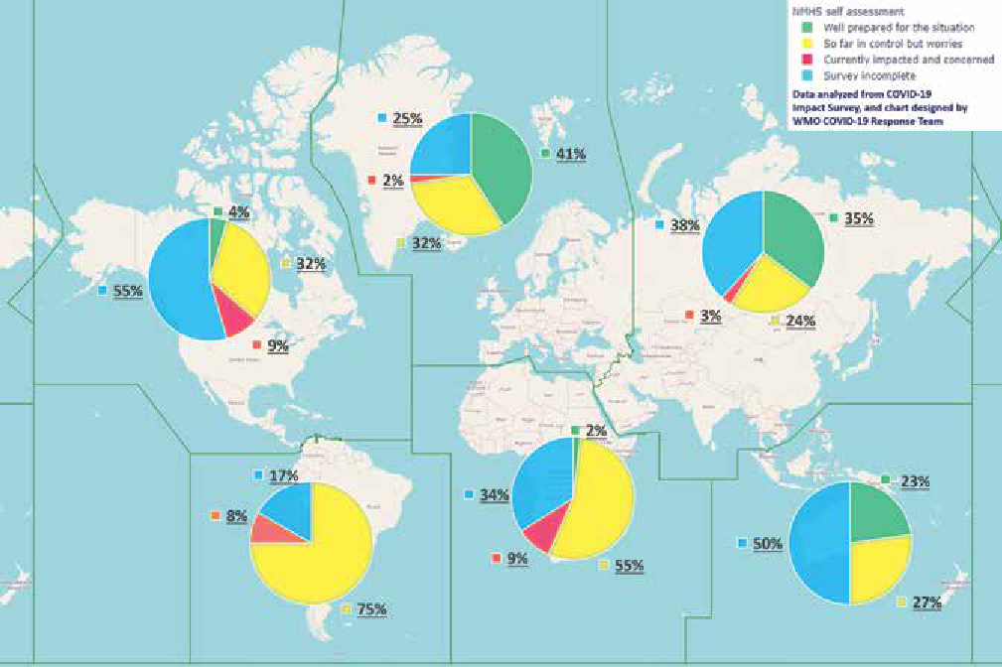Figure 15: Results of WMO survey on potential impacts of COVID-19 on NMHS’ operations (as of 15 June 2020).
Europe
North America, Central America and Caribbean
Asia
Africa
South America
South West Pacific
NHMS self assessment
Well prepared for the situation So far in control but worries
Currently impacted and concerned Survey incomplete
Data analyzed from COVID-19 Impact Survey, and chart designed by WMO COVID-19 Response Team

- The AMDAR Observing System.
- public.wmo.int
- COVID-19’s impact on the ocean observing system and our ability to forecast weather and predict climate change, The Global Ocean Observing System (GOOS) Briefing note, 2020.

- WMO, Atlas of Mortality and Economic Losses from Weather, Climate and Water Extremes (1970-2019), forthcoming.
- UNDRR (2020). Highlights: Africa Regional Assessment Report 2020 (forthcoming). Nairobi, Kenya. United Nations Office for Disaster Risk Reduction (UNDRR).

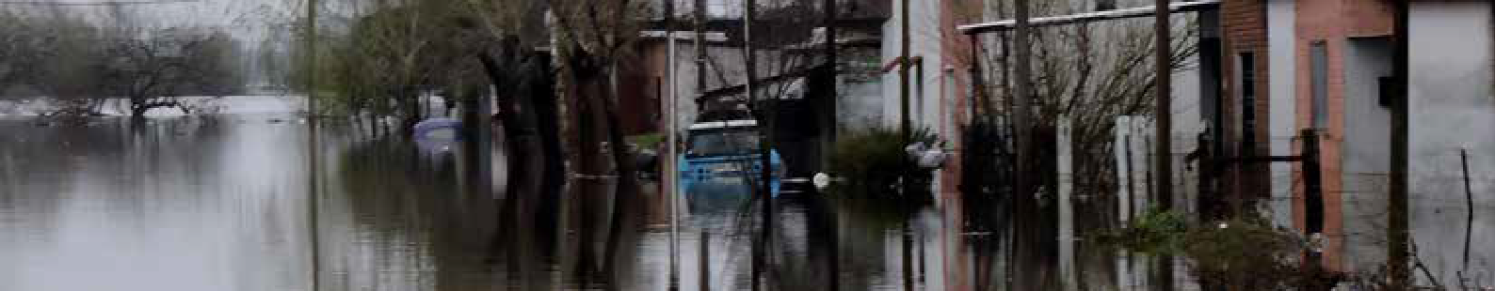Asia is one of the regions most exposed and vulnerable to hydro-meteorological hazards, with the highest number of hazardous events and deaths compared to other regions. In Asia, 3,456 disasters were reported for the 1970-2019 period, leading to a loss of 975 778 lives and economic damage of US$ 1 204 billion.34 Most of these disasters were associated with floods (45%) and storms (36%). Storms had the highest impact on life, accounting for 72% of the lives lost, while floods accounted for the greatest economic loss (57%). The top 10 reported disasters account for 70% (680 837) of the total lives lost and 22% (US$ 267 billion) of economic losses for the region.
Status: Asia
Status: South America

When viewed by decade, there is a rise in the number of reported disasters attributed to weather, climate and water related hazards. In contrast, deaths have, on average, decreased decade by decade, while economic losses have substantially increased over the period.

Economic losses as a result of extreme weather events have substantially increased in Asia in the last 50 years.

Overview of EWS capacities
Based on data from 19 countries (56% of the region), Asia is well placed to respond to extreme weather events and is among the regions with greatest EWS capacity. The data cover 38% and 50% of LDCs and SIDS in the region, respec-
70 000 in 100 000 people are covered by early warnings

Photo: Amir Jina
Photo: Ana Figari

Yes No NA
35%
44%
MHEWS
21%

Figure 18: Members that reported having a MHEWS in place, as a percentage of the total number of WMO Members in the region (34).

100
49%
48%

4%

28%

31%
8%

44%

46%

47%
7%

61%
1%
71%

56%
90
80
70
60
50
40
30
20
10
0
During the 50-year period from 1970-2019, South America experienced 875 reported disasters that resulted in 57,909 lives lost, with a 5% increase in the latter in the last five years. Meanwhile, US$ 103 billion in economic losses were recorded, which represents a 30% increase over the last five years.35 Floods led to the majority of the disasters (59%), deaths (77%) and economic losses (58%). Floods and landslides together account for 73% of recorded disasters, as well as 93% of deaths and 63% of the economic losses.

Floods account for 77% of deaths associated with
weather, climate and water extremes in South America.

Overview of EWS capacities
Alongside Africa, according to the available data, South America also experiences considerable EWS challenges. Data is available from nine countries, representing 75% of the region. The percentage of countries with a MHEWS in place is low (Figure 20), and well below the global average. 60 000 in 100 000 people are covered by early warnings in countries where data are available. Preparedness and response capacities, in particular, as well as monitoring and evaluation of EW benefits require attention (Figure 21). In a WMO-led workshop on IBF in 2018, more effective multidis- ciplinary exchanges among the producers and users and better communication with the media and the public were identified as gaps.36
60 000 in 100 000 people are covered by early warnings

Yes No NA
25%
33%
MHEWS
42%

Figure 20: Members that reported having a MHEWS in place, as a percentage of the total number of WMO Members in the region (12).

100
 | 36% |  | 33% |  | 42% |  | 50% |  | 52%
 | 36% |  | 10%
 | 8%
 | 56% |  | 56% |  | 58%
 | 56% |  | 56% |  | 58% |  | 29% |  | 17%
 | 56% |  | 56% |  | 58% |  | 29% |  | 32%
 | 56% |  | 56% |  | 58% |  | 21% |  | 32%

90
80
70
60
50
40
30
20
10
0

tively. 35% of Members in Asia reported having a MHEWS in place and 70 000 in 100 000 people are covered by
Yes
No NA

Only 17% of countries are using the CAP to disseminate
Yes
No NA

early warnings (across Member countries providing data) (Figure 18).

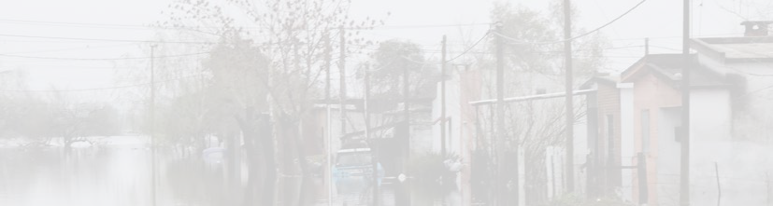Asia is particularly advanced in terms of understanding risks, forecasting and being prepared to respond, with capacities exceeding the global average. Capacities in preparedness and response in particular are much higher than the global average (see Figure 11).

In terms of the implementation of the components of the EWS value chain within the region, monitoring and evalu- ation is the component area with the lowest percentage of implementation among Members for which data are avail- able (Figure 19). 21% of Members reported using CAP for warning dissemination.
Figure 19: EWS capacities in Asia, by value chain component, calculated as a percentage of functions satisfied in each component area, across 34 WMO Members in the region.
warnings.
Figure 21: EWS capacities in South America, by value chain component, calculated as a percentage of functions satisfied in each component area, across 12 WMO Members in the region.

- WMO, Atlas of Mortality and Economic Losses from Weather, Climate and Water Extremes (1970-2019), forthcoming.
- WMO, Atlas of Mortality and Economic Losses from Weather, Climate and Water Extremes (1970-2019), forthcoming.
- WMO RA III Capacity Building Workshop on Impact-based forecast and Warning Services (IBFWS) and on the Common Alerting Protocol (CAP), WMO, 2018.

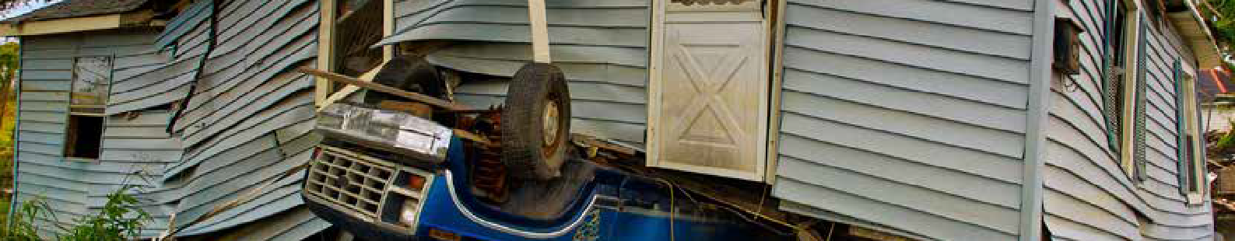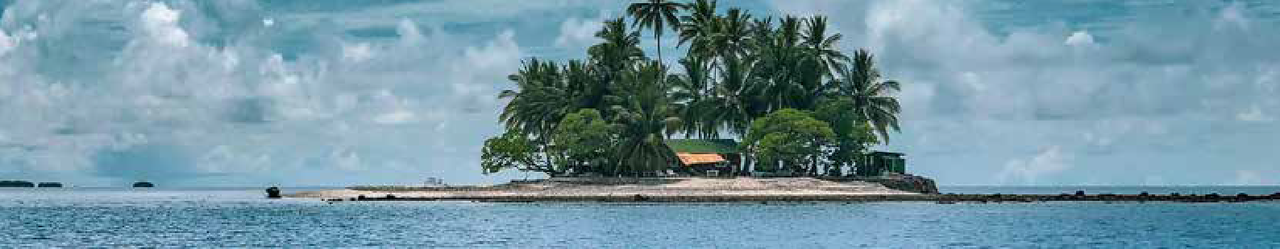In North America, Central America and the Caribbean, from 1970 – 2019, 1,974 reported disasters led to the loss of 74 833 lives and economic damage of at least US$ 1 655 billion.37 The majority of the reported hydro-me- teorological and climate-related disasters in the region were attributed to storms (54%) and floods (31%). Disasters due to storms were reported to be the greatest source of lives lost (71%) and of economic loss (78%). The most signif- icant events in terms of lives lost were Hurricane Mitch in 1998 (17,932), which affected Honduras and Nicaragua, and Hurricane Fifi in 1974 (8 000), which affected Honduras. In terms of economic losses, however, it was Hurricane Katrina in 2005, which led to US$ 164 billion in losses and was the most costly disaster on record.
Status: North America, Central America and the Caribbean
Status: South-West Pacific

The United States of America accounts for a third of all economic losses worldwide (38%) associated with weather, climate and water hazards.

Overview of EWS capacities
Data from 15 countries (68% of the region) show that the region has a relatively strong level of capacity for EWS. The data cover 34% of SIDS in the region. The percentage of countries with a MHEWS in the region is high (Figure 22) and, exceeds the global average. The available data show

96 000 in 100 000 people are covered by early warnings
Photo: Marek Okon

Yes No NA
32%
MHEWS
59%
9%

Figure 22: Members that reported having a MHEWS in place, as a percentage of the total number of WMO Members in the region (22).

100
59%

58%

34%
7%

41%

46%
8%

58%
6%
8%

45%

59%

34%

36%
90
80
70
60
50
40
30
20
10
0

The South-West Pacific region experienced 1 402 reported disasters between 1970 and 2019, resulting in 65 380 lives lost and US$ 163 billion in economic loss. The majority of these disasters were associated with storms (45%) and floods (39%).38 Storm-related disasters are the greatest source of lives lost (71%). Economic losses were more evenly distributed amongst four hazard types: storms (46%), drought (16%), wildfire (13%) and floods (24%). The 1981 drought in Australia led to US$ 17 billion in economic losses and the 1997 wildfires in Indonesia resulted in nearly US$ 13 billion in losses.
Photo: John Middelkoop

Three quarters of all deaths in the South-West Pacific attributed to weather, climate and water related hazards from 1970-2019 occurred in the Philippines.

Overview of EWS capacities
According to data from 13 countries (59% of the region), 41% of WMO Members reported having a MHEWS in place and 73 000 in 100 000 people are covered by early warnings in the countries for which data are available (Figure 24). The region is especially strong in warning dissemination and communication (Figure 25). Nevertheless, only 18% of Members are using CAP for warning dissemination.

73 000 in 100 000 people are covered by early warnings

Yes No NA
41%
45%
MHEWS
14%

Figure 24: Members that reported having a MHEWS in place, as a percentage of the total number of WMO Members in the region (22).

100
48%

29%

37%
7%
7%

45%

49%
6%
6%

59%

55%

64%

45%
90
80
70
60
50
40
30
20
10
0

that 96 000 in 100 000 people are covered by early warnings.
Yes
No NA
The regional overview is not fully representative of SIDS’
Yes
No NA

Advances and successes achieved in implementing MHEWS in the region can be shared and replicated within the region and in other regions lagging in terms of capacity.


The region stands out also for its preparedness and response and monitoring and evaluation capacities (Figure 23) which exceed the global average (see Figure 11). 23% of Members are using CAP for warning dissemination.
Figure 23: EWS capacities in North America, Central America and the Caribbean, by value chain component, calculated as a percentage of functions satisfied in each component area, across 22 WMO Members in the region.
capacities given the lack of SIDS data. 39% of Pacific SIDS provided the data for the analysis and 60% of Pacific LDCs. More data from Pacific SIDS are needed in order to have a full picture of the capacity of EWS within the region.
Figure 25: EWS capacities in South-West Pacific, by value chain component, calculated as a percentage of functions satisfied in each component area, across 22 WMO Members in the region.

- WMO, Atlas of Mortality and Economic Losses from Weather, Climate and Water Extremes (1970-2019), forthcoming. 38 WMO, Atlas of Mortality and Economic Losses from Weather, Climate and Water Extremes (1970-2019), forthcoming.

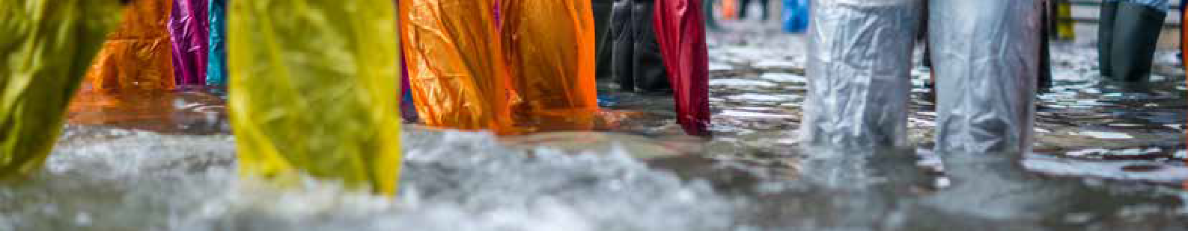In Europe, from 1970-2019, 1,673 reported disasters led to 159,305 deaths and economic loss of US$ 477 billion.39 Although floods (38%) and storms (32%) were the most reported cause of disasters, extreme temperatures led to the highest proportion of deaths (93%), with 148,109 lives
Status: Europe
Status: SIDS
32%
MHEWS
50%
18%
75 000 in 100 000 people are covered by early warnings
SIDS lost US$ 153 billion due to weather, climate and water related hazards since 1970 – a very significant amount given that the average GDP for SIDS is US$ 13.7 billion. However, in seven countries (13%) the GDP is higher than the number reported above, whereas in 81% of SIDS the GDP is lower than US$ 13.7 billion, and in 54% it is lower than US$ 1 billion.40 Storms41 were the deadliest and most costly hazard event for SIDS (Figure 28).

lost during the period during disasters involving this hazard.

Almost 90% of extreme weather, climate and water related deaths in Europe from 1970-2019 were in connection with heatwaves.

Overview of EWS capacities
The data from 36 countries (72% of the region) shows that European nations have above average capacity to deliver

Yes No NA

Figure 26: Members that reported having a MHEWS in place, as a percentage of the total number of WMO Members in the region (50).

100
 | 42% |  | 38% |  | 42% |  | 42% |  | 54%
 | 42% |  | 11%
 | 7% |  | 11% |  | 58% |  | 9% |  | 54%
 | 7% |  | 52%
 | 51% |  | 52% |  | 58% |  | 49% |  | 54%
 |  |  |  |  |  |  |  |  | 13%
 |  |  |  |  |  |  |  |  | 33%

90
80
70
60
50
1970-1979 |  | 58 |  |  | 1970-1979 |  |  |  | 2059 | 1970-1979
1980-1989 |  |  |  | 148 | 1980-1989 |  |  |  | 1825 | 1980-1989

Total = 801 disasters

1%
7%
0%
27%
62%
3%
Number of reported disasters by decade by hazard type

Total = 16 707 deaths
0%
33%
63%
4%
0%
0%
Number of reported deaths by decade by hazard type
Total = US$ 153.9 billion

1%
97%
0%
2% 0%
0%

Reported economic losses by decade by hazard type in USD billion

on all of their EWS needs, especially with regards to the 40
number of MHEWS, and communication and warning
dissemination capacities . 50% of Members reported having 30
a MHEWS in place and 75 000 in 100 000 of the popula- 20
tion are covered by early warnings in countries where data
are available (Figure 26). Moreover, 44% of countries are 10
1990-1999

2000-2009

2010-2019
157

201

237
1990-1999

2000-2009
2577
1961

2010-2019

8285
1990-1999

2000-2009
3.8

8.3
22.3

25.3

2010-2019

94.3

using the Common Alerting Protocol (CAP). Across the 0
components of the EWS value chain, as in other regions, monitoring and evaluation of socio-economic benefits remains a weak area (Figure 27).
Drought Extreme temperature Flood Landslide Storm Wildfire

Figure 28: Distribution of (a) number of disasters (b) number of deaths, and (c) economic losses by main hazard type and by decade for SIDS.

Yes
79,000 in 100,000 people are covered by early warnings

No NA

Overview of EWS capacities
Data for this region are available for 24 Members (41% of

79 000 in 100 000 people are covered by early warnings

Figure 27: EWS capacities in Europe, by value chain component, calculated as a percentage of functions satisfied in each component area, across 50 WMO Members in the region.
SIDS), including countries with advanced as well as less advanced early warning system capacities. 26% of SIDS have a MHEWS in place and 79 000 in 100 000 people are covered by early warnings, a relatively high proportion

Yes No NA

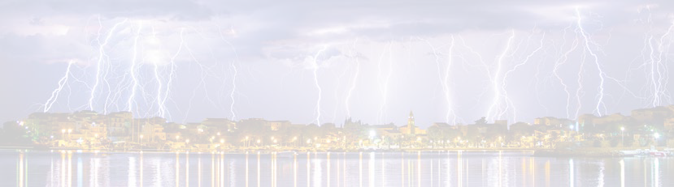
(Figure 29). Overall SIDS capacities for EWS are close to the global average in every area except warning dissemination and communication, which is well below the global average (see Figure 11).
26%
MHEWS
59%
16%

Only 10% of SIDS use the CAP for warning dissemina- tion and communication. Moreover, preparedness and response is also an area for improvement (Figure 30).

More data is needed for SIDS to better understand their capacities, however. Data for individual countries show that capacities vary significantly across the group of SIDS. SIDS had one of the lowest rates of data availability, and LDC-SIDS are particularly under-represented. SIDS EWS successes can be shared with other SIDS in which MHEWS
Figure 29: Members that reported having a MHEWS in place, as a
percentage of the total number of SIDS (58).

100
63%
63%
71%
76%
71%
8% 6%
29% 32%
29%
7%
17%
7%
22%
90
80
70
60
50
40
30
20
10
0

implementation is less developed.
Yes No NA

Photo: Jonathan Ford
Photo: Deepain Jindal

- WMO, Atlas of Mortality and Economic Losses from Weather, Climate and Water Extremes (1970-2019), forthcoming.

- unohrlls.org
- Here storms include tropical storms, and cyclones (hurricanes, typhoons).
Figure 30: EWS capacities in SIDS, by value chain component, calculated as a percentage of functions satisfied in each component area, across 58 SIDS.

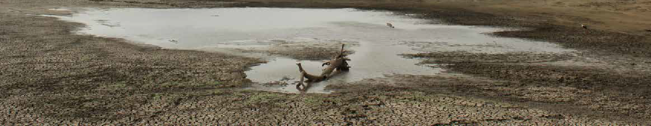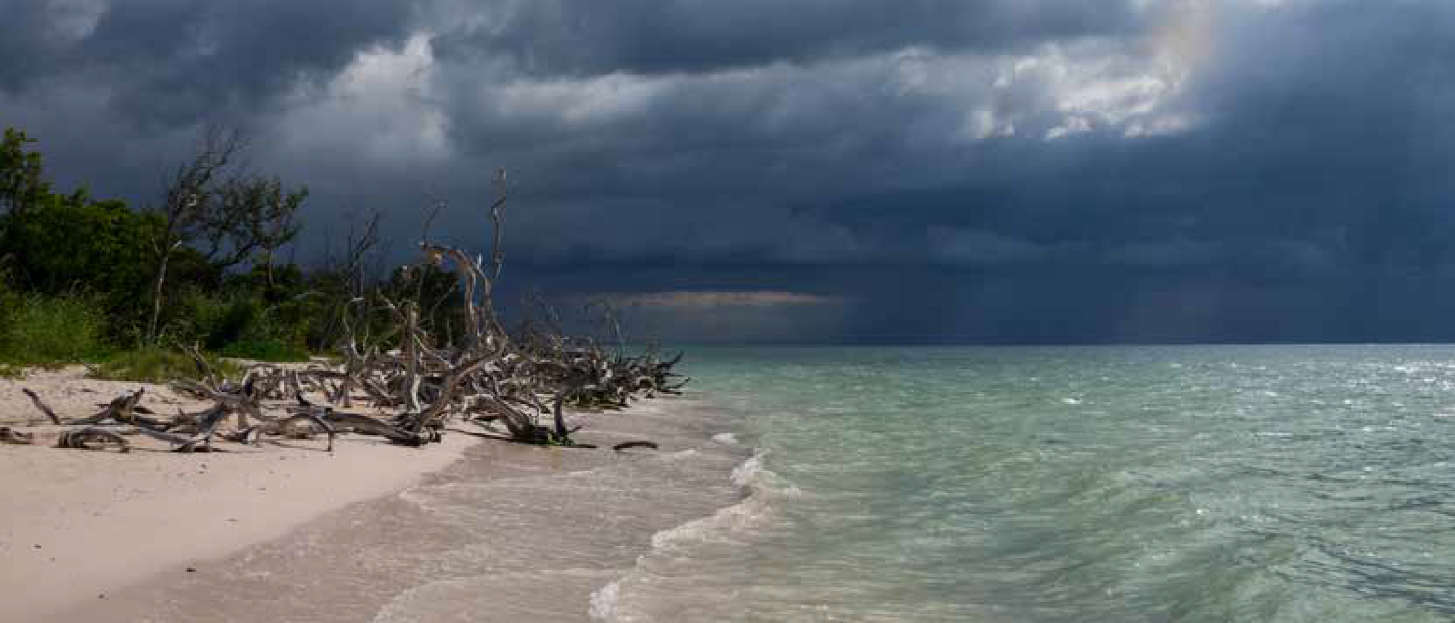Status: LDCs

Around 70% of deaths associated with weather, climate and water related hazards, reported from 1970-2019 occurred in LDCs – with droughts and floods the deadliest and most costly hazard events respectively during that period (Figure 31).
CASE STUDIES
STORMS
Photo: Ana

Keeping economies moving across the Caribbean
Photo: Sebastian Voigt

Total = 1 978 disasters
1%
12%
24% 2%
Total = 1 410 675 deaths
0%
Total = US$ 70.5 billion
0% 0%
6%

41%
with timely and people-centred weather warnings
The Climate Risk and Early Warning Systems (CREWS) initiative Caribbean project is assisting countries to strengthen and streamline regional and national MHEWSs and service delivery capacity to reduce

6%

55%

Number of reported disasters by decade by hazard type

1970-1979 125

1980-1989 218

1990-1999 349

2000-2009 666

2010-2019 620
44% 49%

6%
1% 0%
Number of reported deaths by decade by hazard type
459k
161k

168k
37k

1970-1979

1980-1989 585k

1990-1999

2000-2009

2010-2019

53%

0%

Reported economic losses by decade by hazard type in USD billion

1970-1979 8.7

1980-1989 15.9

1990-1999 17.7

2000-2009 15.7

2010-2019 12.7
economic losses.

CHALLENGE
The Caribbean region’s relationship to climate and weather is complex. On the one hand, the attractive climate is the region’s main economic driver, especially and for the tourism and transportation sectors. On the other, climate and weather generate some of the region’s greatest disaster risks.

The 2017 North Atlantic hurricane season was unprece- dented, unleashing several major hurricanes that affected many Caribbean SIDS, resulting in over 200 deaths and billions of dollars in losses and damage.42 Two Category
5 hurricanes – Irma and Maria – devastated several Caribbean countries and territories, including Dominica,

Supported by the CREWS Caribbean project, the region is now embarking on a process to further strengthen its EWS with the development of a regional strategy to coordinate and address key shortcomings and streamline efforts. The regional strategy sees the private sector as a key stake- holder in the process of strengthening and streamlining the EWS, one of the objectives being that private sector entities, including MSMEs, can manage weather-related risks in a more efficient way.

RESULT
The regional strategy has identified IBF as one key game changer to strengthen MHEWS in the Caribbean, to save more lives and livelihoods, to insulate economic assets

Drought Extreme temperature Flood Landslide Storm Wildfire

Figure 31: Distribution of (a) number of disasters (b) number of deaths, and (c) economic losses by main hazard type and by decade for LDCs.

Overview of EWS capacities
Puerto Rico, Antigua and Barbuda, and Saint Martin/Sint Maarten. Dominica alone experienced damages and losses of roughly US$ 1.3 billion, equivalent to 224% of the island’s 2016 gross domestic product (GDP).

The majority of economic activity in the Caribbean basin is concentrated in the micro, small and medium-sized sector
from costly impacts, and to support business continuity. IBF goes beyond analysing weather information. It includes understanding of potential impacts that hydro- meteorological phenomena may induce and the probability of ‘worst-case scenarios’, which helps to identify possible mitigation measures. IBF would provide more data and analysis concerning the potential impact of disasters that

Data from 35 LDCs, representing 74% of LDCs in the world show that overall EWS capacity across all LDCs is very low. 49% of LDCs do not have a MHEWS in place and just 46,000 in 100,000 people are covered by early warnings (Figure 32).

More data are needed for LDCs to better understand the overall capacity picture. However, the information supplied by WMO Members shows limited capacity to prepare, respond and evaluate action based on early warnings (Figure 33).


46 000 in 100 000 people are covered by early warnings
46,000 in 100,000 people are covered by early warnings
28%
23%

MHEWS
49%

100
90
80
70
60
50
40
30
20
10
0
(MSMEs). With limited access to financial protection and training on business continuity, and constrained oppor- tunities to invest in disaster risk management measures, MSMEs tend to suffer disproportionately and have less capacity than larger, better-capitalized businesses to return to pre-disruption operations in a timely manner.43

APPROACH
EWS has already saved lives. In Anguilla, just before Hurri- cane Irma, the government, after closing schools and government offices, issued warnings, opened shelters, and advised mariners to stay in port or seek safe anchorage. In Antigua and Barbuda, drains were cleaned for heavy rains expected upon landfall. In the Dominican Republic, more than 3 000 people were safely in shelters when Irma hit because of warning and evacuation orders. However,

PARTNERS
World Bank, WMO, and the United Nations Office for Disaster Risk Reduction (UNDRR).
 | 37% |  | 37% |  | 68% |  | 60% |  | 54%
 | 17% |  | 15%
 | 46% |  | 47% |  |  |  |  |  | 21%
 | 46% |  | 47% |  | 68% |  | 20% |  | 21%
 |  |  |  |  | 32%
 |  |  |  |  |  |  |  |  | 25%
 | 46% |  | 47% |  | 32% |  | 20% |  | 25%

can be communicated to the highly vulnerable MSMEs.

Impact-based forecasting (IBF) has been identified as one key game changer to strengthen MHEWS in the Caribbean.

Yes No NA
non-hurricane related quick-onset events such as trough systems, storms and intense rainfall remain less well

Figure 32: Members that reported having a MHEWS in place, as a percentage of the total number of LDCs (47).

Yes

No NA
forecasted and the warnings, when provided, are less actionable.

Figure 33: EWS capacities in LDCS, by value chain component, calculated as a percentage of functions satisfied in each component area, across 47 LDCS.

- Caribbean 2017 Hurricane Season: An Evidence-Based Assessment of the Early Warning Systems, WMO, 2018.
- Fabian Eggers, ‘Masters of Disasters? Challenges and opportunities for SMEs in times of crisis.’ Journal of Business Research. Vol. 115, August 2020, pgs. 199-208.

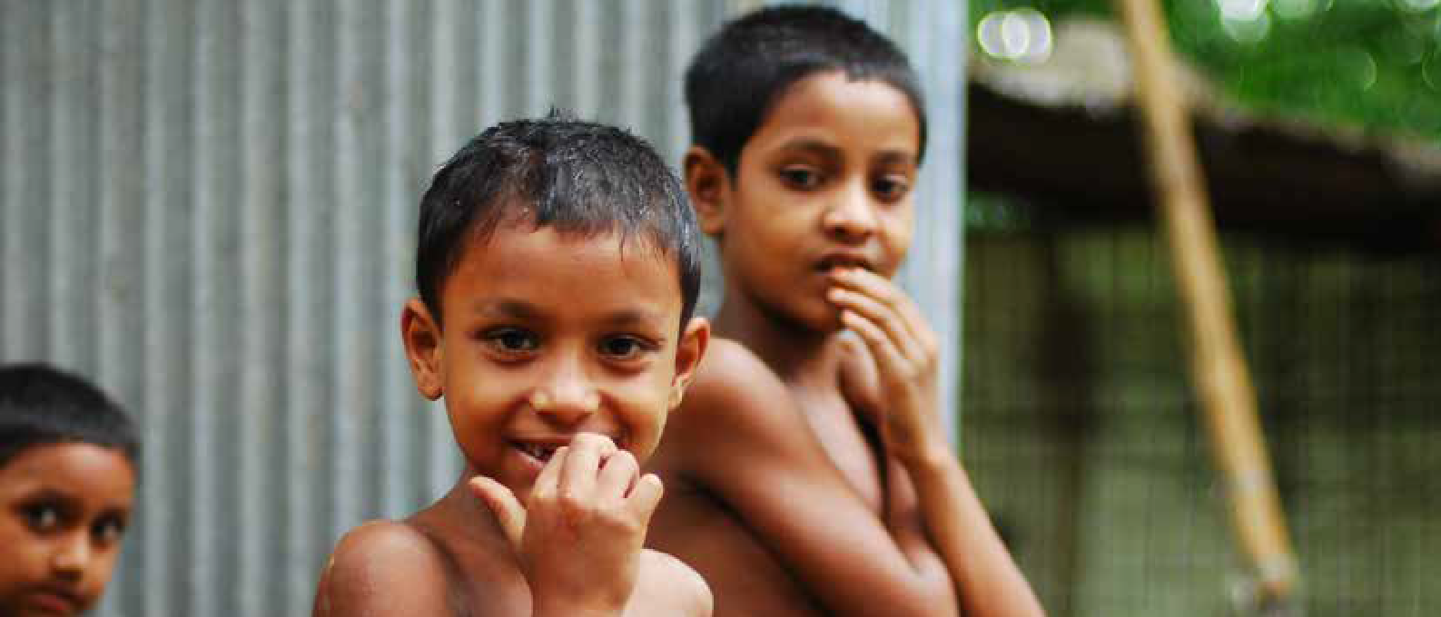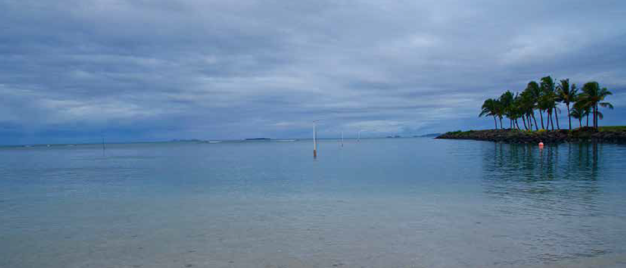CASE STUDIES
STORMS AND FLOODS

Early warnings and anticipatory actions are preparing Bangladesh for the impact of flooding
With a high-density population exposed to multiple hazards, the country is taking a multi-faceted approach to early warnings and early action.
CASE STUDIES
STORMS, SEVERE WEATHER, FLOODS

Fiji’s MHEWS offers protection from tropical cyclones and associated hazards
Photo: Gary Runn
The Severe Weather Forecasting programme, Coastal Inundation Forecasting Demonstration Project and Flash Flood Guidance System are helping to minimize fatalities through successful evacuation warnings to vulnerable communities.

CHALLENGE
Bangladesh has a population of more than 165 million inhab- itants, with a population density of 1 100 individuals per square kilometre – the highest in the world. Density rates in coastal areas number 1 000 individuals per square kilometre, and flood plains constitute 80% of the country’s total area. The country has a long history of natural hazards, of which floods and cyclones are predominantly responsible for the vast majority of the 520 000 deaths recorded over the last 40 years. The Risk-informed Early Action partnership (REAP) was formed in 2019, and it aims to make a billion people around the world safer from disasters by 2025, by bringing the humanitarian, development and climate communities together to take practical solutions for early action to scale. Bangladesh is a great example to do so at large scale. The International Federation of Red Cross and Red Crescent Societies (IFRC), the UK Met Office and the World Food Programme (WFP) have been leading efforts to strengthen early warning systems and scale up early action, supporting the government.

APPROACH
As early as 1965, the government initiated early warning systems for residents living along coastal zones and the results are tangible. Cyclone Sidr, which struck in November 2007, was similar to its two major predecessors (Bhola in 1970 and Gorky in 1991), and it devastated a similar area of the country. However, the estimated casualty figure of 4 234 deaths from Sidr reflected a 100-fold improvement following
37 years44 of effort through the Cyclone Preparedness Programme, established in 1970 following Cyclone Bhola.
Currently, information on hazardous events is provided by the Bangladesh Meteorological Department (BMD) to zonal offices and sub-district offices. The sub-district offices pass this information to unions (at the village level) through high-frequency radios. Volunteers then spread out and issue cyclone warnings throughout villages.
In recent years, the UK Aid’s Asia Regional Resilience to a Changing Climate (ARRCC) project has commenced activities to facilitate the enhancement of the forecasting capability of BMD across all timescales to deliver weather and climate information, and services. These include:
technical support to help build capacity of BMD for IBF, seasonal forecasting and the development of national climate projections; development of sub-regional early warning services for crop-threatening wheat diseases; and the development of new sea-level rise assessments.

RESULT
The Forecast-based financing (FbF) approach, implemented by WFP and the Bangladesh Red Crescent Society (BRCS), has created many benefits for flood-affected households. According to a survey carried out by WFP in August 2019, the average asset loss in FbF target areas has dropped from US$ 78 to US$ 57 after being affected by floods. The FbF approach has been activated four times ahead of floods, in 2017, 2019, and recently in 2020, scaling up the number of beneficiary population from 5 000 vulnerable households in 2017 to more than 300 000 vulnerable people ahead of the recent floods in 2020, and supporting them with a range of early actions based on their needs, for example uncondi- tional cash transfers to very poor households, agricultural inputs to farmers and hygiene and health kits to vulnerable girls and women.

The average asset loss for Bangladeshis affected by floods has dropped from US$ 78 to US$ 57 – a 27% decrease.

CHALLENGE
Hazards often have cascading effects and do not happen in isolation. Tropical cyclones generate heavy rainfall, strong winds, storm surges, coastal, riverine and flash flooding, the latter of which can result in landslides. The Pacific island nation of Fiji is extremely prone to all of these hazards.
Photo: Amir Jina

APPROACH
WMO with the Fiji Meteorological Service (FMS) and other national authorities, with the support of various donors, including the CREWS initiative, has implemented three MHEWS-based projects in Fiji to help better prepare the island in protecting lives and property:
- The Coastal Inundation Forecasting Demonstration Project (CIFDP) was designed as an integrated approach to storm surge, wave and riverine flood forecasting for improved operational forecast and warning capabili- ties. In Fiji, the forecast system developed under CIFDP runs on a desktop computer and produces rapid results. Alerts are broadcast 48 hours ahead of time and warn- ings given with a 24-hour lead time. More frequent updates may be issued depending on the severity of the event. CIFDP also implemented the Japan Meteorolog- ical Agency storm surge model encompassing all of the Fijian islands and developed a decision-tree for issuing warnings. The latter combines inputs of observed and forecasted rainfall, storm surge levels and upstream hydrological conditions, based on expert knowledge, to provide guidance to forecasters.
- The Severe Weather Forecasting programme (SWFP) provides the FMS and Regional Specialized Meteorolog- ical Centre (RSMC) in Nadi with high resolution Numer- ical Weather Prediction data provided by BMKG, the NMHS of Indonesia. FMS also receives a regional severe forecast guidance product from RSMC Wellington on a daily basis. The high-resolution data is utilized for the provision of improved forecasts and early warning services. SWFP outputs are also used as inputs to the Flash Flood Guidance System (Fiji-FFGS). The Fiji-FFGS provides FMSs trained forecasters with the capacity to generate and issue flash flood forecasts and warnings with an improved lead-time of up to 36 hours.

PARTNERS
Bangladesh Meteorological Department, REAP partners (including the UK Met Office, World Food Programme, the Bangladesh Red Crescent Society, the Food and Agriculture Organization of the United Nations and the United Nations Population Fund), the Global Flood Awareness System, the Flood Forecasting and Warning Centre and the Red Cross Red Crescent Climate Centre, German Red Cross.

RESULT
All components of the Fiji CIFDP, SWFP, and FFGS are now fully operational, and have provided comprehensive warnings during major events in the 2019-2020 tropical cyclone season. During tropical cyclone Harold in April 2020, with support through the operational systems of SWFP, CIFDP-Fiji and Fiji-FFGS, the FMS was able to provide timely forecasts and early warnings for hydro-met hazards including for heavy precipitation, flash floods, strong winds, damaging waves and storm surges to the general public, local communities and relevant authorities, thus contributing to minimizing the loss of life and damage to infrastructure and property.

The impact models run before Tropical Cyclone Harold hit allowed people in Fiji to better prepare. It was a first for Fiji.

PARTNERS
WMO, CREWS, Hydrologic Research Center, National Oceanic and Atmospheric Adminis- tration, Fiji Meteorological Service, National Disaster Management Office, Korea Inter- national Cooperation Agency, Korea Meteoro- logical Administration, Environment and Climate Change Canada, Japan Meteorological Agency, National Institute of Water and Atmospheric Research (New Zealand), Bureau of Meteor- ology, (Australia), The Pacific Community (Pacific Islands), and Tonkin and Taylor (New Zealand).

- PeterTatham, Karen Spens, Richard Oloruntoba, May 2009: abstract, “Cyclones in Bangladesh – A Case Study of a Whole Country Response to Rapid Onset Disasters”.

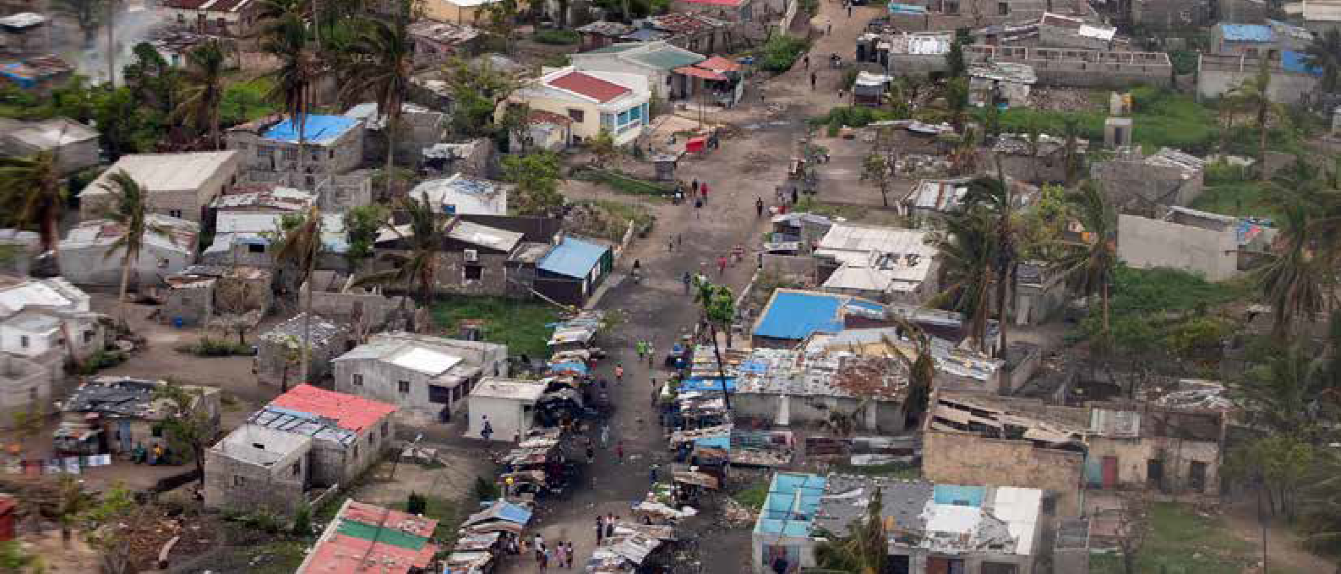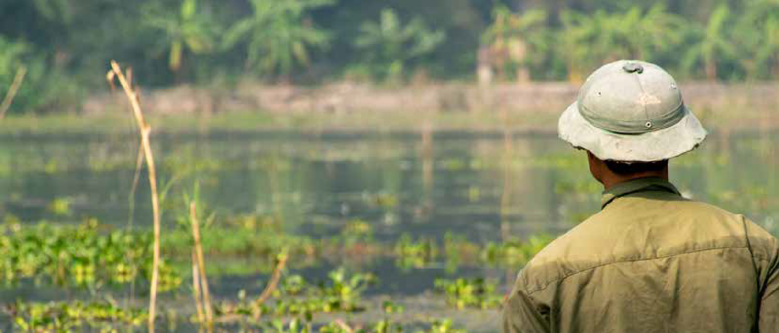CASE STUDIES
STORMS AND FLOODS

Lessons to be learned from Africa’s most devastating cyclones
More lives would have been saved if forecasts had given more information about the potentially damaging impacts of the cyclones and people had understood the imminent danger.
CASE STUDIES
FLOODS

A data-sharing and monitoring platform is protecting lives in Cambodia
Photo: Constant Loubier
Combining on-the-ground data with satellite information, the Platform for Real-Time Impact and Situation Monitoring (PRISM) is providing tools to estimate the impacts of extreme weather to inform preparedness and reduce impacts from climate-related disasters.

CHALLENGE
On the evening of 14 March 2019, tropical cyclone Idai made landfall in the northern vicinity of Beira, Mozambique with 165 km/h winds gusting up to 230 km/h, bringing torrential rains and very high storm surges. The wave height exceeded 10 meters, making it one of the most destructive tropical cyclones ever recorded in the Southern Hemisphere. The town of Buzi and the city of Beira were devastated. One month later, tropical cyclone Kenneth made landfall in the northern province of Cabo Delgado with a wind speed of 220 km/h, making it even stronger than Idai
– and among the strongest cyclones to ever hit Africa.
Idai and Kenneth wreaked havoc on lives, livelihoods, and homes in Mozambique, killing more than 700 people, displacing some 420 000 and affecting more than two million. Cyclone Idai, in particular, which affected densely populated areas, had a magnitude which overwhelmed the institutional and individual capacities to prevent and recover from the impacts of the cyclones.

APPROACH
Benefiting from a well-established global and regional operational network and collaborative efforts coordinated by the WMO, Idai’s intensity, track and expected time and location of landfall were accurately anticipated. This allowed the issue of warnings to communities. However, the flooding resulting from prevailing conditions exacerbated by Idai’s heavy rainfall proved to be more challenging to predict.
Mozambique’s National Institute of Meteorology, National Directorate of Hydrological Resources Management and the National Institute of Disaster Management issued alerts and disseminated warning messages via TV, radio, and megaphones on cars. For both cyclones, forecasts were used to prepare, and in the case of cyclone Kenneth, to evacuate, 30 000 people out of harm’s way.
However, despite the alerts and warnings during and after Idai’s landfall, the total breakdown of communications and power electricity made the further communication of warnings nearly impossible. People were left without a way to receive warnings of impending floods. And the very rapid increase of water levels caused the failure of the community-based flood warning system in place in the Búzi district, exacerbating the flood impact. The

situation was made worse due to the fact that it happened at night. The EWS was not designed or resourced to be able to deal with night-time flooding due to a poor communication infrastructure.

RESULT45
Successes included the accurate cyclone forecasting and collaboration between the disaster management authorities, the Red Cross, and community structures in communicating warnings. However, loss of life and damages could have been reduced with better flood forecasting and improved warnings containing information about expected impacts and specific actions to take. Flood warnings, for example, did not accurately indicate the time floods would hit, nor the magnitude of the flooding. In the case of cyclone Idai, even with accurate forecasting and dissemination of the warnings, nobody expected a storm of such magnitude. People understood that a cyclone was coming but did not necessarily take action because they believed it would be similar to cyclones they had experienced in the past. Moreover, the disseminated warning messages were unclear to the targeted audience, as they did not communicate the potential impact and damage that could be caused, in particular to flimsier houses in poorer communities. The impacts of cyclone Idai demonstrated the greater need for the development of IBF services.

Loss of life and damage could have been reduced with better flood forecasting and improved warnings.

PARTNERS
World Food Programme.

CHALLENGE
With about two million people living in poverty, Cambodia is particularly vulnerable to extreme events including droughts and floods, with farmers struggling to adapt to a changing climate and higher variability in weather conditions. Often information reaches communities too late for households to make informed decisions on when to plant and to harvest, and, critically, when to take action to move their families and assets out of harm’s way in case of severe weather.
Photo: United Methodist News

APPROACH
Working closely with countries and research centres, WFP has developed and piloted PRISM in the Asia-Pacific region. PRISM monitors the risks of extreme weather events on vulnerable communities and automatically generates analyses of potential impacts. This analysis is then used to inform effective preparedness at different levels, disaster mitigation strategies and early response. PRISM is actively used by government partners in Indonesia, Sri Lanka, and Cambodia, and is being launched in Mongolia, with future plans for a deployment in Myanmar.
Bringing together Earth Observation data and early warning system alerts with key information on socio-economic vulnerability, including poverty and food insecurity, PRISM produces near real-time risk and impact maps which are displayed in an interactive dashboard that enables decision- makers to identify and prioritize anticipatory actions and humanitarian responses. The recent integration of Earth Observation data for PRISM in Cambodia is the result of a collaboration with the SERVIR program – a National Aeronautics and Space Administration (NASA) and United States Agency for International Development (USAID) initi- ative, which brings the strength of NASA research capacity to the Government of Cambodia and WFP.
PARTNERS
WMO, ISET-International, International Federation of Red Cross and Red Crescent Societies (IFRC), Mercy Corps, Practical Action (PA), Zurich Insurance Group, Mozambique Red Cross, Mozambique’s National Institute of Meteorology, National Directorate of Hydrological Resources Management and the National Institute of Disaster Management, UK Met Office, German Red Cross.
An innovative component of PRISM Cambodia is the use of field-based impact assessments collected by govern- ment disaster management agencies. These assessments, collected on mobile devices and published to PRISM, provide dynamic information on the current conditions and needs on the ground, including the impact of a disaster and the needs of people affected. Moving forward, PRISM aims to incorporate dynamic data on vulnerability collected by WFP and partners.

RESULT
In Cambodia, WFP launched an upgraded version of PRISM with the Government of Cambodia’s National Committee for Disaster Management (NCDM) in 2020. NCDM will be able to rapidly capture and disseminate critical information on the potential impact of a disaster providing key infor- mation for its own decision making – an important new capability considering the frequent floods and droughts that have affected Cambodia severely in the past few years. PRISM has also provided critical information to the Human- itarian Response Forum in Cambodia, a coordination mechanism on droughts and floods comprised of United Nations agencies and international NGOs working closely with the NCDM to provide support during humanitarian crises.

PRISM estimates the impact of droughts and floods on vulnerable populations, enabling Cambodia to better prepare for, and mitigate, the impact of extreme weather events.

- Zurich Flood Resilience Alliance Post Event Review Capability (PERC) study analyzing the 2019 Cyclone Idai’s impacts in Malawi, Mozambique, and Zimbabwe and Cyclone Kenneth’s impacts in Mozambique. Reducing vulnerability to extreme hydro-meteorological hazards in Mozambique after Cyclone IDAI, WMO, 2019.

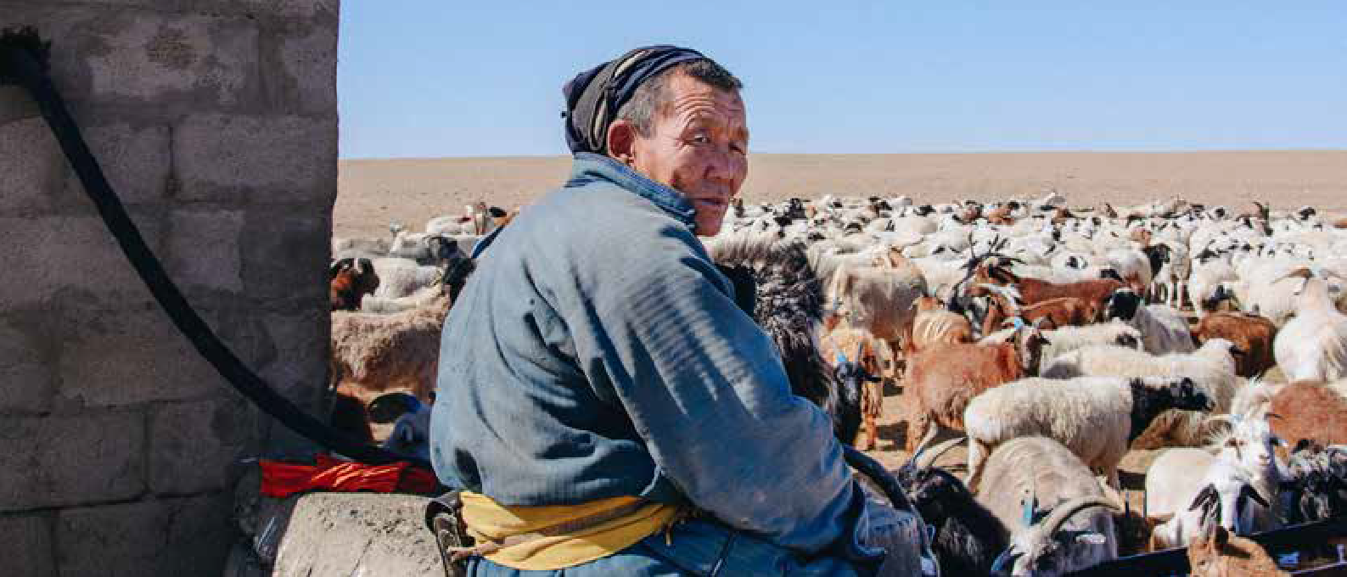CASE STUDIES
SEVERE WEATHER

Protecting Mongolian herding families from dzuds46 through anticipatory action
Food and Agriculture Organization of the UN (FAO) and the Mongolia Red Cross are working to protect livestock farmers from experiencing the adverse impacts of dzuds , which are becoming more severe and frequent than in the past due to climate change.
CASE STUDIES
SEVERE WEATHER

An EWS protecting those living and working in the Lake Victoria Basin, East Africa
Photo: Random Institute
Severe weather warnings can deliver benefits of up to US$ 50 million a year by protecting fishermen and small boat passengers in the Lake Victoria Basin region.

CHALLENGE
Raising livestock remains the most important livelihood in Mongolia and is the sole source of income for 35% of households.

For Mongolians and their livestock, very hot summers and dry, very cold winters have been part of life for centuries. But climate change has made what is known as a dzud more severe and more frequent. During recent dzuds many herding households have lost all their livestock or could not afford extra fodder, of which there is little available anyway. Consequently, they are often threatened with destitution in the space of a single season.

APPROACH
Ahead of the 2018 dzud, two critical warnings were issued to support Mongolian farmers. The Government of Mongolia sounded a first alarm in November, through its Informa- tion and Research Institute of Meteorology, Hydrology and Environment (IRIMHE). The Institute shares a dzud risk map annually, and for the 2018 season it showed half the country already covered by snow. This product is the first of its kind in Mongolia and has become the key service for triggering anticipatory humanitarian action.

The second warning was a joint FAO-WFP Crop and Food Security Assessment pointed towards abnormal dry conditions which resulted in below-average availability of fodder. The warning combined 11 indicators in total, including snow-cover days, weather patterns and agricul- tural vulnerability to show 30% of the country as being at high risk – and another 30% at medium risk – of a severe dzud. Overlaying the monitoring and forecasting together with social and economic information helped closely pinpoint the most vulnerable families to target for anticipa- tory actions. These EWSs were used once again in 2020 by FAO and the Mongolian Red Cross.

RESULT
FAO and the Government acted quickly based on these warnings to support 1,008 vulnerable herders and their families living on the urban fringes of Ulaanbaatar. Anticipatory actions included destocking of livestock, with
households receiving money for the carcasses of a goat and a sheep in December 2017 to cover their immediate needs. Families told FAO interviewers that this helped them to buy extra food supplies at the best time, before prices spiked as the dzud began to bite. Shortly after, FAO distributed 340 tonnes of concentrated feed and 17 tonnes of nutritional supplement to rural herders swiftly followed at the start of 2018, the lean season. FAO distributed the livestock meat from destocking to vulnerable urban households living in poor areas on the edges of Ulaanbaatar. This saved the households a precious US$ 32 over a period of more than two months when finances were especially stretched. Families said they were able to divert the money they saved to buying essentials, such as food, medicine and school supplies. Meanwhile, FAO distributed 340 tonnes of concentrated feed and 17 tonnes of nutritional supplement to rural herders swiftly followed at the start of 2018, the lean season. The Mongolian Red Cross also provided 2 500 herder families with cash transfers and emergency livestock kits. A recent study showed that by providing early assistance before winter conditions reached their most extreme, the Red Cross intervention effectively reduced livestock mortality by up to 50% and increased offspring survival for some species, thereby helping to secure future livelihoods.

An FAO-led impact study found that every US$ 1 spent had a return of US$ 7 in added benefits and avoided losses for rural herders.

CHALLENGE
The Lake Victoria Basin (LVB) is the “lifeblood” of East Africa, supporting 25% of the population, and especially those in the agriculture and fishing industries. Between 3,000 and 5,000 deaths occur each year in the LVB as a result of navigation accidents due to strong winds and high waves.
Photo: Adli Wahid

APPROACH
The WMO Severe Weather Forecasting Programme in Eastern Africa (SWFP-Eastern Africa) began as a demon- stration project back in 2010, designed to protect people across seven countries: Burundi, Ethiopia, Kenya, Rwanda, South Sudan, Tanzania and Uganda. The SWFP is imple- mented through a ‘cascading forecasting process’. It uses numerical weather prediction (NWP) contributions from the World Meteorological Centres in Exeter, Reading and Washington to support the Regional Specialized Meteor- ological Centres (RSMCs) in Nairobi and Dar es Salaam. Due to this operational support from WMO global and regional centres, today the seven countries are able to issue forecasts and warnings at national and local levels, across the LVB region.

Five out of the seven countries are also involved in the HIGHWAY project, set up in 2017 to strengthen the process by providing the latest NWP tools, nowcasting products and a nearcast system which can help NMHSs to issue timely alerts and warnings to fishers and local communities. The HIGHWAY project has also contributed to the enhancement of observation systems used across the LVB. More, and higher quality, observational meteorological data improves NWPs at the regional scale, and increases detection and monitoring capabilities with respect to severe weather.
PARTNERS
FAO-WFP Crop and Food Security Assessment, Government of Mongolia and Information and Research Institute of Meteorology, Hydrology and Environment (IRIMHE), Mongolia Red Cross, Ngoya University of Japan and the Red Cross Red Crescent Climate Centre.

RESULT
A key indicator of the results of the above measures is the value of avoided losses due to the use of climate or weather information. The primary benefits of the interventions on the lake are the reduction in deaths from drowning, for fishermen and small-scale passenger transport, as well as the loss of boats and subsequent loss of livelihoods.

A pilot study showed that around 73% of the sampled population used the supplied weather information. As a result, 46% of the beneficiaries – estimated at around 400 000 people – saved more than US$ 1 000, and 2.56% saved more than US$ 10 000 from loss of property.

3 000-5 000 deaths occur in LVB every year due to
navigation accidents caused by strong winds and high waves.

PARTNERS
WMO, UK Met Office (UKMO), University Corpo- ration for Atmospheric Research (UCAR), Kenya Meteorological Department (KMD), Rwanda Meteorological Agency (Meteo Rwanda), Tanzania Meteorological Authority (TMA), Uganda National Meteorological Authority (UNMA), ActionAid Uganda, Lake Victoria Basin Commission (LVBC) and East African Community (EAC).

- Term used to describe severe weather conditions in Mongolia.

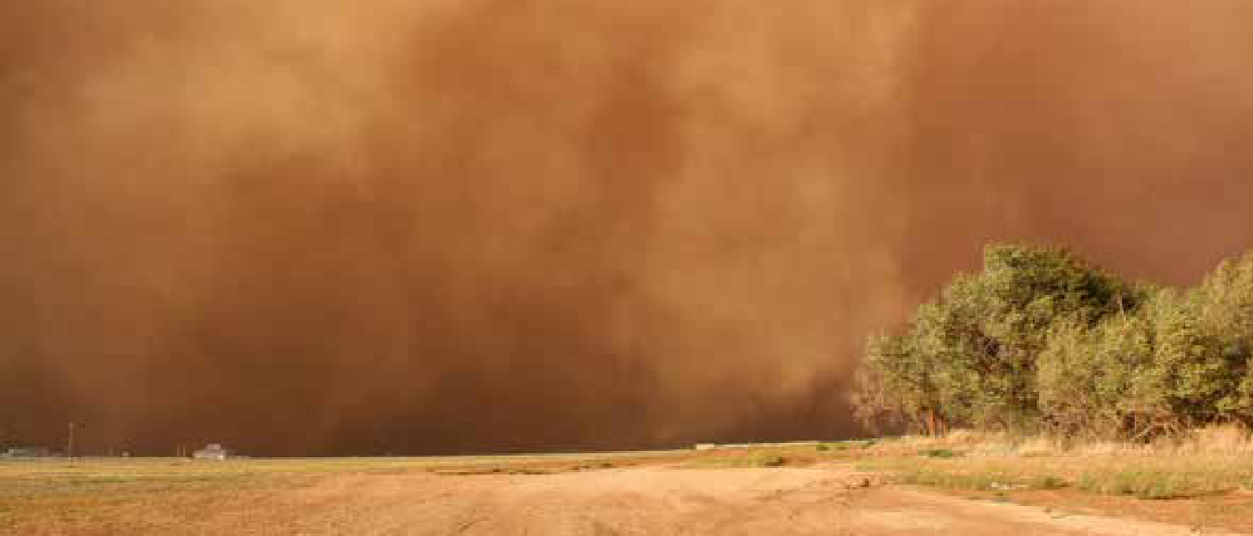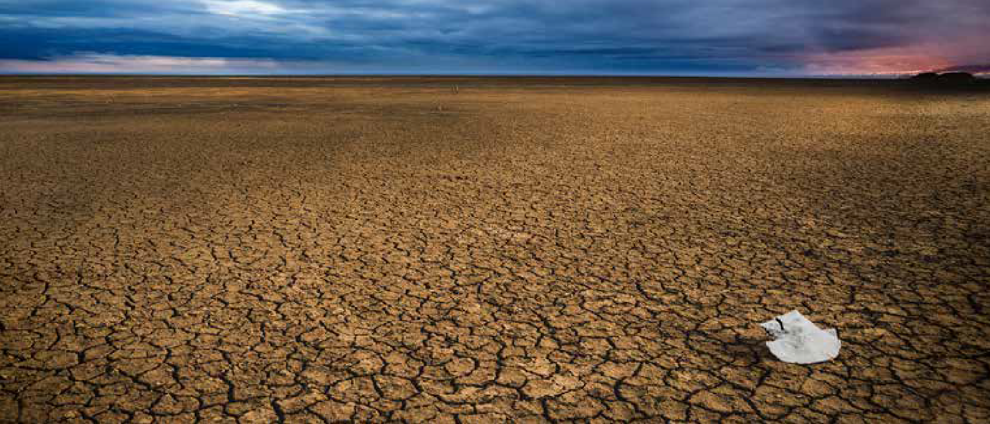CASE STUDIES
DROUGHT

The Greater Horn of Africa protects itself with a range of early warning products
Seasonal forecasts and advisories of historical rainfall anomalies provide early warning of potential drought conditions.
CASE STUDIES
SAND AND DUST STORMS

Preparing Burkina Faso to protect human health from sand and dust storms
Photo: KCBD Communities
The WMO Sand and Dust Storm Warning Advisory and Assessment System (SDS-WAS) will be crucial in reducing short-term impacts, as well as equipping national risk management efforts in the longer term.

CHALLENGE
Like many parts of the tropics, the Greater Horn of Africa is exposed to extreme climate events, including drought. In an attempt to reduce the impact of such climate events, WMO and the United Nations Development Programme (UNDP) set up the regional Drought Monitoring Centre (DMC) in Nairobi, as well as a smaller centre in Harare, covering 24 countries in the eastern and southern African sub-region. DMC Nairobi later became an Intergovernmental Authority on Development (IGAD) institution and was renamed the IGAD Climate Prediction and Applications Centre (ICPAC). ICPAC is a WMO Regional Climate Centre (RCC).

APPROACH
The story stretches back over two decades to the first Greater Horn of Africa Regional Outlook Forum in 1998, when the tools available for seasonal forecasting were limited. Seasonal forecasts from computer-based models of the climate were only just beginning and the high-powered computing facil- ities needed were much more limited. Consequently, a mix of various simpler tools and “forecaster judgement” - the so-called “semi-subjective” method - became the norm across Regional Climate Outlook Forums established to issue seasonal climate outlooks, including for the Greater Horn of Africa Climate Outlook Fourm (GHACOF).
The semi-subjective method has served the Eastern Africa region well for many years with advice on seasonal prospects informing preparatory action in a number of sectors including agriculture, food security, livestock, water, health, conflict and media. Through work over many years, led by ICPAC’s Climate Modelling Group, collaborations and data links with these modelling centres and research organ- isations have strengthened, with information from climate models increasingly used in generating the GHA forecasts.
So, when in 2017 WMO decided that the climate model methodology had developed sufficiently to replace the semi-subjective method, ICPAC was ready. In a transformational change at GHACOF 52 in May 2019 ICPAC adopted a fully objective climate model-based forecast methodology. The new system replaces 20 years of the semi-subjective forecast
and heralds a new era in seasonal forecast services. The objective approach is based more deeply in the underlying climate science and is much better suited to the development of customized services for socio-economic sectors.

RESULT
As the above improvements illustrate, countries in the region have made tremendous advances to mitigate and anticipate losses from extreme climate events, including drought. These improvements extend into the preparedness and response measures adopted by governments.
For example, following a massive drought in the 1970s, the Government of Ethiopia established the Relief and Recovery Commission (RRC) to manage the effects of droughts in the country.47 Ethiopia’s early warning system (EWS), established in 1976,48 has been consistently improved over the last decades and is supported by various government ministries. The current EWS monitors all threats to food insecurity, including drought, pests, and diseases.49 The Productive Safety Net Programme (PSNP) was established to provide contingency budgets and risk financing should certain communities suffer from drought impacts. As a result, when comparing the drought from 1983-1984 and the 2009-2012 drought, which lasted for almost the same duration of time and affected the same areas of Ethiopia, the numbers suggest a significant reduction in mortality. The number of deaths associated with the drought in the 1980s was 300 000 people with 7.5 million others affected. While the total mortality associated with the 2009-2012 drought is unknown, the crude mortality rate for the population admitted to feeding centres was only 0.6%.50

ICPAC has developed a range of climate- and drought-related products designed to reduce the impact of extreme climate events.

CHALLENGE
Sand and dust storms (SDS) pose a major challenge to sustainable development in arid and semi-arid regions. They occur when strong or turbulent winds lift large amounts of sand and dust from bare, dry soils into the atmosphere.
Photo: Sérgio Gonçalo
These storms are becoming more frequent as a result of anthropogenic climate change and unsustainable land and water use.51 A significant part of the dust emission is a consequence of human-induced factors, such as poor agricultural practices or land and water mismanagement.

APPROACH
The SDS-WAS52 enhances the ability of countries to deliver timely, quality sand and dust storm forecasts, observa- tions, information and knowledge to users through an inter- national partnership of research and operational commu- nities. More than 20 organizations currently provide daily global or regional dust forecasts in different geographic regions. Seven global models and more than 15 regional models contribute to SDS-WAS.

RESULT
The Sand and Dust Storm Warning Advisory System for in Burkina Faso, which received funds from the CREWS initiative, is a good example of SDS-WAS effectiveness. Launched in October 2018, the product was designed and generated by the Spanish Meteorological Agency (AEMET) and the Barcelona Supercomputing Center in collabora- tion with the Burkina Faso National Meteorological Agency (ANAM).
Colour-coded maps show the risk of high dust concentra- tions during the following 48 hours for the 13 provinces into which Burkina Faso is divided. The warning levels are computed using the dust surface concentration predicted by the SDS-WAS Northern Africa Middle East Europe Node multi-model median, which is generated daily from 12 numerical predictions released by different meteorolog- ical services and research centres around the world. The warning thresholds are set differently for each region,
PARTNERS
ICPAC.
as they are based on the climatology of the prediction product itself, using a percentile-based approach.
According to ANAM in Burkina Faso, the system is being used by local weather forecasters in their daily working routine, providing valuable information about dust situa- tions and helping them to assess them quickly.

This kind of tailored product is a huge time-saver for weather forecasters thanks to the capability of summarizing inputs from a wide range of diverse sources into a single forecast product.
PARTNERS
WMO World Weather Research Programme (WWRP) and Global Atmosphere Watch (GAW).

- DPPC Ethiopia, 2005. “Ethiopia: National Information on Disaster Reduction.”
- Adaptation Partnership. “Disaster Risk Management Programs for Priority Countries: Ethiopia.”
- Ibid.
- Government of Ethiopia DRMFSS, “Emergency Nutrition Quarterly Bulletin, Second and Third Quarter 2011.”

- WMO SDS-WAS, 2020: Sand and Dust Storm Warning Advisory and Assessment System. Science Progress Report. World Meteorological Organization (WMO), GAW Report No. 254 & WWRP Report 2020-4. Geneva, Switzerland, June 2020, 45pp.
- SDS-WAS.

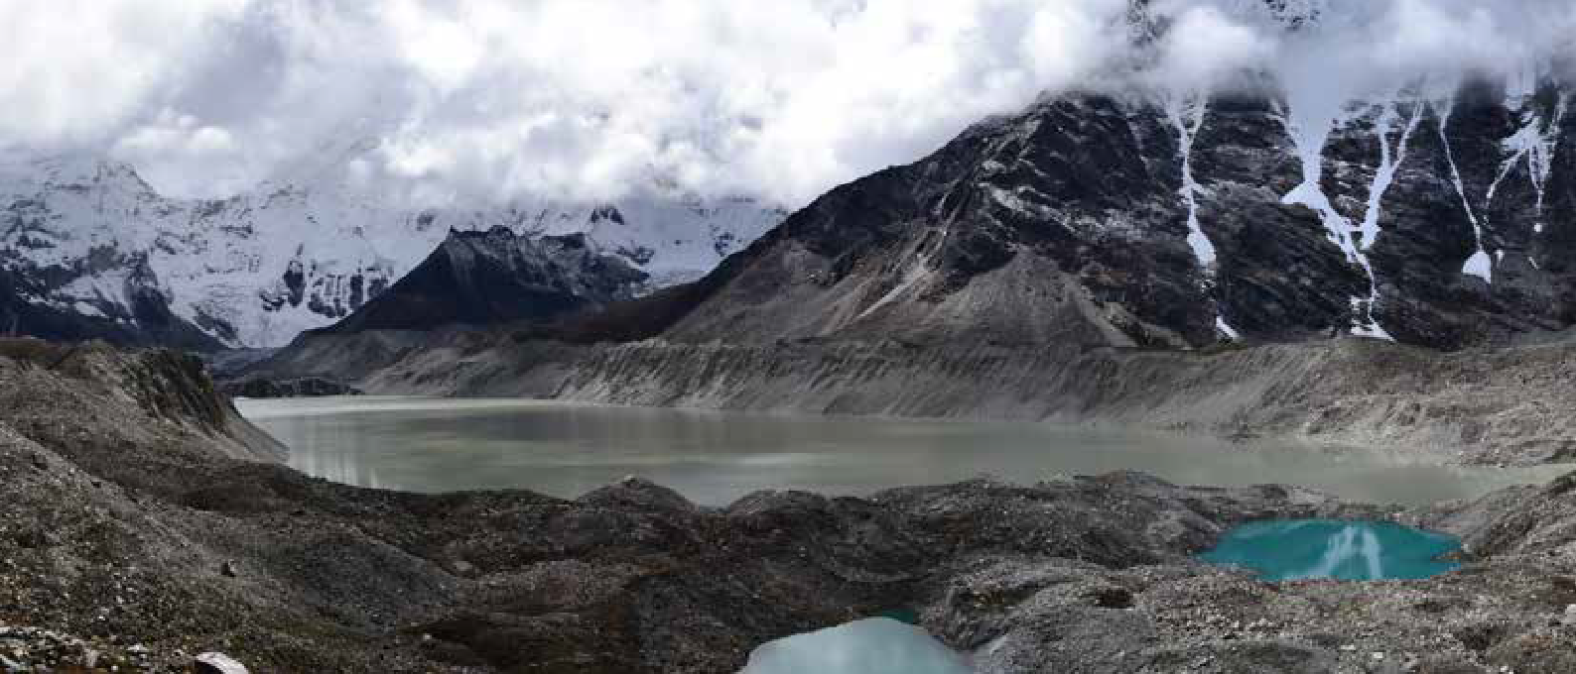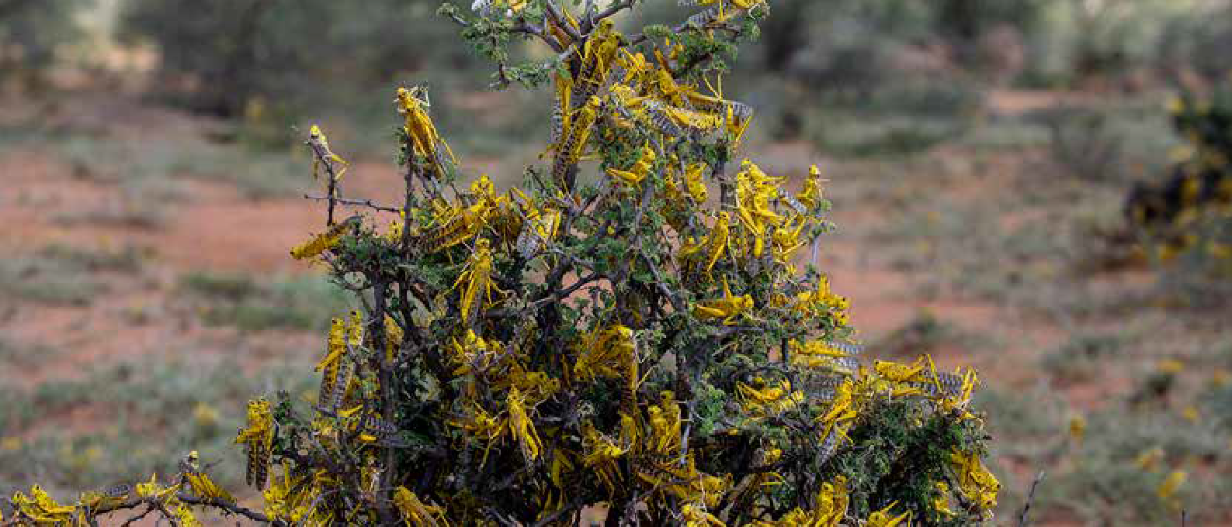CASE STUDIES
LOCUST SWARMS

EWS protects African nations from upsurge in desert locust
Photo: Sven Torfinn
Desert locust early warning intervention has stopped the risk spreading further, while saving millions of dollars’ worth of cereal across 10 countries.
CASE STUDIES
GLACIAL LAKE OUTBURST FLOODS

Alleviating the dangers of melting glaciers in Nepal
Nepal’s EWS includes hydro-met and Glacial Lake Outburst Flood sensors and automatic sirens, to ensure that major vulnerable settlements around Imja Lake are alerted to risks of flooding.
Photo: UNDP

CHALLENGE
After Cyclone Pawan made landfall in early December 2019, flooding in the Horn of Africa created highly favour- able breeding conditions for the desert locust. The region is facing the worst desert locust crisis in over 25 years, and the most serious in 70 years for Kenya. Desert locust swarms are also moving across India, Pakistan and the Islamic Republic of Iran. The situation remains alarming, particularly in Ethiopia, Kenya and Somalia and is under control for now in Sudan, Eritrea, Egypt, Saudi Arabia and Oman. In January 2020, FAO scaled up its activities and launched a formal appeal to contain the locust upsurge.

APPROACH
Control and surveillance operations were led by national governments, with FAO providing support in the form of pesticides, bio-pesticides, equipment, aircraft and training. FAO’s Desert Locust Information Service (DLIS) issued 10 warnings on the situation and inform the governments of the affected countries. This input was integrated into FAO’s desert locust global EWS.

Once alerted to the situation, the governments of the affected countries mobilized staff and resources to kick-start the control operation and engaged with FAO to design, implement and monitor technically sound and to-scale operations. The United States National Oceanic and Atmospheric Administration (NOAA), in collaboration with FAO, has customized its HYSPLIT dispersion model so that it can be used for tracking desert locust swarms forward and backward in time. The model results are incor- porated into FAO’s advice and forecasts which are then provided to affected countries for improved preparedness and response.

FAO has also rapidly expanded its original eLocust3 digital tool, a rugged handheld tablet that sends data from the field via satellite, to new versions for smartphones, a GPS satellite communicator and a web form. FAO’s DLIS uses satellite imagery to monitor rainfall and green vegetation in locust breeding areas and is putting into operation a new product that monitors soil moisture for locust breeding. In collaborating with Airbus, FAO is using remote sensing technology to estimate damage caused by the outbreak.

RESULT
Thanks to FAO support, 400,000 hectares have been protected across 10 countries thus far. Based on prelimi- nary analyses and projections of areas controlled, and the likely damage caused if not protected, 720,000 tons of cereal were saved or secured across Djibouti, Eritrea, Ethiopia, Kenya, Somalia, South Sudan, Sudan, Uganda, the United Republic of Tanzania and Yemen, worth around US$ 220 million. This is enough to feed almost five million people for one year. Through damage averted to rangeland and livestock tropical units, an additional 350,000 pastoral households have been spared from livelihood loss and distress.

720 000 tons of cereal were saved across 10 countries, worth around US$ 220 million.

CHALLENGE
More than 60 years ago in the lower reaches of the Himalayas, a few ponds formed due to the slow melt of the Imja glacier. Today, the ponds are gone. Instead, Imja Lake has taken their place, as a huge body of water that stretches for nearly two kilometres.

The lake poses a deadly threat. Six glacial lakes have been identified as high risk and Imja Lake is the second highest in Nepal, as classified by the International Centre for Integrated Mountain Development in 2010. As the glacier has been melting in recent years due to global warming, the lake water levels keep rising. The fear is it could burst its banks or, worse yet, that a quake could trigger an outburst, with water cascading downstream killing thousands of people. Such an outburst could result in massive destruc- tion, affecting up to 500 000 inhabitants, and damaging property worth over US$ 9 billion.

APPROACH
To blunt the threat, the Government of Nepal, with support from the Global Environment Facility’s Least Developed Countries Fund and UNDP, has built a system to relieve pressure on the lake. Sensors monitor water levels and water is released via a canal. The system, operated by Nepal’s Department of Hydrology and Meteorology (DHM), consists of hydro-met and Glacial Lake Outburst Flood (GLOF) sensors and automatic sirens in six major vulner- able settlements. A decision support system uses 10 GLOF detection sensors to verify events, as well as the Iridium communication system to trigger warnings, based on the data received from the monitoring system put in place. The DHM receives data and information through its web portal and is able to communicate GLOF risk warnings to the National Emergency Operation Center, which is capable of informing vulnerable communities and tourists of any risks posed by Imja GLOF events, using SMS messages through major telecom providers in Nepal. Imja Lake has also been lowered by 3.4 meters, through water level lowering techniques.

PARTNERS
FAO, the US National Oceanic and Atmospheric Administration and Airbus.

RESULT
An effective EWS has been put in place resulting in a reduc- tion of the GLOF risks posed by the lake. The EWS reduces the imminent risk posed by the Imja Glacial Lake to more than 12,000 vulnerable people living downstream within the Imja Dudh Koshi river valley.

The EWS now covers over 59 000 people with this service downstream, and over 48 000 people upstream of the valley. The EWS was effective in protecting people in the August flood of 2017, not only within the country but also across the border in China.

The EWS now protects over 59 000 people downstream within the Imja Dudh Koshi river valley.

PARTNERS
The Government of Nepal, Department of Hydrology and Meteorology, the Global Environ- ment Facility and the United Nations Develop- ment Programme.

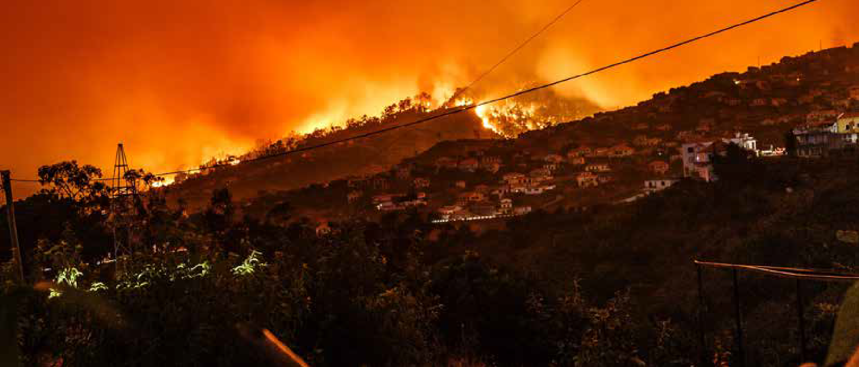CASE STUDIES
GLACIAL LAKE OUTBURST FLOODS
Photo: Shahid Durrani
CASE STUDIES
WILDFIRES

Reducing risks and vulnerabilities from glacial lake outburst floods (GLOFs) in Northern Pakistan
District and community authorities across two regions are now able to prioritise and plan measures to minimise potential losses from GLOFs.
Europe is reaping benefits from a regional and global wildfire information system
The European Forest Fire Information System (EFFIS) supports wildfire systems in 43 countries, saving nations hundreds of millions of Euros in reduced losses.
Photo: Michael Held

CHALLENGE
People living in northern Pakistan are affected by numerous climate-related hazards, including floods, avalanches and landslides, all of which result in extensive human and material losses. Climate change will exacerbate some of these natural hazards and lead to significant impacts on the region’s development. The largest glaciers in the world outside the Polar Regions are in the Himalayan Karakorum Hindukush mountain ranges in northern Pakistan. This region, the source of large river systems, plays an impor- tant role in global atmospheric circulation, biodiversity, water resources, and the hydrological cycle.

APPROACH
A project funded by the Adaptation Fund and implemented by the Government of Pakistan with support from UNDP, is aimed at reducing risks and vulnerabilities from GLOFs and snow-melt flash floods in the Himalayan Karakorum Hindukush (HKH) mountain ranges of Northern Pakistan. To achieve the overall goal, the project helped develop the capabilities of local level institutions (Agriculture, Livestock and Forest departments of Gilgit Baltistan and Chitral) and federal level institutions (Ministry of Kashmir Affairs and Gilgit Baltistan, Ministry of Environment and National Disaster Management Authority) to understand the nature and extent of GLOF risks in Pakistan, and their effects on human and economic development in all sectors. Three main approaches were pursued: improvement in policies, awareness generation and infrastructure development.
By the end of the project, at least two policies have been reviewed and/or revised to address or incorpo- rate GLOF risk reduction. GLOF mitigation was included in the National Climate Change Policy launched in 2013. A Disaster Management Act now incorporates GLOFs and other climate-related risks.
Existing DRM guidelines were integrated into long-term climate risk planning. A comprehensive disaster risk reduction plan is available to address the biggest GLOF threats in the most vulnerable communities, now available through a web-based GLOF risk database. The project upgraded traditional early warning systems by equipping them with modern science-

RESULT
More than 1 000 people in vulnerable communities, of which 50% were women, were sensitised and made aware of GLOF-related hazards, preparedness and adaptation. A total of 200 people, including 80 women, participated in disaster risk management strategies and gained knowl- edge of techniques for mitigating risks and losses during future GLOFs and other climate change-related disasters. Community Based Organizations (CBOs) were trained in the operation and maintenance of the EWS and ensure its continued functionality.

The project was scaled up with US$ 37 million funding from the Green Climate Fund to build 250 engineering structures to reduce risks to GLOFs and to enhance the early warning systems.53 That project has about 29 million beneficiaries.

The project was scaled up with US$ 37 million funding from GCF to build 250 engineering structures to reduce risks to GLOFs.

CHALLENGE
Wildfires are a global hazard that contribute to huge environmental damage and economic losses. Every year, around half a million hectares of natural areas are burnt across the European Union. Climate change is expected to further exacerbate wildfire risks.
According to analysis by World Weather Attribution scien- tists, climate change has increased the chance of the “extreme fire weather” by at least 30 per cent.54 Scien- tists estimate that if global temperatures were to rise by 2°C55 the fire-weather conditions experienced in summer 2019–20 “would be at least four times more common as a result of human-caused climate change”.56

APPROACH
The European Forest Fire Information System (EFFIS)57 was created to collect standardized information on wildfires, supporting the wildfire management organiza- tions in European countries, with harmonized reporting of wildfire information in support of the European Commis- sion services and the European Parliament. In 2000, the EFFIS became one of the first regional information systems covering a large number of countries in Europe.
Since then, EFFIS has evolved to support wildfire infor- mation systems in 43 countries in Europe, the Middle East and North Africa. At a national level, EFFIS provides an ensemble of information including the prediction of wildfire danger in the coming days, seasonal fire weather monitoring, updated information on ongoing fires up to six times a day, analysis of wildfire severity, and assessment of wildfire damages.

PARTNERS
Adaptation Fund, United Nations Development Programme and Ministry of Environment, Govern- ment of Pakistan.
The extension of EFFIS to the global level developed into a Global Wildfire Information System (GWIS),58 a joint initiative of Copernicus and the Group on Earth Observations (GEO), using advanced methods on data processing for wildfire detection and monitoring, numerical weather prediction models and remote sensing to enable enhanced prepared- ness and effectiveness in wildfire management. GWIS is set to

54 worldweatherattribution.org
be a unique resource supporting developing countries which may not have proper access to information on wildfires.

RESULT
The economic benefits of establishing the EFFIS have been quantified in different ways. The cost of setting up and operating the system, currently within the Copernicus Emergency Management Services (CEMS), is estimated at €
1.8 million a year. The estimated cost of replicating the tools of EFFIS at a national level would be of the order of € 77.5 million a year.
The benefits provided by EFFIS for preventing environ- mental damage and economic losses by the wood industry in Europe are between € 255 million and € 375 million a year.59 This is based on the contribution of EFFIS to the reduction of burnt areas and how this reduction reverts to reduced environmental damage and reduced economic damage to the wood industry. Adding the savings in operating a regional wildfire early warning and information system to the benefits in saving environmental and economic losses, which is estimated to be an average of € 315 million, the total estimated benefits of EFFIS amount to around € 390.5 million a year in the European Union.
The direct benefits of international cooperation and enhance- ment of civil protection’s capacity in developing countries through GWIS are harder to quantify but likely to be highly significant. A 10% reduction of environmental damage world- wide would avoid about € 13 trillion of economic losses.

The total estimated benefits of EFFIS amount to around € 390.5 million a year in the European Union.
PARTNERS
European Commission – Joint Research Centre, Group on Earth Observations.

based techniques to ensure effectiveness and sustainability.

53 FP018 “Scaling-up of Glacial Lake Outburst Flood Risk Reduction in Northern Pakistan”, GCF funding amount: US$ 37 million.
- Studies based on IPCC data say there’s a 95% chance we’ll pass 2°C by the year 2100.
- Van Oldenborgh et al, Attribution of the Australian bushfire risk to anthropogenic climate change.
- EFFIS.
- GWIS.
- PwC, 2019. Analysis of benefits by the EU Copernicus services carried out by PwC for the European Commission.

CASE STUDIES
HEAT WAVES

Effective heat alert systems save lives in Southeast Australia
At a time when heat waves are becoming more frequent and more severe, Australia’s refined and improved system alerts authorities when severe heat is likely to trigger excess mortality.
Investment
Adaptation finance is only a very small fraction (5%) of climate finance, according to Climate Policy Initiative
Photo: Ilaria Spadafora
In 2018, globally, around 108 million people required help

Adaptation finance for disaster risk management interventions, which include early warning and rapid response systems, has been increasing over the years, from US$ 1.9 billion in 2013-2104 and US$ 2.9 billion in 2015-2016 to US$ 6.6 billion a year on average. Compared to the total tracked annual adaptation finance, as well as the total adaptation needs, however, these figures still represent a minimal share.
Photo: Wim Van T Einde

Tracking of investments for improving risk information

CHALLENGE
Record heat waves in southeast Australia in January 2009 and January 2014 led to an increase in mortality and morbidity, well in excess of the rates expected for the time of year. Both heat waves recorded daily maximum tempera- tures well in excess of 40 °C over three and four-day periods respectively, and minimum temperatures above 25 °C.

Drought and heatwaves substantially increased the risk of wildfires. The likelihood of the weather conditions that led to wildfires has increased by at least 30% since 1900, as a result of anthropogenic climate change.60

APPROACH
During the January 2009 heatwave, a prototype heatwave alert system was only in testing phase, based on research identifying a threshold temperature above which excess mortality occurred in Melbourne, Australia. By the time of the January 2014 heat wave, the heat alert system had been considerably refined, based on further scientific work and interactions between climate scientists and public health authorities.

The heat alert system relies on predicted daily tempera- tures routinely provided by the Bureau of Meteorology. When the temperature at any time in the next seven days is predicted to exceed the threshold identified as triggering excess mortality, a heat wave alert is issued to local govern-
wave alert system in 2014. This suggests that the heat wave alert in 2014 saved many lives.

Media briefings also alert the general community to the heat wave alert, and to actions that could be taken to minimize health risks associated with high temperatures. The recently increased quality of the temperature forecasts issued by the Bureau of Meteorology in Australia means that these forecasts provide credible warning of heat waves. The increased forecast quality, and the introduc- tion of heat wave alert systems, have come at an impor- tant time, as record heat waves become more frequent and more severe.

The heat wave alert system has come at an important time for Australia, as record heat waves become more frequent and more severe.
from the international humanitarian system as a result of storms, floods, droughts and wildfires. By 2030, it is estimated that this number could increase by almost 50%, at a cost of around US$ 20 billion a year.61 An increase in climate-related disasters indicates that upscaling of adaptation investment across the board is required, including specifically in reducing weather, water and climate-related risks through investments in improving access to risk information and MHEWS enhancement.

The good news is that climate finance has reached record levels, crossing the US$ half-trillion mark annually for the first time over the 2017-18 period.62 Action still falls far short of what is needed under a 1.5˚C scenario, however.

For adaptation finance, estimatesinclude that US$ 180 billion will be needed annually for the period 2020-2030 globally, as suggested by the Global Commission on Adaptation,63 of which US$ 50 billion a year is necessary for Non- Annex I countries64 to achieve their nationally determined contributions (NDCs).65 These amounts are considerably higher than current funding for adaptation (Figure 34).

Dual Benefits Finance Mitigation Finance Adaptation Finance

PARTNERS
Monash University, Bureau of Meteorology of Australia, WMO and World Health Organization Climate and Health Office.
 |  | 579 | the Pacific, Central America and the Caribbean. From the
463 |  | 30 | total portfolio, US$ 17 million is financing the disaster  reduction and recovery sector, of which US$ 6 million is
22 |  |  | channelled to Africa.
 |  | 537 | AGENCE FRANÇAISE DE DÉVELOPPEMENT

367
27
and MHEWS enhancement is insufficiently detailed for accurate assessment of the level of financing needed for hydro-met systems and the specific components of such systems that require attention. Nonetheless, important information on financing levels and directions is beginning to emerge. Examples of current financing for risk infor- mation and EWS include:

ADAPTATION FUND (AF)
The AF portfolio consists of a total of US$ 745 million going into 107 projects for adaptation across various sectors, as of June 2020. Of that total, 102 projects in the amount of US$ 580 million have hydro-met compo- nents. Those projects are geographically distrib- uted as follows: US$ 225 million in Africa, US$ 99 million in South America, US$ 101.5 million in Asia, US$ 26 million in Eastern Europe, and US$ 129 million in the Pacific, Central America and the Caribbean. The total invested specifically in hydro-met components is US$ 46 million66, of which US$ 20 million is directed to Africa, US$ 8 million to South America, US$ 7 million to Asia, US$ 5 million to Europe, and US$ 3 million to

(AFD)

ment authorities, emergency services, the health and aged care sectors, government departments and agencies, and major metropolitan service providers.

RESULT

336

2013-2014
436

2015-2016

2017-2018

The AFD portfolio includes a total of 34 projects with hydro-met components operating in the most vulner- able countries, into which US$ 227 million has flowed to addressing hydro-met components of those projects. Africa dominates the portfolio with a total fund of

In the days immediately after the 2009 heat wave, deaths
increased by 60% relative to the weeks before the heat wave. The excess mortality associated with the 2014 heat wave (167 deaths) was substantially lower than in 2009 (374 deaths), even though the 2014 heat wave lasted longer.

After the 2014 heat wave, deaths increased by 25% relative to the mortality in the two weeks before. The only substan-
Figure 34: Overview of climate finance (in Billions of US$) Including finance for adaptation, mitigation and other climate finance that has dual benefits for mitigation and adaptation. Source: CPI.

- IFRC, ‘Cost of Doing Nothing’.
- Global Landscape of Climate Finance, 2019.
US$ 136 million going to hydro-met components, followed by South East Asia with US$ 43 million and South America with US$ 37 million. AFD’s portfolio also includes research focussed projects such as the

tial difference between the two heat wave events was the better developed, implemented and communicated heat

60 van Oldenborgh, G.J. et al. 2020: Attribution of the Australian bushfire risk to anthropogenic climate change, Nat. Hazards Earth Syst. Sci. Discuss.
- Adapt now: A Global call for leadership on climate resilience, Global Commission on Adaptation, 2019.
- Non-Annex I countries refer to parties to the United Nations Framework Convention on Climate Change (UNFCCC) not listed in Annex I of the Convention, which are mainly developing countries.
- The Adaptation Gap Report 2018, UNEP, 2018.
- This amount relates to projects under implementation only. There are additional projects that have been endorsed by the Board and are currently under development.

CLIMSUCAF67 in Ivory Coast. A total of US$ 198 million is committed to addressing disaster risk reduction and US$ 106 million has financed early warning systems, with the majority flowing to Africa.

CREWS INITIATIVE
The CREWS initiative was established in 2015 at the United Nations Climate Change Conference (COP 21) as a financial mechanism to save lives and livelihoods through the expansion of early warning systems and services in the Least Developed Countries (LDCs) and Small Island Developing States (SIDS) – the world’s most vulnerable countries. Currently, a total of US$ 41 million has been invested to strengthen climate services and early warning information systems covering 44 LDCs and SIDS. CREWS portfolio includes 13 regional and country projects. Africa dominates the portfolio with a total of US$ 20 million. CREWS has also helped mobilize an additional (approximately) US$ 270 million from public funds of other development partners.

GREEN CLIMATE FUND (GCF)
The total GCF funding that has been committed to hydro-met related projects amounts to around US$ 877 million.68 Asia Pacific and Africa continue to dominate the portfolio with a combined share of 85% of the total resources. Latin America & Caribbean and Eastern Europe represent 11% and 4% respectively. Of the 36 projects which made up the hydro-met portfolio, the combined resources from both the GCF and co-financing sources are about US$ 1.8 billion.

GLOBAL ENVIRONMENT FACILITY (GEF)
As of December 2019, through the Least Developed Countries Fund and Special Climate Change Fund, GEF has invested a total of US$ 1.78 billion for climate change adaptation. Of that total US$ 780 million69 (44%) is funding projects with climate information services, EWS and disaster risk reduction components. Around US$ 353 million has specifically been invested in hydro-met related projects, with 75% going to Africa, 15% to Asia and the rest to Europe, Central Asia, Latin America, Caribbean and Small Island Developing States. EWS- related projects dominate the portfolio with around US$ 510 million invested . Of this total, the majority (US$ 300 million) is heading to Africa, with US$ 97 million going to Asia.

WORLD BANK
In 2020, World Bank funding that supports hydro-met components amounts to US$ 1.1 billion spread across more than 60 projects. The hydro-met investments have increased as compared to 2019 (from US$ 944 million to US$ 1.1 billion). Asia (US$ 453 million) and Africa (US$ 353 million) dominate the portfolio with the highest share of the total funds, followed by South-West Pacific with a total of US$ 100 million, and Europe with US$ 83 million.

FUNDING IN WEST AFRICA
Currently, funding for hydro-met related projects (57) across West Africa is estimated to amount to around US$ 2 billion, with funding from AF, the World Bank, CREWS, GCF, GEF, AFD, the European Union and the UK Department for International Development (DFID). Around US$ 363 million of this is invested to address activities that relate to climate services and early warning systems.

These 57 projects were reviewed to analyse the extent to which the MHEWS components are addressed by those projects. Only 34 out of 57 project documents contained enough details to be analysed.

The results show that the majority of the funding goes to observations, with 38% of projects addressing obser- vations (Figure 35). The MHEWS component most frequently addressed in these projects is detection, monitoring, analysis and forecasting activities, followed by disaster risk knowledge (Figure 36). Just 26% of the projects have an activity that relates to preparedness and response, however, which is also receiving the least funding as compared to the other components. (Prepar- edness for response was identified in the preceding analysis as a priority weak link in the MHEWS value chain in some regions, including in Africa).

This level of detail will be needed to adequately track MHEWS funding effectiveness and areas in need.

$18’475’000
Warning Dissemination & Communication
Monitoring & Evaluation of User Outcomes
Disaster Preparedness & Response

$26’342’082

$29’289’471
Detection, Monitoring, Analysis & Forecasting
$49’959’095
Disaster Risk Knowledge
$50’351’635
Observations
$55’849’923

Figure 35: Funding addressing the five MHEWS components plus observations (as identified in the 34 out of 57 reviewed projects).

26%
Disaster Risk Knowledge
Monitoring & Evaluation of User Outcomes
Warning Dissemination & Communication
Observations
Disaster Preparedness & Response

38%

41%

47%

59%
Detection, Monitoring, Analysis & Forecasting
85%

Figure 36: Percentage of projects addressing the MHEWS components plus observations (as identified in the 34 reviewed projects).
Gaps

OVERALL, TOO FEW WMO MEMBERS HAVE MHEWSS IN PLACE
Photo: Amir Jina
Just 40% of WMO Members report having a MHEWS in place. Increased reporting by Members that have not yet provided data, and further hazard-by-hazard analysis of MHEWS capacity in relation to hazard exposure, would provide a more complete picture of global needs.

ONE THIRD OF THE POPULATION IS NOT COVERED BY EARLY WARNINGS
Warning dissemination and communication is consistently weak in many developing countries – and improved, and more readily available, communication technologies are not being fully exploited. One third of every 100,000 people in countries providing data are not covered by early warnings, and only 24% of WMO Members use the Common Alerting Protocol.

CAPACITY WORLDWIDE TO TRANSLATE EARLY WARNING INTO EARLY ACTION IS INSUFFI- CIENT – ESPECIALLY IN LDCs
LDCs in Africa and among SIDS face numerous capacity gaps, especially when it comes to the number of countries with full value-chain MHEWS. Although countries in these regions can access and disseminate warnings from WMO global and regional centres, the warnings will not save lives if communication systems and preparedness plans and measures are not also in place. Translating early warnings to early action requires national and local plans to be in place – not just communication systems, but also the knowledge of how to act once the warning has been released.

SUSTAINABLE OBSERVATIONS ARE KEY, BUT INADEQUATE
Sustainable observations are a fundamental pre-requisite for risk information and early warnings. But observations are insufficient and inadequate in Africa, the South-West Pacific, South America and Antarctica. For example, the number of fully reporting African upper-air stations decreased from 57% in 2011 to just 22% in 2019. In Africa, in 2019, just 26% of surface network stations reported according to requirements.

THERE IS A NEED TO IMPROVE THE TRACKING OF HYDRO-MET FINANCE FLOWS FOR MHEWS AND ASSOCIATED SERVICES AND BENEFITS
Despite annual tracked climate finance crossing the half-trillion-dollar mark for the first time in 2018,70 the tracking of hydro-met finance flows to support the implementation of EWS across all regions is insufficiently detailed to assess the degree to which it is targeting risk information and MHEWS needs and gaps. Given the proven effectiveness of risk information and EWS in reducing mortality, damage and losses, improved harmonisation of data reporting by organisations to enable tracking of investments in specific MHEWS component areas would permit a better analysis of where investment is needed, and of returns on these investments.

THE TRACKING OF THE SOCIO-ECONOMIC BENEFITS OF EWS IS INCONSISTENT
Overall, the tracking and reporting of socio-economic outcomes and benefits brought about by EWS is inconsistent and non-standardised. As investment in these systems increases there will be a need to significantly strengthen reporting on, and assessment of, their benefits in relation to their costs. This point applies to the case studies included in this report – some of which include quantifiable benefits associated with the interventions, while others provide only anecdotal or qualitative results.

MORE DATA IS NEEDED SPECIFICALLY ON SIDS
This report is based on data from 138 WMO Members, including 74% of world LDCs. Only 24 SIDS have provided data, however, (41% of world SIDS), which severely constrains what can be said about the current state of EWS in the remaining countries. Similarly, few SIDS have provided data for the Sendai Framework reporting of Target G as of April 2020.71 According to UNDRR, 34% of LDCs and 5% of SIDS are reporting on Target G.

- 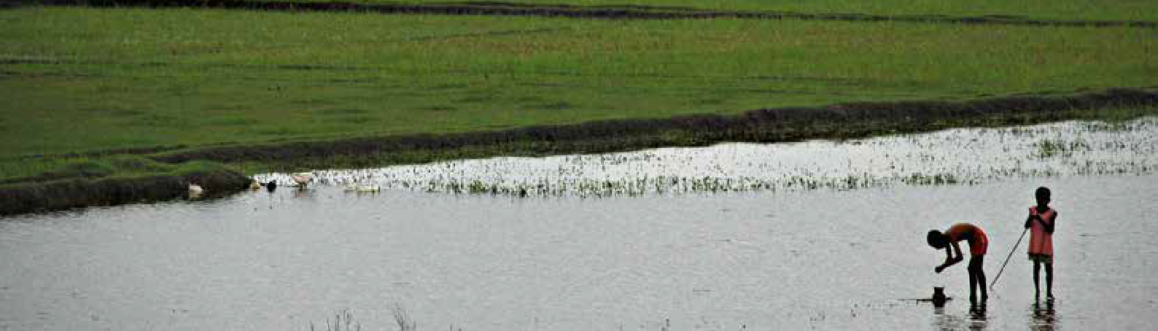www.climsucaf.org
- Represents the full amount of the funds allocated to hydro-met related projects.
- Represents the full amount of the funds allocated to hydro-met related projects.

70 CPI, 2019.
71 UNDRR, 2020.

INVESTMENTS NEED TO FILL THE CAPACITY GAPS IN LDCS ESPECIALLY IN AFRICA AND SIDS FOR EFFECTIVE EWS
Photo: Amir Jina
As the data in this report shows, there are clear gaps in EWS capacity worldwide, but especially in LDCs and across Africa as well as in South America. Additional investments should be directed to these regions to establish MHEWSs, enhance prepar- edness and build systems capacity for dissemination and communication of early warnings in LDCs, including especially LDC SIDS. Warning system enhancements must take into account changes in hazard frequency and security, exposure, and vulnerability, given that preparing for what happened in the past is no longer sufficient for addressing future risks.

EARLY WARNING INFORMATION MUST TRANSLATE TO EARLY ACTION
There is a need to invest in enhancing countries’ capacities when it comes to communication and dissemination of early warnings as well as in impact-based forecasting. Alerts need to explain what a forecast means for each given location, specifically the types of impacts associated with the forecast (i.e. not just the amount of rain, but which areas might be flooded as a result and who and what are likely to be affected). Early warning information must also be provided in the right language and use the right communication channels. Preparedness efforts and EWSs are only effective if they actually enable early action by at-risk communities ahead of impact, to ensure the safety of both the people and their livelihoods. Without explicit investments in decision-making systems, contextualised alerts and communication strategies – and the capacity of communities to act on the warning – other EWS components will be ineffective.

SUSTAINABLE FINANCING IS NEEDED TO SUPPORT THE GLOBAL OBSERVING SYSTEM
Sustainable financing is needed for the global observing system, as foundational global public good. Such financing needs to be tracked independently as it underpins all services, not only EWS. This is being addressed through the development of the Systematic Observations Financing Facility.72 As shown in this report, systematic observations are a critical element of the overall EWS value chain.

TRACK FINANCE FLOWS IN MORE DETAIL TO IMPROVE UNDERSTANDING OF CLIMATE RISK FINANCING EFFECTIVENESS
To successfully assess the cost-benefit ratio of investments in climate information and early warning systems there is a need to come up with a hydro-met marker that can be applied to tracking adaptation finance flows. As defined by the World Bank, hydro-met services provide real-time weather, water, early warning, and climate information products to end users, based on weather, water and climate data. Such a marker would entail the use of hydro-met keywords which could be used to identify projects with hydro-met systems and services elements. Detailed analyses would then be needed to assess which parts of the end-to-end early warning systems and which hazards are being addressed, in order to identify areas of need. Eventually projects should be built up from standard components such as those identified in this report, so that financing can be systematically targeted towards the parts of the systems where support is needed.

DEVELOP MORE CONSISTENCY IN MONITORING AND EVALUATION OF EWS EFFECTIVENESS
Monitoring and evaluation of the results and benefits of the use of climate information and EWS is patchy and incon- sistent. Systematic documentation of adaptation outcomes and returns on investments are essential for financial sustainability. To measure the effectiveness of early warning systems, the relevance and cost/benefit evaluation of decisions and measures triggered by the warnings needs to be assessed. Indicators, as suggested by this report’s case studies, can include, for example: people covered by early warnings per 100 000 of population; number of people evacuated (indicator G-6 of the Sendai Framework); number of people sheltered; and avoided disaster losses in terms of human and/or economic losses.

FILL THE DATA GAPS
Data on climate information and EWS capacity from many countries and particularly SIDS, is still lacking. Just 41% of SIDS provided data for this report – and much more data is required to assess the capacity and implementation gaps within SIDS. Moreover, there is the need for gender-disaggregated data to be able to address the different needs of vulnerable people73 and leave no-one behind.

- Establishing the Systematic Observations Financing Facility.
- Multi-hazard Early Warning Systems: A Checklist, WMO, 2018.

Annex
Table 1: Monitoring framework for end-to-end MHEWS implementation in the context of Sendai Framework Target G and corresponding WMO data.
Recommendations

MHEWS Component
1. Disaster Risk Knowledge | 2. Detection, Monitoring, Analysis and Forecasting | 3. Warning Dissemination and Communication | 4. Preparedness and response capabilities | 5. Monitoring and Evaluation
MHEWS Component: Description
Disaster risk knowledge based on the systematic collection of data  and disaster risk assessments  - Key hazards and related threats are identified  - Exposure, vulnerabilities, capacities and risks are assessed | Detection, monitoring, analysis and forecasting of the hazards and possible consequences  - Monitoring systems are in place  - Forecasting and warning services are in place  - Institutional mechanisms are in place | Dissemination and com- munication, by an offi- cial source, of authorita- tive, timely, accurate and actionable warnings and associated information on likelihood and impact  - Organizational and decision-making processes are in place and operational  - Communication systems and equipment are in place and operational  - Impact-based early warnings are communicated  effectively to prompt action by target groups | Preparedness at all levels to respond to the warnings received  - Disaster preparedness measures, including response plans, are developed and operational  - Public awareness and education campaigns are conducted  - Public awareness and response  are tested and evaluated | Monitoring and evaluation of socio- economic benefits of early warning systems  - Outcomes and benefits associated with climate services and early warnings are tracked and documented
- Roles and responsibilities of stakeholders are identified
- Risk information is consolidated
MHEWS Component: Sendai Framework Target G indicator
(G-5) Number of coun- | (G-2) Number of countries | (G-3) Number of people | (G-4) Percentage of
tries that have accessi- | that have multi-hazard | per 100,000 that are | local governments
ble, understandable, usa- | monitoring and forecasting | covered by early | having a plan to act
ble and relevant disaster | systems | warning information | on early warnings
risk information and |  | through local
assessment available to |  | governments or through
the people at the national |  | national dissemination
and local levels |  | mechanisms
MHEWS Component: Corresponding WMO data
- Accessible, understandable, usable and relevant disaster risk information and assessment available to people at the national and local levels  - NMS contribution and/or engagement in these risk assessments  - Hazard, exposure and vulnerability information used in country as an input into emergency planning and the development of warning messages | - Monitoring and forecasting systems in place for multiple hazards occurring simultaneously or  cumulatively over time  - MHEWS warning of potential cascading impacts  - Impact based forecasting  - National committee or platform composed of ministries, agencies and other stakeholders in place at the national or sub-national levels, which coordinates Disaster Risk Reduction activities  - NMS membership in national committee or platform coordinating DRR activities | - Communication channels used to disseminate products and services  - NMS warnings delivered using Common Alerting Protocol (CAP) format  - [Number of people per 100,000 covered by early warning informa- tion through local gov- ernments or through national dissemination mechanisms in your country]*  *not incorporated in the calculation of the degree to which this component is being implemented and rather is presented as a separate overall indicator | - Percentage of local governments in the country having a plan to act on early warnings | - Performance of MHEWS evaluated in the country  - Feedback and lessons learned translated into improvements of the MHEWS  - NMS engaged in performance reviews of the national MHEWS/DRR platform  - Performance and role of NMS evaluated (e.g. service delivery and coordination) within the national MHEWS/ DRR platform  - Feedback and lessons learned translated into improvements of the MHEWS


JN 20392
Photo: Remy Venturini

For more information, please contact:
World Meteorological Organization
7 bis, avenue de la Paix – P.O. Box 2300 CH 1211 Geneva 2 – Switzerland

Strategic Communications Office

Tel.: +41 (0) 22 730 87 40/83 14
Fax: +41 (0) 22 730 80 27
Email: communications@wmo.int
public.wmo.int

