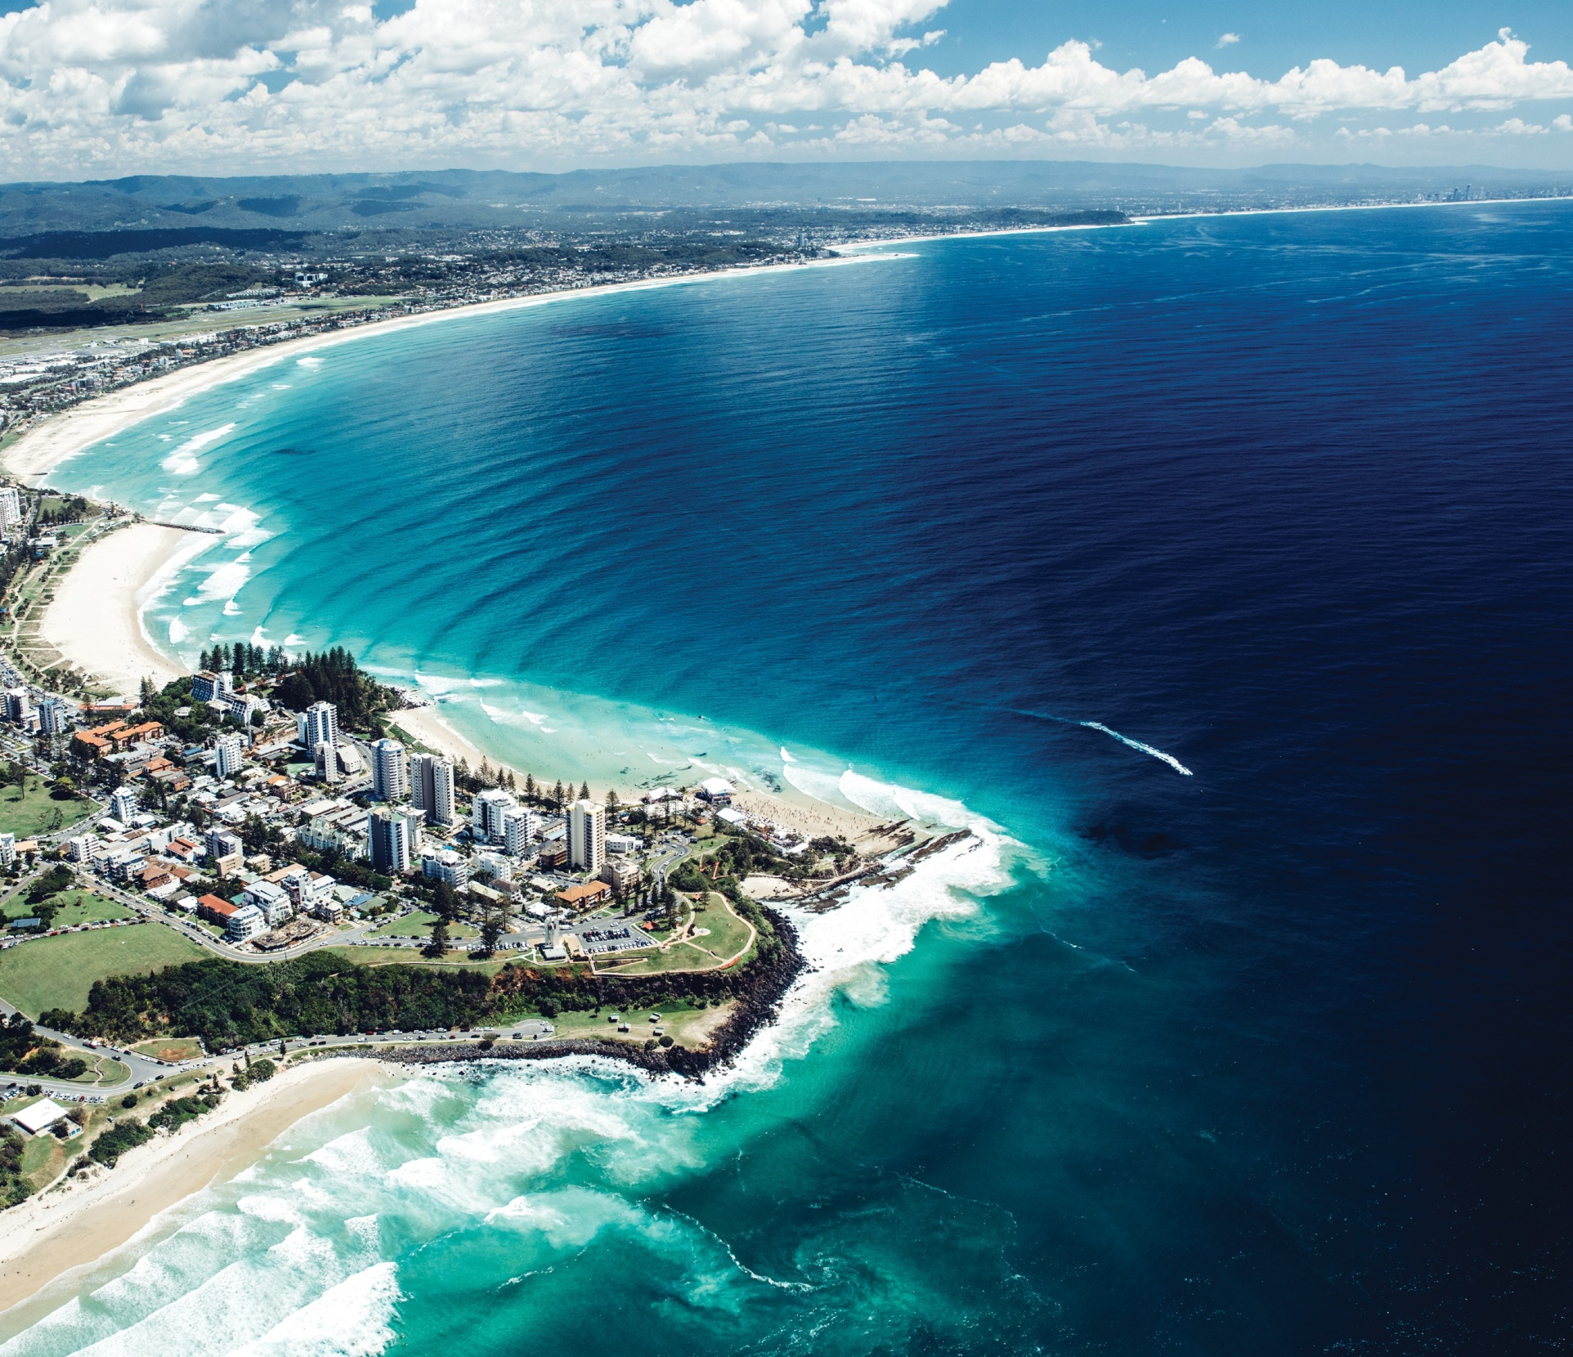

REGISTRATION

IS NOW OPEN

AACcess All Areas ISAAC 2018 GOLD COAST AUSTRALIA

21-26 JULY 2018

ISAAC is excited to announce that registration is now open for the 18th Biennial Conference of the International Society for Augmentative and Alternative Communication, being held at the Gold Coast Convention and Exhibition Centre on the

**Gold Coast, Queensland, Australia**, from **July 21 through 26, 2018**.

The ISAAC 2018 Conference provides four days focusing on the latest in research and clinical innovations in AAC plus social events with fantastic networking and entertainment. The conference also includes an exhibit with opportunities to meet representatives from companies who work for best outcomes in communication for all.

As well as the main conference, registration for the Pre-Conference Workshops and AAC Camp is also open. ISAAC 2018 Pre-Conference Workshops offer an opportunity to hear about best-practice in AAC from presenters around the world.

The AAC Camp, “Let’s Get Real” is themed around reality TV and will provide lots of fun and learning for AAC users of all ages.

**Register today** at [**www.isaac-online.org**](http://www.isaac-online.org/) and we’ll see you on the Gold Coast, Australia in July 2018!