
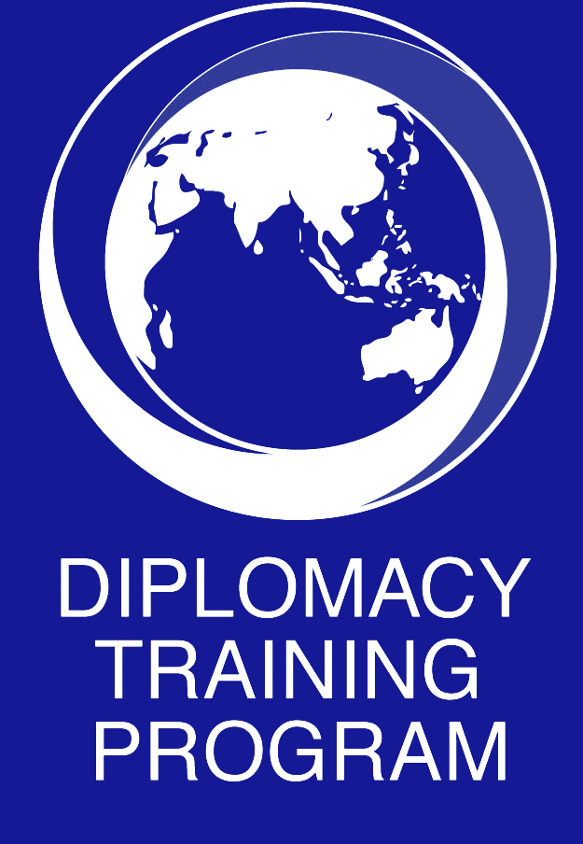
Call for Applications

Business, Human Rights, and the Sustainable Development Goals (SDGs) in the Pacific:
A Civil Society Capacity Building Program

April 30 -May 5, 2018, Fiji
In partnership with Pacific Islands Association of NGOs (PIANGO), Citizens Constitutional Forum (CCF) and Business and Human Rights Resource Centre (BHRRC)
Summary

The Diplomacy Training Program (DTP) and partners are calling for applications for a Pacific regional capacity building program for civil society on Business, Human Rights and the SDGs in the Pacific to be held in Fiji from April 30 – May 5, 2018.

This 5-day regional program will build the knowledge, skills and capacities of community advocates to protect and promote human rights and sustainable development in the Pacific. It will build knowledge of international human rights standards and mechanisms that can be applied and integrated into effective advocacy strategies. It will build practical skills for engaging with governments and business. Participants will learn from each other, share knowledge and build practical solidarity networks.

Trainers on the program will include Professor Surya Deva, member of the UN Working Group on Business and Human Rights as well as other leading experts and practitioners.

Why this Training?

Communities across the islands of the Pacific are being increasingly impacted by extractive industries, including deep sea mining, forestry, fisheries, infrastructure and tourism. Women, children, Indigenous peoples and persons living with disabilities are particularly vulnerable.

Community representatives and advocates need to build their knowledge, skills and networks to exercise their right to participate in decisions that affect them, and to be able to engage effectively with government and business to influence policies and projects, and their impacts.
Ensuring that economic development benefits communities and is economically and environmentally sustainable are major challenges. Informed participation is critical to sustainable development.

New global frameworks and guidelines on sustainable business practices and human rights are tools that advocates can use as they engage with business and the private sector, including on planning for realisation of the Sustainable Development Goals (SDGs). There is a significant knowledge gap in CSOs, government, and business of these new global standards on business and human rights and of the SDGs.

Knowing international standards and law, and how to seek redress, advice and support enables advocates to hold governments and business to account for their impacts – and to influence
them for sustainable, equitable development consistent with the cultures of the Pacific.

What will participants learn?

The curriculum will be finalised to meet the needs of the selected participants. Program content will include the following:
- International human rights standards and mechanisms;
- The new global development agenda – the SDGs;
- The UN Guiding Principles on Business and Human Rights and the OECD Guidelines on Multinational Enterprises;
- Skills in strategic advocacy and lobbying, and engaging the private and government.

All participants will receive a certificate from UNSW on completion of the training.

Trainers and Training Methodology

Trainers on DTP programs are experienced local, regional and international human rights practitioners, academics, and officials who understand and support DTP’s philosophy of participatory training. Professor Surya Deva, current Chairperson of the UN Working Group on Business and Human Rights, will be one of the trainers on the program. DTP recognizes and values the experiences and skills that participants bring to its programs. The training is interactive and sharing experiences and lessons with others is actively encouraged.

Who Should Apply?

The program is for community advocates from Pacific Island nations who work for and with NGOs/CSOs and who have the capacity to apply the training to their work. Consideration is given to ensuring a gender balance within each course.

Course Fees

The DTP is an independent NGO and course fees are an important source of income for its work. The course fee for the program is US$2000 and covers tuition, accommodation, food, field trips, and resource materials for the 5-day program. Travel expenses to and from Fiji are not included in this fee. A limited number of scholarships (full or partial) will be offered. NGOs are invited to enquire about subsidised spaces.

How to Apply

Application forms can be downloaded from the DTP website or can be requested from dtp@unsw.edu.au. All applications must be received by DTP by February 14, 2018. Applications will be acknowledged on receipt.

About the Diplomacy Training Program and Partners
The Diplomacy Training Program (DTP) is an independent NGO affiliated with the University of New South Wales, providing practical training in human rights and advocacy in the Asia-Pacific region (www.dtp.unsw.edu.au).

