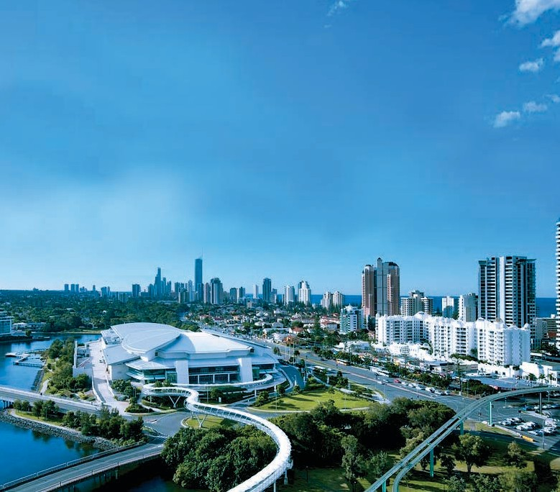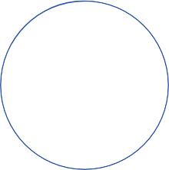

HOLDTHEDATE

AACcess All Areas ISAAC 2018 GOLD COAST AUSTRALIA

21-26 JULY 2018

ISAAC is excited to announce the 18th Biennial Conference of the International Society for Augmentative and Alternative Communication, **ISAAC 2018**, will be held at the Gold Coast Convention and Exhibition Centre

in **Gold Coast, Queensland, Australia,** on **July 21-26, 2018.**

**JOIN US** for AAC events and perspectives, the latest in research and clinical innovations, workshops, seminars, exhibits, social events, entertainment – everything you have come to expect from an ISAAC conference, and more!

Mark your calendar today, and save the date for ISAAC 2018 in Australia!

For more information, visit us at [**www.isaac-online.org**](http://www.isaac-online.org/) and follow #ISAAC2018 on Twitter.