# Australia Awards Women Trading Globally Invitation to participate



#### Are you a woman who owns and operates a successful small

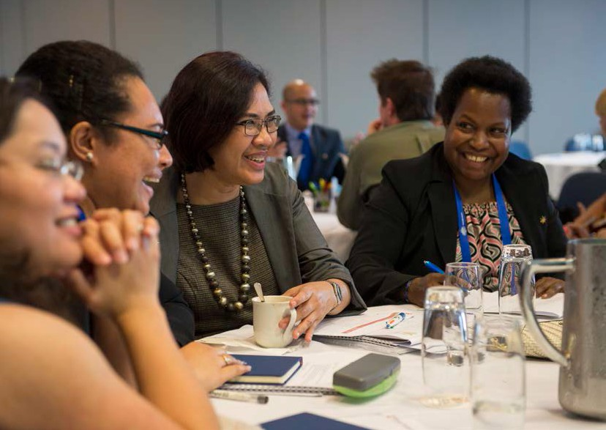

**business? Do you wish to learn about international trade and how you might be able to embark on the pathway**

**of growing your business into new international markets?**

The Australian Department of Foreign Affairs and Trade, under its Aid for Trade and Australia Awards programs, and in partnership with the Export Council of Australia, has pleasure in inviting you to participate in a short course ‘Australia Awards: Women Trading Globally’.

The course is offered to Pacific women with their own business who are ‘export ready’.

During the course participants will;

* learn about doing business in and with Australia
* connect with other women entrepreneurs from across the Pacific and Australia
* enable you to grow your business and expand internationally.

This two week residential Australia Awards short course is funded by the Australian Government.

Do you wish to learn about

international trade and how you might be able to embark

on the pathway of growing your business into new international markets?



The program consists of one week of training in Brisbane, Australia, and one week of training in Sydney, Australia.

### Requirements:

* You own and operate a successful business or you play a leading role within your business
* You reside in one of these countries:

Fiji Vanuatu

Solomon Islands Samoa

Tonga

Papua New Guinea

Kiribati Nauru

Federated States of Micronesia Marshall Islands

Cook Islands Niue

Tuvalu Tokelau Palau

* You have a strong command of English—spoken and written
* Your business has export capabilities
* You are able to travel to Australia from 12 to 24 November 2017
* You are keen to expand your international business capability

### The program includes:

* Comprehensive international business capability training
* Practical, hands-on exercises
* Site visits
* Networking opportunities

See the draft program schedule for further details.

For successful applicants, all costs* associated with this program will be funded by the Australian Government. These include;

* + International airfares and visas
  + All meals and accommodation in Australia
  + Transportation within Australia
  + Workshops and workshop materials
  + Organised social functions

* Excludes items of a personal nature.

This program will enable you to grow your business and expand internationally. Please complete the attached application form and return

it to [collinsrex@export.org.au](mailto:collinsrex@export.org.au) by close of business on **Friday 25 August 2017.**

You will be notified of the success of your application by close of business on **Friday 08 September 2017.**

# Week 1: Brisbane Program

|  |
| --- |
| **DAY 1: Introduction to Growing a Global Business** |
| * Benefits of Going Global: including exporter case studies from female CEOs |
| * International Business Plan |
| * Going global for the right reasons and commitment to export success |
| * SWOT analysis |
| * Product/service ready checklist and review of international business template for international success |
| * Briefing on how to develop an export plan pitch |

#### Facilitate the undertaking of the following exercises:

|  |
| --- |
| * Review of business case studies |
| * Prepare an introductory checklist for a case study business |
| * Undertake a group SWOT analysis for a case study business |
| * Prepare a Product/Service Readiness checklist for a case study business |
| **DAY 2: How to select the right market** |
| * How to select the right market & research |
| * Your target market |
| * The four Ps |
| * Your USP |
| * Market analysis |
| * Market options and promotion |

#### Facilitate the undertaking of the following exercises:

|  |
| --- |
| * Undertake a review of a target market for a case study business |
| * Undertake a competitor analysis for a case study business |
| * Complete an international pricing template for a case study business |
| * Complete a market metrics template for a case study business |
| * Complete a market entry template for a case study business |
| **DAY 3: Export Marketing and Preparing to Visit the Market** |
| * Marketing planning including marketing promotion |
| * Cultural considerations |
| * Ensuring the company website supports the export strategy |
| * Packaging, labelling, translations, and IP protection considerations |
| * Preparing for market visits |
| * Understanding the market culture |
| * Trade Missions and Trade Shows |

#### Facilitate the undertaking of the following exercises:

|  |
| --- |
| * Complete a buyer’s decision process for a business case study |
| * Complete a media strategy for a business case study |
| * Undertake an exercise to review global trade fairs for a business case study |
| * Attendees will be given time during the session to design a plan and ask questions about taking the completed exercises from Days 1-3 to expand into an export plan. |

# Week 1: Brisbane Program (Continued)

|  |
| --- |
| **DAY 4: Export Documentation (Overview only)** |
| * General awareness of transport documents requirements |
| * Documents required by importing country authorities |
| * Documents that could be required by local authorities |
| * Special documentation |
| * Letters of Credit: what are they and how to use them |

#### Freight and Logistics

|  |
| --- |
| * Incoterms 2010 & international pricing strategy |
| * Trade Terminology explained |
| * Common freight costs |
| * Choosing the right freight forwarder |
| * Marine insurance for air and sea cargo |

#### Facilitate the undertaking of the following exercises:

|  |
| --- |
| * Group exercise to complete an example set of documentary requirements |
| **EARLY EVENING NETWORKING FUNCTION**  Networking function that will provide delegates with an opportunity to network with representatives from industry & government in QLD, and CEOs of local Brisbane companies. |
| **DAY 5: Financing for Export Success** |
| * Methods of payment |
| * Understanding how a documentary letter of credit can mitigate risk |
| * Alternate methods of payment protection and other risk management strategies |
| * Managing foreign exchange risk |
| * How credit insurance can protect your receivables |
| * Finance options for global growth |

#### Pitching Skills

|  |
| --- |
| * Handy hints for delivering an elevator pitch |
| * Presentation skills |
| * Presentation practice |

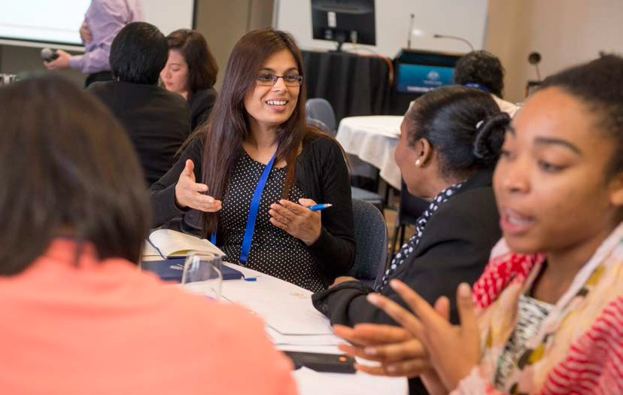

# Week 2: Sydney Program

|  |
| --- |
| **DAY 1: Roundtable with experts on doing business in the Pacific** |
| **DAY 2: Indigenous Advocacy** |
| * The day’s education program on indigenous advocacy issues will be led by the Diplomacy Training Program at the University of New South Wales. |
| **DAY 3: Exporter site visits** |
| * THE ECA will coordinate two local site visits with NSW based exporters. |
| **DAY 4: Presentation of export plans** |
| * Participants will have a chance for one on one consultations with our experts to review the material presented to date and a chance for a facilitated review of their export plans. |
| * In the afternoon, all participants will be invited to pitch their organisation’s export plan & be critiqued in a fun, interactive and comfortable environment. |
| **EARLY EVENING NETWORKING FUNCTION**  Networking reception with local business, state and federal government agencies and business chambers. A formal presentation of the winners from the export pitching exercise will be announced. |
| **DAY 5: Tour of Australian innovation hubs** |
| * Sydney is home to more than 26 innovation hubs, from Fishburners for the tech sector to Stone and Chalk for the fintech sector. On the final day, participants will be invited to meet and tour stand out innovation hubs in Sydney and have the opportunity to hear from a Venture Capitalist. |